Management of Common areas Information sheet
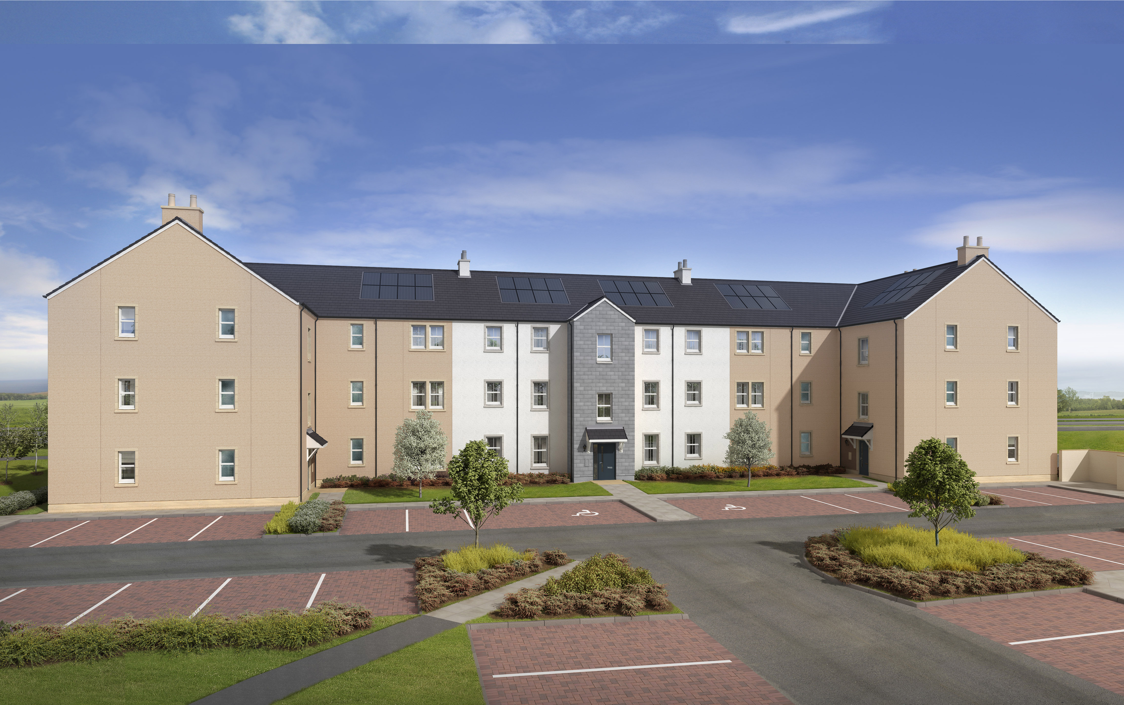
The Chapter, Charleston
Plots 620 - 643

Statement of Intent

VISION

To create and sustain Scotia’s neighbourhood developments for the benefit of all.

AIMS
Scotia will provide a structure for owners which will enable them by way of legal framework (DMS: Development Management Scheme) to maintain all common areas for the benefit of all.

DELIVERY
The structure provided to owners through which they will be empowered to maintain common areas will be as follows:

- Each owner will automatically become a member of the Owners’ Association and will be bound by the rules set out in the DMS when they buy their house. The Owners' Association will have specified powers, including the ability to own land within the development and to maintain the common areas within the development.

- The development will be regulated by the rules set out in the DMS. The DMS will define the common areas (referred to as "scheme property" in the DMS) which will be maintained. The rules contained in the DMS are enforceable by the Manager appointed by the Owners' Association. The Manager acts as agent for the Owners' Association and must exercise his powers in good faith for the benefit of the Owners' Association.

- All development areas which are not conveyed to individuals or adopted by the Local Authority may be transferred to the Owners’ Association and such areas will thereafter be owned by the Owners’ Association and managed for the benefit of the owners within the development.

- The Owners' Association must appoint a Manager at the first annual general meeting of the association. The Manager will manage the scheme property for the benefit of the owners. The Manager should be an established firm of Property Managers/Factors and can be appointed by Scotia until the first annual general meeting of the Owners' Association. Thereafter, the Manager can be replaced or re-appointed by the Owners’ Association at an annual general meeting.

- The Owners' Association will be entitled to elect an advisory committee for the purpose of providing advice to the Manager as to the effective management of the scheme property.

- Scotia will collect for the Manager a deposit (referred to as a “float”) equivalent to the estimate of 1 year Management/Factoring charges from each owner at handover.

- Prior to completion of the development, responsibility for share of maintenance charges will follow the phased completion of common areas. The cost of maintaining common parts in blocks of flats will be paid for only by the owners of the flats within those blocks. Scotia will be liable to meet the share of maintenance that is attributable to any completed but unsold properties.

- The Manager will be responsible for ensuring the effective management of common areas based upon the initial instruction from Scotia and thereafter from the Owners’ Association. The management services to be provided will include, but not be limited to:

- Inspection, maintenance and repair of the scheme property and the common parts of any flatted blocks within the development.
- Accounting i.e. advance budgeting and accounts.

YOUR FACTOR
Life Property Management
Westpoint House
Prospect Road
Arnhall Business Park
Westhill
AB32 6FJ
Tel: 01224 737 272
Fax: 01224 766 901
Email: enquiries@lpmonline.co.uk
Web: www.lpmonline.co.uk

FACTORS RESPONSIBILITIES
The factor is responsible for the management of maintenance and repairs of the common property areas only.

