Customer Specification
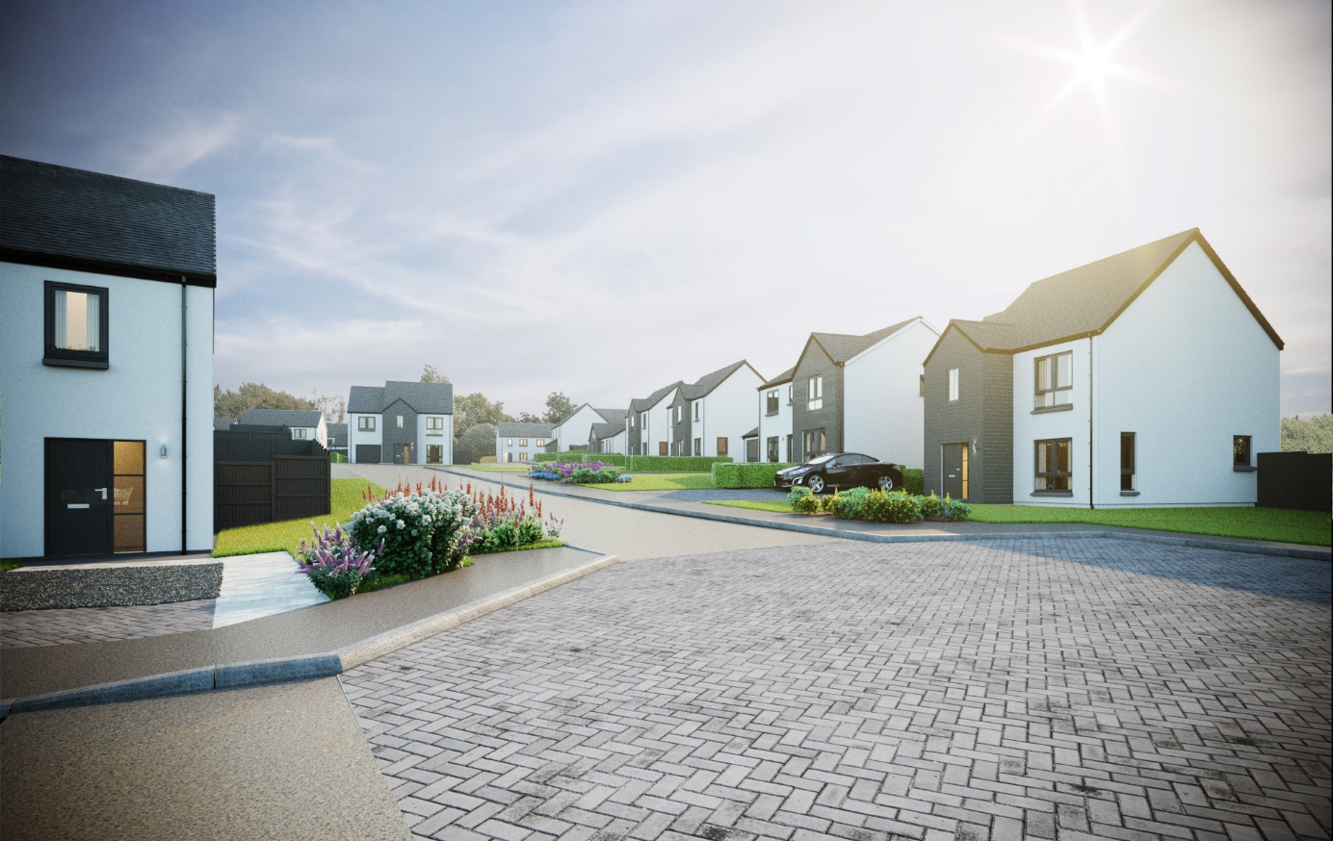
Knockhall, Newburgh
Plots 1-32, 37-38 & 44-49

Walls
External walls will be of timber frame construction with external leaf of render block-work, or feature timber or timber effect cladding may be used in some situations.
Internal walls will be made up of timber studs with insulation and plasterboard finish.

Roof, fasciae & guttering
All roofs to be finished in concrete interlocking roof tiles.
Fasciae, soffits and all gutters/downpipes are to be black uPVC.

Exterior colour finishes
The dry dash render finish to blockwork will be specified as a white backing coat with Nordic white chips above a grey basecourse.
Timber cladding will be black/grey Siberian Larch, which is treated with a Synthesa vacuum coating which provides weatherproofing and aids natural colour ageing, for which routine maintenance is recommended on a 5-10 year cycle, depending on exposure.

Floors
The ground floor will be of smooth finished concrete.
The first floor will be made up of timber joists finished with moisture resistant chipboard flooring above and plasterboard ceiling below.

Windows and doors
All windows are double glazed high performance grey uPVC externally, with white internal finishes and satin chrome finish ironmongery.
The front entrance doors are to be of vertically lined and grained grey external colour finish (white internal finish) GRP construction, with satin chrome finish ironmongery and a glazed sidelight.
A door number will be fitted and the Local Authority may require you to maintain this under the auspices of the Civic Government (Scotland) Act 1982.
Outward opening French doors are to be double glazed high performance grey uPVC, with white internal finishes.
Internal doors to be ladder moulded white painted finish doors with polished chrome finish ironmongery.

Internal finishings
Medium density fibreboard (MDF) square profile facings and skirting boards.
Wardrobes and dressing areas will have a hanging rail/s, painted finish shelving and, where shown on drawings, will be fitted with silver mirror/frame sliding doors, except in the case of a narrow aperture, where a conventional opening timber door will be used.

Internal decoration
Two coats of timeless emulsion to walls of all rooms.
Two coats of timeless emulsion to all ceilings.
Timeless painted finish to all internal woodwork.

Staircase
Painted timber balustrading and hardwood handrail.

Plumbing, central heating and ventilation
A gas “wet” system with thermostatically controlled radiators will be fitted in all properties.
This incorporates an Alpha FlowSmart system comprising an InTec boiler, a GasSaver flue gas heat recovery unit and in some cases a thermal store, with a programmable room thermostat.
A de-centralized mechanical extract ventilation (dMEV) system will be fitted, comprised of continuously running extractor fans within the kitchens and “wet” rooms.

Electrical installation
Ample white finish power points will be fitted throughout, including TV and telephone points in the Living room, Master bedroom and, in some house types, a Family/Dining area.
Isolation for kitchen appliances may involve the use of a grid switch in a central location.
Shaver points in all en suites and bathrooms.
All rooms (including Utility cupboards) will be fitted with ceiling light pendants, with a single additional downlighter fitted above shower cubicles. All lighting fixtures will be installed with low energy type bulbs and positions of electrical points can be seen on plot specific drawings.
Some house designs will also have a mix of feature lighting within the kitchen.
External lighting will be provided at a front and rear door.
A doorbell will be fitted.
Smoke, heat and carbon monoxide detectors will be fitted as required by building regulations, with an additional carbon dioxide (CO2) monitor fitted in the principal bedroom in order to record increased levels of carbon dioxide generally produced by exhaled air.

Solar photovoltaic panels
Photovoltaic panels will be installed on the roof of each plot in line with the requirements of relevant Building Standards which mandate the use of a renewable energy source in order to meet with the carbon dioxide emissions standards for individual homes.
Electricity generated by these panels will be available for use at nil cost to the homeowner, with additional needs supplied and charged via your own supplier. Any surplus generated capacity that is not used will be exported to the National Grid.
Specific layouts/positions of panels will vary between plots/house types. Images shown on elevation drawings are indicative only and further information can be provided on request.

Fibre broadband internet connectivity
Infrastructure will be installed at the development to provide FTTP (Fibre to the Premise) technology, which provides estimated speeds of up to 300Mbps at the entry point to the home.
Final connection and service provision within the home remains the homeowner’s responsibility and ultimate connection speeds will be dependent on the service provided by the chosen communications provider.

Kitchen
A choice of German cabinets and varied laminate work surfaces are offered as standard, and will include built-in stainless steel electric oven, electric induction hob, recirculating extractor hood and either a tall integrated fridge/freezer or separate built under fridge and freezer, depending on individual layouts.
A coordinating laminate up-stand will be fitted above the work surface with a glass splash-back behind the hob.

Utility rooms & cupboards
Where applicable, utility rooms will be fitted with the same style of cabinets, work surfaces and up-stands as chosen for the kitchen.
Designated spaces on kitchen drawings or in Utility cupboards will be fitted with plumbing (cold water feed and drainage) and electrics for connecting purchaser’s own single or dual self-condensing appliances.

W.C., bathrooms and en suites
All will comprise a w.c. and wash hand basin from a range which is of contemporary appearance with appropriate style tap fitments etc.
Where there is no en-suite, the bath in the bathroom will be fitted with a separate thermostatically controlled flexible shower kit and screen.
En-suites will have a shower tray with up-stand on panelled edges, complete with screen and thermostatically controlled valve.
Fitted mirrors are to be located above basins in bathrooms and en-suites, where possible.
Choice of wall tiling to sill height on the basin surrounding wall panel in bathrooms and, where appropriate, en-suites. Where an over bath shower is fitted as standard, tiling to a height of approximately 1.8m on the 3 walls above the bath, otherwise a minimum of one row of tiling around the bath in bathrooms.
Aqua panelling will be fitted within the shower cubicle of an en-suite.

Gardens
Where possible, gardens will be graded to suit the contours of the development and in some cases this may involve the creation of slopes instead of retaining structures. Where such retaining structures exist, designs will be approved by an engineer in order to maintain different ground levels on opposite sides and may be of masonry construction, timber sleepers and vertical posts and/or other suitable formats.
Turf will be laid to front gardens.
The rear gardens will be rotovated topsoil with a footpath constructed of grey riven paving slabs leading to a rotary clothes drier, which is provided.
Gravel topped French drains may be included to aid drainage, these will require to be retained and maintained.
General drainage can be improved by garden establishment and maintenance, which may require further investment and take the form of tree, shrub and/or other planting; considered grading of land; and the addition of soft and hard landscaping features. Works should be planned and undertaken subject to professional advice and in line with relevant regulations.

Fencing, hedging and walling
Plot specific details may be viewed on development plans which are available within the marketing suite.
Where a boundary is shared with other plots on the development and fencing has previously been erected, this will not be replaced and may be subject to natural weathering.

Parking, driveways & garages
Parking areas and driveways will generally comprise an initial 3000mm of lock block leading from the public footpath, with the remaining driveway between this and the house being washed gravel in a Bodpave® system.
Garages will be of single leaf masonry construction with a render finish to match the associated house.
The roof will be finished with concrete interlocking roof tiles. They will have an “up and over” retractable, vertically lined entrance door, with grey painted finish.
Garage internal walls will be of concrete block finish, with a concrete floor and power and lighting will be provided.

Street lighting
The layout of street lighting will be designed in accordance with Local Authority Guidelines and, once approved, available to view on development plans.

Efflorescence and ‘lime bloom’
Natural salts within wall materials may appear as a white deposit on external and internal walls as part of the normal drying out process. These are neither harmful nor detrimental to wall finish, durability or strength in the long term.
Exposure to normal weather conditions and naturally acidic rain water usually removes the majority of such deposits within the first year of completion.

Factoring
All public open spaces will be maintained by a factor appointed by the developer, please consult the factoring information document for specific details.

Development Management Scheme and/or Deed of Conditions
All owners will be required to comply with the terms of the Deed of Conditions/Development Management Scheme.
For further details please ask the Sales Adviser.

Warranties
New build residential properties have the benefit of the 10-year NHBC Buildmark cover. Access to a plot specific NHBC online HUG (Home User Guide) will also be provided from the point of handover until the expiry of the warranty.

Applicable Building Warrant
Building (Scotland) Regulations 2004; Domestic Handbook 2017
Please consult your Sales Adviser for further information. Scotia Homes Limited reserves the right to vary the above specifications where necessary but to similar or higher standards.

