Customer Specification

Hazelwood, Blairgowrie
Plots 094-113

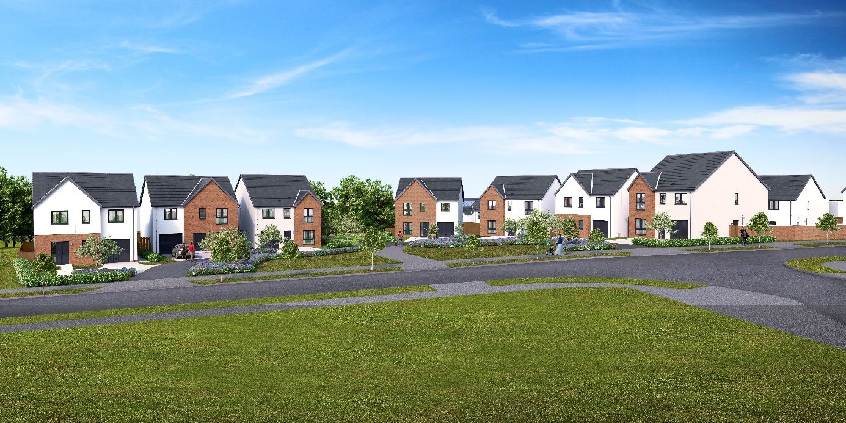

Walls
External walls will be of timber frame construction with external leaf of rendered blockwork, or feature areas of facing brick.
Internal walls will be made up of timber studs with insulation and plasterboard finish.

Roof, fasciae, soffits & rainwater goods
All roofs to be finished in concrete interlocking roof tiles.
Fasciae and soffits are to be white uPVC, gutters/downpipes are to be black uPVC.

Exterior colour finishes
The dry dash render finish to blockwork will be specified as Nordic white drydash chips on a pre-mixed white render backing coat above a facing brick basecourse.
Feature brick will be Alnwick Blend wire cut clay facing brick by Ibstock with grey mortar beds to feature areas as denoted on the elevation drawings and below the damp proof course to all basecourses.

Floors
The ground floor will be of smooth finished concrete.
The first floor will be made up of timber engineered floor joists finished with moisture resistant chipboard flooring above and plasterboard ceiling below.

Windows and doors
All windows will be double glazed uPVC; in anthracite grey colour (equivalent to RAL 7016) finish externally, white internally; with graphite finish handles.
Front entrance doors will be of GRP construction in an uPVC frame and either solid or part-glazed; in anthracite colour (equivalent to RAL 7016) finish externally, white colour internally; with brushed chrome finish handles and a letter plate.
Rear entrance doors will be of GRP construction in an uPVC frame and fully glazed; in anthracite grey (equivalent to RAL 7016) finish externally, white internally; with graphite finish handles.
Internal doors will be ladder moulded solid core timber, in Timeless painted finish, with any glazed doors having a single pane. Handles will be of polished chrome finish with satin grips, all other door ironmongery will be of chrome silver finish.

Internal finishings
Skirting boards and door facings will be square-faced and finished with a rounded edge, with all internal woodwork in Timeless painted finish.
Wardrobes, including walk-in wardrobes, will have a hanging rail/s and Timeless painted finish shelving, (where shown on drawings) fitted with silver mirror/frame sliding doors, except in the case of a narrower opening, where a conventional opening timber door will be used.

Internal decoration
Two coats of Timeless emulsion to walls and ceilings of all rooms.
Timeless painted finish to all internal woodwork.

Staircase
A timber-formed staircase with solid half-height balustrade partition which will be painted to match the walls and fitted with a painted hardwood capping piece.

Plumbing, central heating and ventilation
A gas “wet” system with thermostatically controlled radiators will be fitted in all properties.
This incorporates an Alpha E-TEC 33 or 38 combination boiler, with a programmable room thermostat.
A de-centralized mechanical extract ventilation (dMEV) system will be fitted, comprised of continuously running extractor fans within the kitchens and “wet” rooms.

Electrical installation
Ample white finish power points will be fitted throughout, including TV and telephone points in the Living room and master bedroom.
TV points will be wired to a central distribution point and to the roof space with future installation of an aerial/dish and final connection being the homeowner’s responsibility.
Isolation for kitchen appliances may involve the use of a grid switch in a central location.
Shaver points in all en suites and bathrooms.
All rooms (including Utility cupboards) will be fitted with ceiling light pendants, with a single additional downlighter fitted above shower cubicles. All lighting fixtures will be installed with low energy type bulbs and positions of electrical points can be seen on plot specific drawings.
Some house designs will also have a mix of feature lighting within the kitchen.
External lighting will be provided at a front and rear door.
A doorbell will be fitted.
Smoke, heat and carbon monoxide detectors will be fitted as required by building regulations, with an additional carbon dioxide (CO2) monitor fitted in the principal bedroom in order to record increased levels of carbon dioxide generally produced by exhaled air.

Solar photovoltaic panels
Photovoltaic panels will be installed on the roof of each plot in line with the requirements of relevant Building Standards which mandate the use of a renewable energy source in order to meet with the carbon dioxide emissions standards for individual homes.
Electricity generated by these panels will be available for use at nil cost to the homeowner, with additional needs supplied and charged via your own supplier. Any surplus generated capacity that is not used will be exported to the National Grid.
Specific layouts/positions of panels will vary between plots/house types. Images shown on elevation drawings are indicative only and further information can be provided on request.

Fibre broadband internet connectivity
Infrastructure will be installed at the development to provide FTTP (Fibre to the Premise) technology, which provides estimated speeds of up to 300Mbps at the entry point to the home.
Final connection and service provision within the home remains the homeowner’s responsibility and ultimate connection speeds will be dependent on the service provided by the chosen communications provider.

Kitchen
A choice of cabinets and varied laminate work surfaces are offered as standard, and will include built-in stainless steel electric oven, electric induction hob, recirculating extractor hood and either a tall integrated fridge/freezer or separate built under fridge and freezer, depending on individual layouts.
A coordinating laminate up-stand will be fitted above the work surface with a glass splash-back behind the hob.

Utility rooms & cupboards
Where applicable, utility rooms will be fitted with the same style of cabinets, work surfaces and up-stands as chosen for the kitchen.
Designated spaces on kitchen/utility room drawings or in Utility cupboards will be fitted with plumbing (cold water feed and drainage) and electrics for connecting purchaser’s own single or dual self-condensing appliances.

W.C., bathrooms and en suites
All will comprise a w.c. and wash hand basin from a range which is of contemporary appearance with appropriate style tap fitments etc.
Where there is no en-suite, the bath in the bathroom will be fitted with a separate thermostatically controlled flexible shower kit and screen.
En-suites (and some bathrooms additionally to the bath) will have a shower tray with up-stand on panelled edges, complete with screen and thermostatically controlled valve.
Fitted mirrors are to be located above basins in bathrooms and en-suites, where possible.
Choice of wall tiling to sill height on the basin surrounding wall panel in bathrooms and, where appropriate, en-suites. Where an over bath shower is fitted as standard, tiling to a height of approximately 1.8m on the 3 walls above the bath, otherwise a minimum of one row of tiling around the bath in bathrooms.
Wet wall panelling will be fitted within the shower cubicle of an en-suite.

Gardens
Where possible, gardens will be graded to suit the contours of the development and in some cases this may involve the creation of slopes instead of retaining structures. Where such retaining structures exist, designs will be approved by an engineer in order to maintain different ground levels on opposite sides and may be of masonry construction, timber sleepers and vertical posts and/or other suitable formats.
Turf will be laid to front gardens.
The rear gardens will be rotovated topsoil with a footpath constructed of grey concrete paving slabs leading to a rotary clothes drier, which is provided.
Smaller garden areas which are not directly suitable for standard or additional turf may be completed with loose gravel or appropriate planting.

External surface water drainage
Land drainage may be designed and installed as required to mitigate the potential for localized areas of ponding caused by the following issues; surface water run-off after heavy rainfall, poor draining soils, steeply sloped areas of land, earthwork platforming and surface water run-off from adjacent land.
This may be strategic in nature and may partly/wholly traverse an individual plot. Development/plot specific information is available via the development site plan and/or on request with further information included within the Home Owner’s Information Pack issued prior to handover.
Typical specification will be for the provision of gravel-topped French drains, which can be covered by turf, however this will diminish the effectiveness of the drainage and the drains themselves, which must be retained and maintained in order to provide land drainage to individual and adjacent plots/land. Removal or inadequate maintenance of drains may invalidate warranty/ies in the event of excess rainfall and resulting ponding, with responsibility within an individual plot remaining that of the owner, noting that drainage may continue into neighbouring plots or land adopted by the Local Authority.
General drainage can be improved by garden establishment and maintenance, which may require further investment and take the form of tree, shrub and/or other planting; considered grading of land; and the addition of soft and hard landscaping features. Planting and growth in the early years of a development will also assist in establishing natural drainage routes for surface water. Developments can take several years to settle and the perceived issue of localized ponding and/or wet gardens reduce significantly in the first two to three years after development. Major landscaping works should be planned and undertaken subject to professional advice and in line with relevant regulations.

Fencing, hedging and walling
Plot specific details may be viewed on development plans which are available within the marketing suite.
Where a boundary is shared with other plots on the development and fencing has previously been erected, this will not be replaced and may be subject to natural weathering.

Parking, driveways & garages
Parking areas and driveways will have a surface finish of charcoal grey coloured lock block leading from the public footpath.
Garages will be of single leaf blockwork construction, with exterior wall and roof finishes to complement the associated house.
The vehicular entrance door will be a Garador Carlton retractable door, with vertically lined anthracite grey (equivalent to RAL 7016) colour finish and matt silver handles.
The pedestrian entrance door will be of GRP construction within an uPVC frame, in anthracite (equivalent to RAL 7016) finish and with brushed satin chrome finish handles.
Garage internal walls will be of concrete block finish, with a concrete floor and power and lighting will be provided.

Street lighting
The layout of street lighting will be designed in accordance with Local Authority Guidelines and, once approved, available to view on development plans.

Efflorescence and ‘lime bloom’
Natural salts within wall materials may appear as a white deposit on external and internal walls as part of the normal drying out process. These are neither harmful nor detrimental to wall finish, durability or strength in the long term.
Exposure to normal weather conditions and naturally acidic rainwater usually removes the majority of such deposits within the first year of completion.

(Factoring and) Public open spaces
All public open spaces will be adopted by Perth & Kinross Council.

Development Management Scheme and/or Deed of Conditions
All owners will be required to comply with the terms of the Deed of Conditions/Development Management Scheme.
For further details please ask the Sales Adviser.

Warranties
New build residential properties have the benefit of the 10-year NHBC Buildmark cover.

Applicable Building Warrant
Building (Scotland) Regulations 2004; Domestic Handbook 2019
Please consult your Sales Adviser for further information. Scotia Homes Limited reserves the right to vary the above specifications where necessary but to similar or higher standards.

