Customer Specification
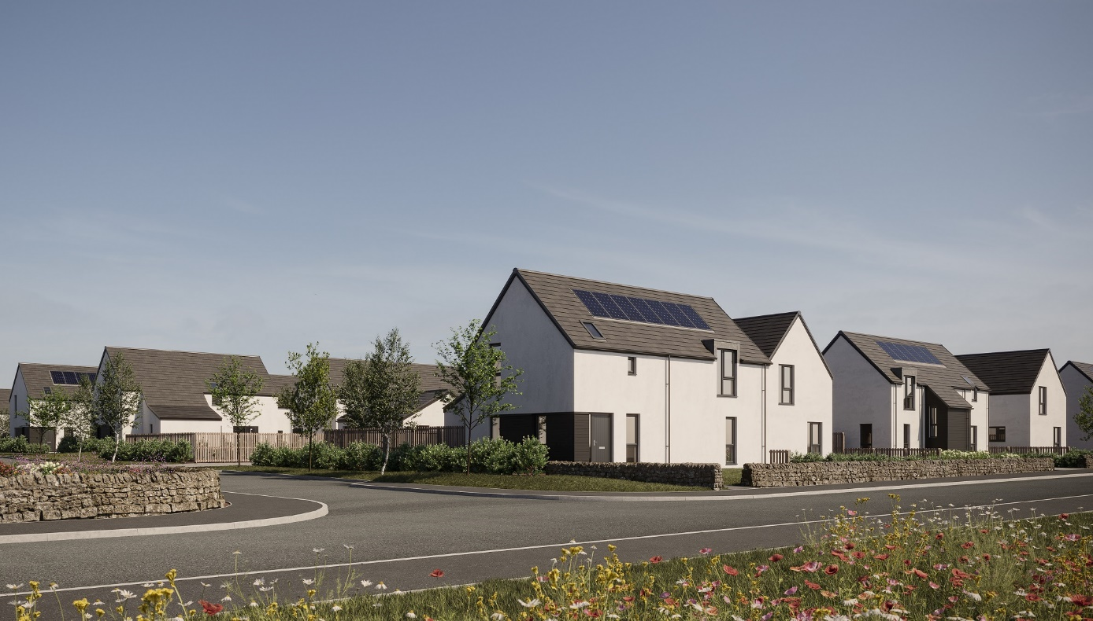Willowburn, Tarves

Walls
External walls will be of timber frame construction with an external leaf of either rendered blockwork or feature panels of timber cladding.
Internal walls will be of plasterboard finish mounted on timber studs.

Roof, fasciae & guttering
Roofs will be finished in Marley Edgemere smooth grey interlocking concrete roof tiles. Where applicable, fasciae and guttering/downpipes will be black finish uPVC.

Exterior colour finishes
The dry dash render finish to blockwork will be specified as a white backing coat with Nordic white chips above a grey basecourse.
Timber cladding will be Thermopine, with a Teknos coating in black/grey colour which provides weatherproofing and for which routine maintenance is recommended on a 5-10 year cycle, depending on exposure.

Floors
The ground floor will be of smooth finished concrete. Upper floors will be timber joisted with chipboard flooring.

Windows and doors
All windows will be double glazed uPVC; in anthracite colour (equivalent to RAL 7016) finish externally, white internally; with satin chrome finish handles.
Separate roof and combination windows will be of timber construction.
Front entrance doors will be of GRP construction in an uPVC frame with a glazed sidescreen; in anthracite colour (equivalent to RAL 7016) finish externally, white colour internally; with satin chrome finish handles and a letter plate.
Rear entrance doors will be of uPVC construction and fully glazed; in anthracite (equivalent to RAL 7016) finish externally, white internally; with chrome silver finish handles.
Sliding patio doors will be of glazed uPVC construction; in anthracite colour (equivalent to RAL 7016) finish externally, white colour internally; with satin or polished chrome finish handles.
Internal doors will be ladder moulded semi-solid core timber, in Timeless painted finish, with any glazed doors being clear single panel. Handles will be of polished chrome finish with satin grips, all other door ironmongery will be of satin or polished chrome silver finish.

Internal finishings
Skirting boards and door facings will be square-faced and finished with a rounded edge, with all internal woodwork in Timeless painted finish.
Wardrobes will have a hanging rail/s and Timeless painted finish shelving, fitted with silver mirror/frame sliding doors, except in the case of a narrower opening, where a conventional opening timber door will be used.

Internal decoration
Walls and ceilings will be of Timeless painted finish.

Staircase
Staircase balustrades will be of solid, Timeless painted plasterboard finish, with a Timeless painted timber handrail.

Plumbing, central heating and ventilation
A gas “wet” system with thermostatically controlled radiators will be fitted in all properties.
This incorporates an Alpha system comprising an E-Tec boiler with a programmable room thermostat. In some plots/house types, this may include a GasSaver flue gas heat recovery unit and/or a thermal store.
The gas supply will be of liquid propane gas fed from a communal storage tank located within the development.
A de-centralised mechanical extract ventilation (dMEV) system will be fitted, comprised of continuously running extractor fans within the kitchens and “wet” rooms.

Electrical installation
Ample white finished power points will be fitted throughout, with a telephone/digital TV/satellite multi-point in the living room and master bedroom. TV points will be wired to a central distribution point and to the roof space with future installation of an aerial/dish and final connection being the homeowner’s responsibility.
Isolation for kitchen appliances may involve the use of a grid switch in a central location.
A shaver point will be fitted in bathrooms and en suites.
All rooms (including Utility cupboards) will be fitted with ceiling light pendants, with a single additional downlighter fitted above shower cubicles. All lighting fixtures will be installed with LED bulbs and positions of electrical points can be seen on plot specific drawings.
Some house designs will also have a mix of feature lighting within the kitchen.
External lighting positions can be seen on plot specific drawings. Public elevations will be fitted with a stainless steel up and downlighter with PIR sensor on public elevations, with a bulkhead style light fitting on private elevations.
A doorbell will be fitted.

Solar photovoltaic panels
Photovoltaic panels will be installed inset to the roof tiles of each plot in line with the requirements of relevant Building Standards which mandate the use of a renewable energy source in order to meet with the carbon dioxide emissions standards for individual homes.
Electricity generated by these panels will be available for use at nil cost to the homeowner, with additional needs supplied and charged via your own supplier. Any surplus generated capacity that is not used will be exported to the National Grid.
Specific layouts/positions of panels will vary between plots/house types. Images shown on elevation drawings are indicative only and further information can be provided on request.

Fibre broadband internet connectivity
Infrastructure will be installed at the development to provide FTTP (Fibre to the Premise) technology, which provides estimated speeds of up to 300Mbps at the entry point to the home.
Final connection and service provision within the home remains the homeowner’s responsibility and ultimate connection speeds will be dependent on the service provided by the chosen communications provider.

Kitchen
A choice of cabinets and varied work surfaces are offered as standard, and will include built-in stainless steel electric oven, electric induction hob, recirculating extractor hood and a tall integrated fridge/freezer.
A coordinating laminate up-stand will be fitted above the work surface with a glass splash-back behind the hob.

Utility rooms & cupboards
Where applicable, utility rooms will be fitted with the same style of cabinets and work surfaces/upstands as chosen for the kitchen.
Designated spaces on kitchen drawings or in Utility cupboards will be fitted with plumbing (cold water feed and drainage) and electrics for connecting purchaser’s own single or dual self-condensing appliances.

W.C., bathrooms and en suites
All will comprise a w.c. and wash hand basin from a range which is of contemporary appearance with appropriate style tap fitments etc.
Where there is no en suite, the bath in the bathroom will be fitted with a separate thermostatically controlled flexible shower kit and screen.
En suites will have a shower tray with upstand on panelled edges, complete with screen and thermostatically controlled valve.
Fitted mirrors are to be located above basins in bathrooms and en suites, where possible.
Choice of wall tiling to sill height on a minimum of the basin surrounding wall panel in bathrooms and, where appropriate, en suites.
Where an over bath shower is fitted as standard, there will be tiling to a height of approximately 1800mm on the 3 walls above the bath, otherwise one row of tiling around the bath in bathrooms.
Wet wall panelling will be fitted within the shower cubicle of an en-suite.

Gardens
Where possible, gardens will be graded to suit the contours of the development and in some cases this may involve the creation of slopes instead of retaining walls.
Turf will be laid to front gardens and shrubbery may be installed in some areas in accordance with the approved landascaping layout. The rear gardens will be rotovated topsoil with a footpath constructed of grey riven paving slabs leading to a rotary clothes drier, which is provided. Small/isolated areas of rear gardens which are not suitable for future turf, such as between paths and fences/garages etc., may be filled with loose gravel.
Open French drains may be included to aid drainage, these will need to be retained and maintained.
General drainage will be improved by garden establishment and maintenance.

Parking, driveways & garages
Parking areas and driveways will generally comprise an initial 3000mm of lock block/paviours leading from the public footpath, with the remaining driveway between this and the house being washed gravel held within a cellular paving grid system.
Garages will be of single leaf blockwork construction, with exterior wall and roof finishes to complement the associated house.
The vehicular entrance door will be a Garador Carlton retractable door, with vertically lined anthracite (equivalent to RAL 7016) colour finish and a satin finish handle.
The pedestrian entrance door will be of uPVC construction within an uPVC frame and with brushed satin chrome finish handles.
All garages are equipped with power and lighting.

Street lighting
Designed in accordance with Local Authority Guidelines.

Fencing, hedging and walling
Rear gardens will generally be enclosed by 1800mm single-sided hit and miss fencing; changing to shiplap on front/public boundaries; with this height reducing to 900mm on side boundaries between the rear garden and the front of the house, and then changing to hedging running to the front boundary.
A mixture of post and wire or 1200mm timber fencing may be used in conjunction with hedging on boundaries that overlook open aspects.
Feature walling may be used on the Duthie Road frontage and for boundary finishes around common areas such as the propane gas storage tank area.
Where a boundary is shared with other plots on the development and fencing has previously been erected, this will not be replaced and may be subject to natural weathering.
Installation and growth of hedging may be subject to growing season.
Plot specific variations may be checked on site plans.

Efflorescence and ‘lime bloom’
Natural salts within wall materials may appear as a white deposit on external and internal walls as part of the normal drying out process. These are neither harmful nor detrimental to wall finish, durability or strength in the long term. Exposure to normal weather conditions and naturally acidic rain water usually removes the majority of such deposits within the first year of completion.

Factoring
All public open spaces will be maintained by a factor appointed by the developer, please consult the factoring information document for specific details.

Development Management Scheme and/or Deed of Conditions
All owners will be required to comply with the terms of the Deed of Conditions/Development Management Scheme. For further details please ask the Sales Adviser.

Warranties
New build residential properties have the benefit of the 10-year NHBC Buildmark cover.

Applicable Building Warrant
Building (Scotland) Regulations 2004, Technical Handbook 2019 Domestic (effective on all applications from 01st October 2019)
Please read the above in conjunction with site/plot plans and consult your Sales Adviser for further information. Scotia Homes Limited reserves the right to vary the above specifications where necessary but to similar or higher standards.

