
HOME OWNER’S
INFORMATION PACK (HOIP)
for
PARK VIEW AT MIDMILL, KINTORE

www.scotia-homes.co.uk
Please read this document in conjunction with the NHBC booklet ‘Guide to your new home – A practical guide to looking after your new home’, the Sales Specification / Bespoke Options documents (received at reservation stage), plot specific drawings and Statement detailing Extras/Options (both issued at reservation stage or as you have confirmed any choice of these).
(1074.PV) Rev. 1 11/09/2025
Contents
Page
HOME SAFETY INFORMATION 4
Davies’ EMERGENCY COVER 4
nHBC buildmark warranTY 5
YOUR NEW HOME’S POSTAL ADDRESS 9
CUSTOMER CARE & ONGOING MAINTENANCE 9
LABELLING OF KEY SERVICES 14
HEATING & HOT WATER - ASHP TYPE & SYSTEM 14
RADIATOR SAFETY PRECAUTIONS AND RADIATOR NOTES 18
HOT AND COLD WATER SERVICES 21
OPERATING INSTRUCTIONS FOR THE ELECTRICAL INSTALLATION 26
IF AN ELECTRICAL CIRCUIT FAILS 28
solar pv (PHOTOVOLTAIC) panels 29
SMOKE, HEAT & CARBON DIOXIDE DETECTORS/ ALARMS 32
TELEVISION INSTALLATION 34
TELEPHONE INSTALLATION 36
Fibre broadband internet connectivity 36
EXTRACTOR FANS (DMEV SYSTEM) 39
VENTILATION AND AVOIDING CONDENSATION 40
KITCHENS 45
PROVISION FOR A GROUND FLOOR SHOWER 65
WALL TILING 66
SHOWER WALL PANELLING (where fitted) 66
INTERNAL DRAINAGE – ACCESS POINTS 66
CONSTRUCTION OF WALLS, roofs, PARTITIONS, FLOORS & CEILINGS 67
FIXING TO WALLS, CEILINGS OR FLOORS – IMPORTANT NOTICE 68
WINDOWS AND FRENCH DOORS 69
EXTERNAL DOORS 73
INTERNAL DOORS 74
FLOOR FINISHES 74
ROOF SPACE 76
GARAGEs (where applicable) 77
external fixings 80
efflorescence 80
CARE AND MAINTENANCE OF BOUNDARY WALLS 81
EXTERNAL AREAS 88
DRAINAGE CONSIDERATIONS 92
METERS 97
UTILITY SUPPLIERS 97
biodiversity & eco-habitats 99
LOCAL AUTHORITY REFUSE AND RECYCLING COLLECTION 100
winter procedures 100
council tax 100
SCHEDULE OF MATERIALS 101
NOTE:
The information contained in this document is for our standard house types and may not cover specific variations requested by you. It is believed to be correct at the time of writing but may be subject to specific variations in design, materials or any other factors which have effect before, during and after the construction process. Consequently, it should be treated as general guidance and cannot be relied upon as providing an accurate description of any of the matters illustrated therein.
HOME SAFETY INFORMATION
We are delighted that you have purchased one of our new homes and we hope very much that you enjoy living in it. We go to great efforts to design and build our homes to provide you with high levels of safety, but all homes have inherent risk, and it is our aim to help you identify and manage these risks.
This Home Owner’s Information Pack contains a lot of information about the different systems within your new home and you are encouraged to read all the supplied ‘user manuals’ before using any of your home’s systems or appliances. Specifically, we would like to draw your attention to some key risks that are sadly all too often common causes of accidents in domestic properties:
Fire safety http://www.firescotland.gov.uk/your-safety.aspx
General home & garden safety http://www.rospa.com/home-safety/advice/general/home-garden-safety-checklists/
We recommend that you take the time to look at the important safety information and advice provided in the links (to the right of the above points and accessible via www.scotia-homes.co.uk). Following the advice will help keep you and your loved ones safe and able to enjoy your new home in the future.
If you do have any safety concerns about any aspect of your new home, please contact our customer care department customercare@scotia-homes.co.uk.
Davies’ EMERGENCY COVER
Your home is covered under Davies Group’s Home Emergency Assistance Cover for a period of 24 months from your legal date of entry and the following notes provide some outline points for your information.
This cover includes items such as blocked/burst pipes (where they occur within your home) and damaged window/door locks where there is a risk to security. Some examples are shown in the list below - please note that some of these examples may not apply to your own property.
In an emergency situation where any of the covered items are affected you should contact Davies Group directly instead of Scotia - at the time of writing, the emergency contact number is 0345 1552374.
Any non-emergency problem occurring inside your home (and occurring within 24 months of your legal date of entry and which is not classed as an emergency by Davies Group) should be reported to the Scotia customer care department during normal office hours.
Please also note that any problems in the communal external areas should also be reported to the factor – these areas are also not covered by Davies Group.
Examples of what is covered | Examples of what is not covered
Internal Plumbing & Drainage (inside your home)  Repairs to your internal plumbing and drains including where there is a loss of water to your property, Blocked drainage and leaks (inside your home)  Clearing blocked toilets and waste pipes (inside your home) | Showers including the shower unit, controls, outlet or shower head  Replacement of water tanks/radiators, thermostatic radiator valves, hot water cylinders and sanitary ware
Clearing total blockages to your drainage pipes (inside your home) | Shared drains  External guttering, rainwater downpipes, rainwater drains and soakaways
Electrical Emergency & Breakdown  An emergency caused by, or breakdown of, the domestic electrical wiring supply system, including permanent damage caused by a power cut | All non-permanent wiring/electrics, e.g. kettles, fairy lights or any other and appliances with plugs  Shower unit or immersion heater unit
Security  Making your property secure in the event of broken locks for external windows and doors that are your responsibility | Doors (and windows) which do not secure your property, such as internal porch doors, internal doors and internal conservatory doors  Failure of breakdown of the external locking mechanisms to doors or windows for outbuildings or a garage
nHBC buildmark warranTY
Your warranty and insurance with NHBC – please find extracts below from the NHBC document which was issued to you at reservation.
What is Buildmark?
Buildmark is a joint agreement between your builder and NHBC to provide warranty and insurance on your newly built home.
Protection is provided to you, the purchaser, from exchange of contract with deposit protection insurance. This is followed by a two-year post-completion builder warranty, supported by an NHBC dispute resolution service and guarantee. So, if you encounter any problems with your home during this time, contact your builder in the first instance and they should put things right. If you remain dissatisfied, you can contact NHBC for assistance.
• The resolution service: we contact the builder about the problems reported to us.
If the builder does not deal with the matter to your satisfaction, we will investigate and decide what the builder must do to meet their responsibilities
• The guarantee: you are protected by the NHBC guarantee for what we or a court decides the builder should have done to meet their responsibilities. If the builder does not meet their responsibilities, we will do so on their behalf. Alternatively, we will pay you what it would cost us to have the work done.
After the initial two-year builder warranty period, NHBC provides an eight-year insurance policy (years three to 10) against damage to the home caused by the failure of your builder to build specific parts of the main structure to NHBC Technical Requirements. NHBC will pay the cost or carry out remedial works for issues covered by the policy if the cost exceeds the minimum claim value (MCV).
What does Buildmark cover?
• Before legal completion: loss of your exchange deposit, or having to pay more to complete the build of your home, because the builder is insolvent or has committed fraud
• Builder warranty period: failure by the builder to meet NHBC Technical Requirements when building your home or preparing your land
• Insurance after the builder warranty period: physical damage to your home because the builder failed to build specific parts of your home to meet NHBC Technical Requirements
• Extra insurance for Building Regulations: imminent danger to someone’s physical health or safety because the builder failed to meet specific Building Regulations when building the main structure of your home (this is only available if NHBC undertook the Building Control service on the home)
• Insurance for contaminated land: contamination on or in your land which could have resulted in a statutory notice being issued under the legislation or official guidance in force at that time.
What's not covered by Buildmark?
Buildmark only protects you against the items outlined in your Buildmark policy document.
There are some things that are not NHBC’s responsibility, such as, but not limited to:
• Wear and tear, neglect and failure to undertake appropriate maintenance
• Storms and other severe weather conditions
• Fire and smoke
• Damp, condensation and shrinkage which is not a result of the builder failing to meet NHBC Technical Requirements.
Full details and a glossary of terms can be found in the Buildmark policy booklet. If you are unsure about what is covered, you can contact NHBC to check, or go to www.nhbc.co.uk.
During the insurance period after the initial builder warranty period has expired, Buildmark is designed to insure your home against damage caused where specific parts of the property have not been built to NHBC Technical Requirements. The diagram below shows you the parts of the home that are typically covered.
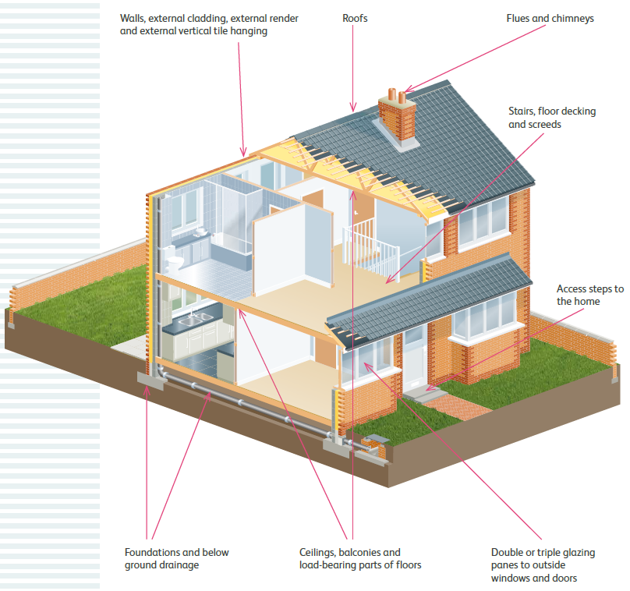
Whether your new home is a house or an apartment, there are some things which you should be aware of:
• This image is for illustration purposes only
• The Buildmark policy does not take the place of buildings or contents insurance
• There are certain conditions, limits and exclusions that apply; different periods and conditions also apply to common parts
• Please read your policy document for full details about your cover.
Are there financial limits?
Limits that apply to new build properties for claims under Buildmark are as follows:
• Pre-completion: the exchange deposit paid in part payment of your home, up to 10% of the original purchase price or £100,000, whichever is lower
• Post-completion: the original purchase price, up to a maximum of £1m.
Limits are different for conversions and continuous structures: see the policy booklet for more details.
What is minimum claim value?
We do not require policyholders to pay the first part of any claim. Instead, we operate a minimum claim value (MCV).
If the cost of the work you are claiming for is below the MCV, we will not do the work or pay anything towards the cost. If it exceeds the MCV, we will complete the work or pay the cost in full and you will not have to make a contribution.
The MCV applies to claims made to NHBC after the builder warranty has expired. This applies in years three to 10 but please refer to the policy booklet for more details. The amount then increases by £50 each consecutive year thereafter.
See the Buildmark policy booklet for full details of the MCVs at www.nhbc.co.uk.
Helping you before, during and after your move
Your conveyancer will give you your Buildmark policy documents, including your Buildmark certificate, when you buy your new home; you should read it to check for specific details about the cover, conditions and exclusions.
NHBC has a wealth of information to support you before, during and after your move. Their website (www.nhbc.co.uk) is a great starting point for helpful information and guidance.
YOUR NEW HOME’S POSTAL ADDRESS
You will have been supplied with your new address at varying points through the purchase process, with this being created, approved and registered with the Local Authority, Royal Mail etc. much earlier in the construction process of the development, as is required for the registering of many other matters, such as utility connections.
Address registration instigates addition to the Royal Mail’s PAF (Postcode Address File) from which many sources need to draw address information using various subscription services.
The very last stage is “activation” of the address with Royal Mail so as to allow postal deliveries, which we request routinely, but is not allowed until 2 weeks before occupation in order that postal workers are not delivering junk mail to building sites. However, the address still exists on the PAF, it is just hidden from public view until that activation takes place and will not show on the public “Postcode Finder” section of the Royal Mail website until they have completed activation.

Common objections from external providers that reject the address normally mean they are reverting to public searches rather than the full PAF, or they are using an outdated copy of the PAF. In this case, insistence should be stated that they (the provider) must pursue updated copy of the PAF as it would be impossible for us to hand over a property without the address being registered.
CUSTOMER CARE & ONGOING MAINTENANCE
Should you need to contact our customer care department and your query cannot be answered by reference to this document, there are various contact methods available to you:
Customer Care Department, Scotia Homes Ltd., Balmacassie, Ellon. AB41 8QR
Electronic mail: customercare@scotia-homes.co.uk
Telephone: 01358 722441
www.scotia-homes.co.uk
The Customer Care team will normally contact you by e-mail shortly after handover by way of introduction, following this up with further contact around 7 days after your date of entry to note any ‘living items’ you may have noticed in the property.
Examples of which are:
- internal doors requiring trimmed after floor coverings have been laid
- internal doors not latching
- taps dripping or toilet flush running
Examples of items we do not accept at this stage are:
- paintwork (shrinkage 2mm and above will be dealt with at the twelve-month maintenance stage)
- dents/marks/scratches to any surfaces, glass, sanitary ware or walls etc.
- repairs/paintwork to skirting boards if flooring has been fitted by your own contractor
- external items such as chipped slabs or steps
- landscaping – topsoil and turf (if applicable) to be maintained from date of handover
Around eleven months after you have moved in, we will write and invite you to your upcoming twelve-month maintenance stage. The letter will provide information on the process and guidance on items you may expect to find in your property, such as: popped nails; excessive shrinkage; minor adjustments to doors/windows as required, all in accordance with the terms of the two year Builder’s warranty.
What we will not undertake to rectify:
· Painting of whole walls.
· Hairline shrinkage cracks (less than 2mm).
· Any damage to the property caused after handover and not previously reported i.e. scratches, marks, chips to walls (internal and external), wear and tear or lack of general upkeep.
· Any cracking/paintwork to skirting boards, if flooring has been fitted by your own contractor.
· Discolouration of walls or ceilings due to candle smoke.
· Mould caused by lack of ventilation.
· Any issue not considered a warranted defect under the terms of the NHBC Buildmark warranty.
Where applicable, the air source heat pump installation within your home should be first serviced twelve months after the commissioning date and on an annual basis thereafter. This will comply with warranty requirements, ensure it is in safe working order and help to identify any normal age and use-related maintenance that may be required. This is the homeowner’s responsibility and failure to do so may result in warranties being voided and/or unexpected breakdown. Further information is covered later in this document and within manufacturer/instruction manuals.
Further maintenance to your property
We would also make you aware that, once we have attended to the twelve-month maintenance issues, no further works will be carried out in respect of items such as popped nails or general shrinkage. It is entirely normal that shrinkage will occur in a new home and, to this end, please refer to the NHBC ‘Guide to your new home’ document. Nails may pop in or out through the surface of the plasterboard and further shrinkage may occur, these can be filled and then painted in the course of your own decoration.
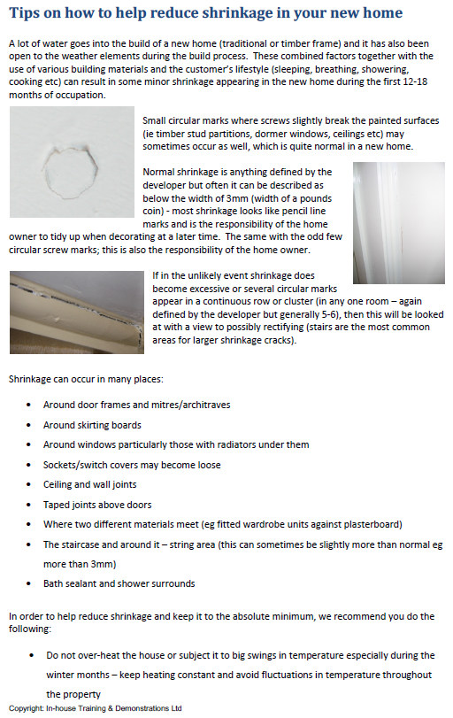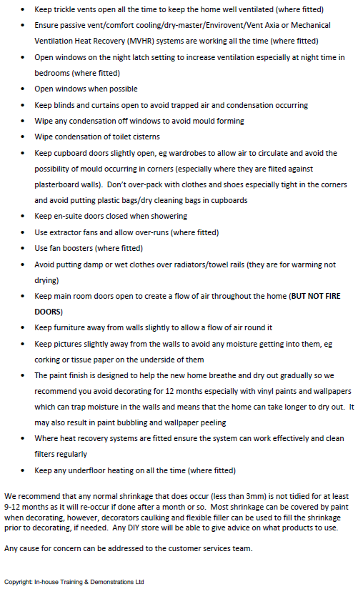

LABELLING OF KEY SERVICES
You may find identification tags throughout your new home, which provide easy reference for key valves and taps which may be required to isolate services in the event of an emergency or as part of routine maintenance.
The image below shows briefly what these are in reference to, and the specific tags will be shown throughout this HOIP, alongside more detail as to their specific function. These are provided as an aid and we recommend that you familiarise yourself with their location. As with all matters relating to plumbing, electricity or which may threaten your health and safety, we suggest the use of a qualified contractor for more complicated works or if you are not fully competent.

HEATING & HOT WATER - ASHP TYPE & SYSTEM
Heating and hot water are provided by a Daikin Low Temperature Altherma air source heat pump (ASHP) with an integral hot water tank.
An annual service of the ASHP and inspection/maintenance of the associated equipment, in accordance with the manufacturer’s instructions, is required so as not to invalidate manufacturer and NHBC warranties. A typical contractor is detailed within the Schedule of Materials. Please be aware that the requirement for annual service starts from the date of commissioning which may occur sooner than the date of ownership of the property and this service requirement remains with the owner of the property at the time. For the avoidance of any doubt, this means service is due 12 months from the commissioning date shown on the ASHP unit itself and/or commissioning records.
Never obstruct the outlets or ventilation to the ASHP system.
The outdoor unit always requires a free flow of air. Do not allow a build-up of leaves, snow etc. around the unit. Never tamper with the ASHP installation or equipment.
The indoor unit is either located within the garage, within a separate cupboard or enclosed by a housing in a finish to complement the other furniture within the Utility Room. This has internal space and access doors designed to meet with installation and access requirements. This space and access should be maintained both for ventilation and maintenance.
A copy of the user manual & service instructions together with the installation, commissioning, and service record logbook for the above are with your instruction manuals, please refer to the simplified controller instructions on the following pages.
In addition, the following user videos provide some useful reference:

https://youtu.be/ZNvnFdFHMR8?si=lo4iNqMA2m9kD43q – Daikin Altherma MMI Controller Setting Schedules

https://youtu.be/d1Sd0aEtWRw?si=rEhzG_esRqarAkgo - Madoka Navigate Controller Menus

https://youtu.be/V9Q-W35wi9s?si=qvHbalZSNM8Al0vt - Daikin Altherma Madoka End User Video FULL

https://youtu.be/ZS05xeq9NUw?si=Kxze5gNcBMghP36n - Daikin Altherma MMI End User Video FULL



For air source heating systems, particular care should be taken to avoid risks of burns and scalding, of legionella, and of electrocution and fire:
- unvented hot water systems are used to avoid the need for a cistern at high level and allow mains water to be supplied directly to the storage cylinder, but present risks of burns and scalds. So, if an unvented system is used:
- systems should incorporate appropriate safety devices and controls to regulate temperature and pressures within the system; o installations should be carried out by people with appropriate training and practical experience, usually members of a registration scheme operated by a recognised professional body such as the Scottish and Northern Ireland Plumbing Employers Federation (SNIPEF).
- to control the risk of legionella and similar pathogens, a secondary heat source, typically an immersion heater coil, is needed to raise the temperature of the stored water, once a week for a short time, to at least 60°C, in accordance with guidance to the Water Byelaws.
- as in any system where stored water is heated to control the risk of pathogens, provision must be made to prevent scalding, with a device such as a thermostatic mixing valve to limit the temperature of water delivered to a bath.
- to avoid the risk of electrocution and fire, the air source heat pump system should be installed in accordance with BS 7671, also known as the Institute of Electrical Engineers (IEE) Wiring Regulations 17th edition; In addition, care should be taken so that an installation does not encroach on the requirements of accessibility in Standard 4.1, particularly outdoor units around entrances and the routes to entrances.
Please refer to Davies’ emergency care or Scotia Customer Care section above for emergency contact details.
RADIATOR SAFETY PRECAUTIONS AND RADIATOR NOTES
Myson Premier HE roundtop radiators have been installed in your home. Should the radiator become chipped or paint damage occur then touch up paint (RAL 9016) can be purchased from the Myson sales office on 0845 402 3434.
Radiators are hot when in use and as such users should ensure that those who may come into close proximity to hot radiators are aware of the risks of burns from prolonged contact.
Where necessary, users should take steps to minimise the risks of burns from hot radiators (for example where there are very young children in the room). Where applicable, consideration should be given to placing guards in front of the radiators or reducing the temperature of individual radiators by turning the thermostatic radiator valve to a low setting.
Radiators are heavy items and are securely fastened to the wall on installation, with appropriate fasteners to secure the radiator bracket and suit the construction of the wall.
Decorative covers (such as the decorative perforated MDF or timber covers that you can purchase from DIY stores) will significantly reduce the output of a radiator and thermostatic radiator valves should not be fitted inside these radiator covers (as this will stop the valves from working efficiently). These covers are not recommended as they will, by consequence, impede an individual room’s heat requirement, which your new heating system has been carefully designed to provide. The only exception to this would be the comments above regarding safety of young children. If you do need to fit a radiator cover for this purpose then you should use one of the metal mesh type covers, similar to a fireplace guard, which will not impede the flow of heat from your radiator into the room.
Radiators should not normally be used for the mounting of clothes racks, cat beds or other such fixtures. The mounting brackets of the radiator are designed to support the weight of the radiator itself and water contents, allowing for an adequate safety margin, and additional weight may compromise this margin and cause risk of failure, leaks and potential hot water burns.
Appropriate facilities are required by Building Regulations for internal and/or external drying facilities and these are provided (please see “Ventilation and avoiding condensation”). Radiator-mounted drying rails and other devices may lead to excessive internal moisture and any chips/damage caused to the radiator itself may compromise the protective coating and potentially lead to corrosion/failure, which may not be covered by warranties.
Note regarding curtains – Heavy curtains or lined curtains drawn over the windows are an effective way of reducing any heat loss through the windows during the autumn and winter months. The sooner you draw the curtains in the evening the more heat you will save. However, please note that if there is a radiator located below the window, and the curtains are too long and cover the radiator then much of the heat generated by the radiators will not find its way into the room and will instead be wasted out the window. Curtains covering the thermostatic radiator valves will also interfere with the operation of the valves.
Please see the notes from the manufacturer below:
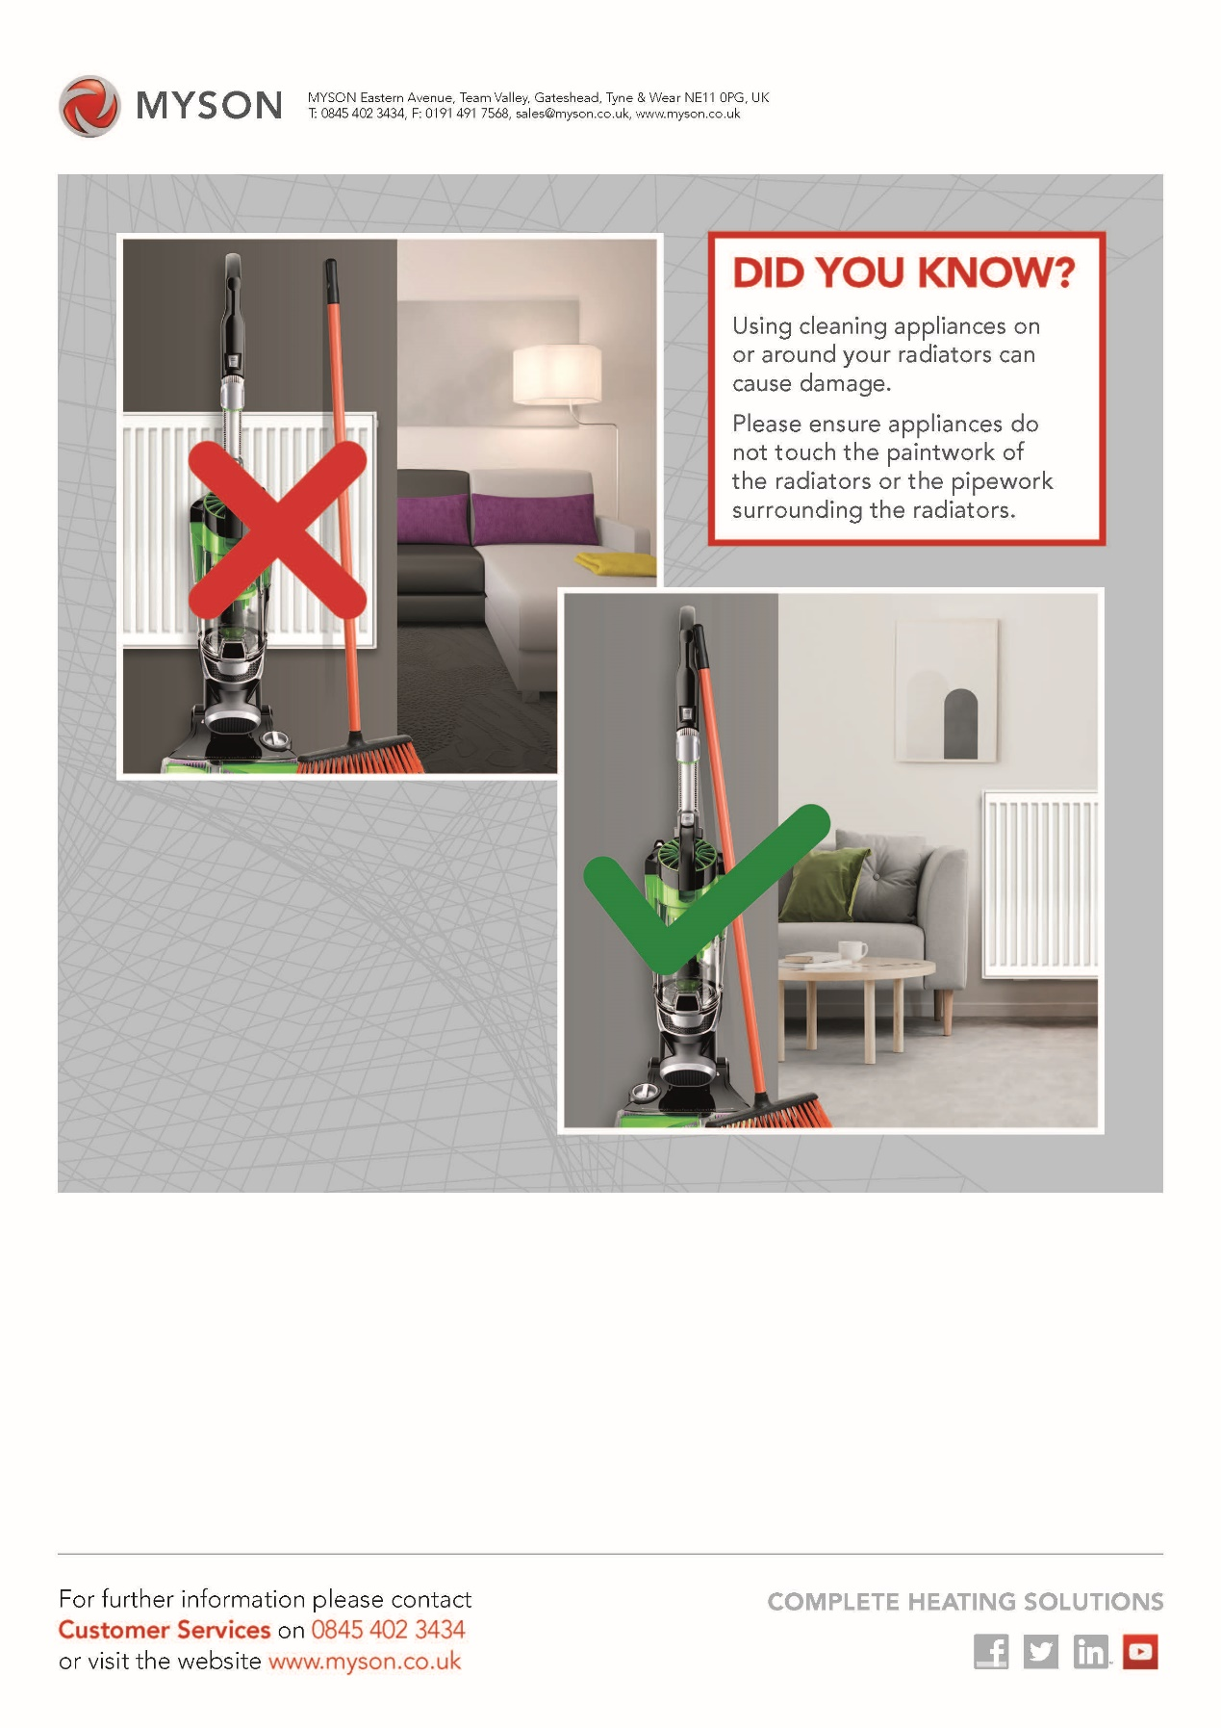
HOT AND COLD WATER SERVICES
Mains Cold Water Service
The internal stopcock for the incoming cold water service is located typically under the kitchen or utility sink which, in an emergency, should be used to shut off the water in your house.
There is also an external stopcock located in a boundary box within the public footpath near your house which also shuts off the water to your house (this is primarily for the water authority’s use in an emergency).
Make sure that you know where your mains water stopcocks are located so that you can turn them off quickly in an emergency.
You may find the external tap isolation valve identified using the tag below:

Domestic Hot Water
The Daikin Altherma Air Source Heat Pump installation produces domestic hot water in an energy efficient manner and the operation of this is fully explained in the enclosed Instruction Manuals. Please also refer to the notes in the Heating and Hot Water Installation section above.
External Water Tap
Kemper “Frosti” frost-proof external tap.
An upgraded frost-proof tap has been fitted, which has frost protection built-in, meaning that there is no risk of burst pipes and the water supply does not need to be isolated in cold weather. This protection also prevents germ growth, meaning potable water is maintained.
When turning this tap off after use, the tap will automatically drain off the excess water remaining in the last “leg” of pipework – it is normal that up to 150ml of water will continue to drain after the tap is closed. This means that normal isolation procedures you may have been used to with conventional external taps do not need to be followed in cold temperatures.
However, the tap will only be able to do this if there is no additional device/hose fitted to the tap. Therefore, in cold conditions, please ensure any further hoses/extensions/pressure washers etc. are disconnected from the tap, with the tap opened and closed briefly thereafter, thereby enabling it to self-protect. It is good practice not to leave anything permanently connected to the tap in order to prevent accidental damage.
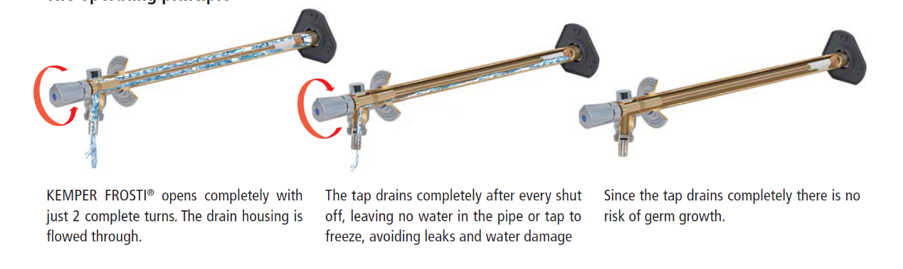
Sanitary Ware/Taps
Introductory notes:
Sanitary ware and taps should be cleaned in accordance with the manufacturer's instructions, copies of which are enclosed in your handover pack or are available from the manufacturer’s web site. The following are some important points to remember when cleaning and maintaining your sanitary ware and taps. Note that the information in this section covers standard sanitary ware and fittings being installed at the date of preparation of this document - if you have asked for different fittings as a client choice then the following notes may not be applicable.
Baths:
The bath should always be cleaned immediately after use, preferably while the water is running out and the bath is still warm. Hot soapy water with a cloth should be used and the bath wiped dry.
Never allow solvents such as dry-cleaning agents or paint strippers to come into contact with an acrylic bath.
Never use gritty or abrasive cleaners on the sanitary ware which can cause scratches and other damage.
The manufacturer of the bath (where fitted) recommends the use of an anti-slip mat when a shower is installed over the bath.
WCs
Please note that WC cistern valves should be checked periodically and maintained as described in the manufacturer’s instructions contained in your handover pack. We recommend that if you contact a plumber if you suspect that a WC valve has developed a fault.
A concealed cistern may be used where a bulkhead will be formed with a screw-fixed MDF cover which may be removed for access maintenance.
A specific type of screw/cap is used so as to provide secure and discrete fixing, whilst enabling easy access for maintenance. Should this require future replacement of the screw/cover, the product used is the Stem Fix Screws and Caps M4.5 x 35mm with a matt white cap.
Images below of typical concealed cistern bulkhead top & fixing detail:
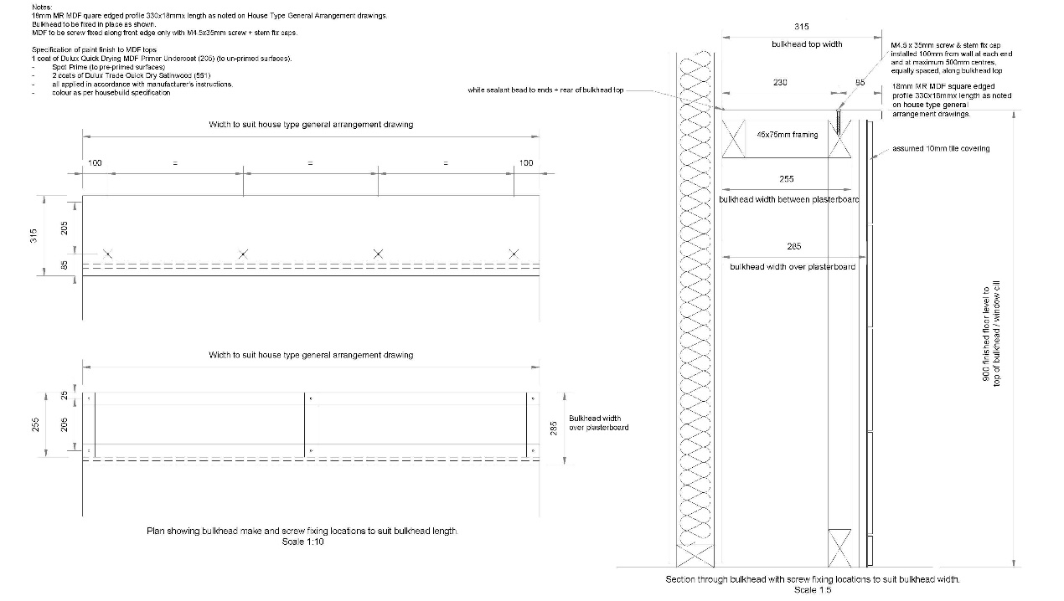
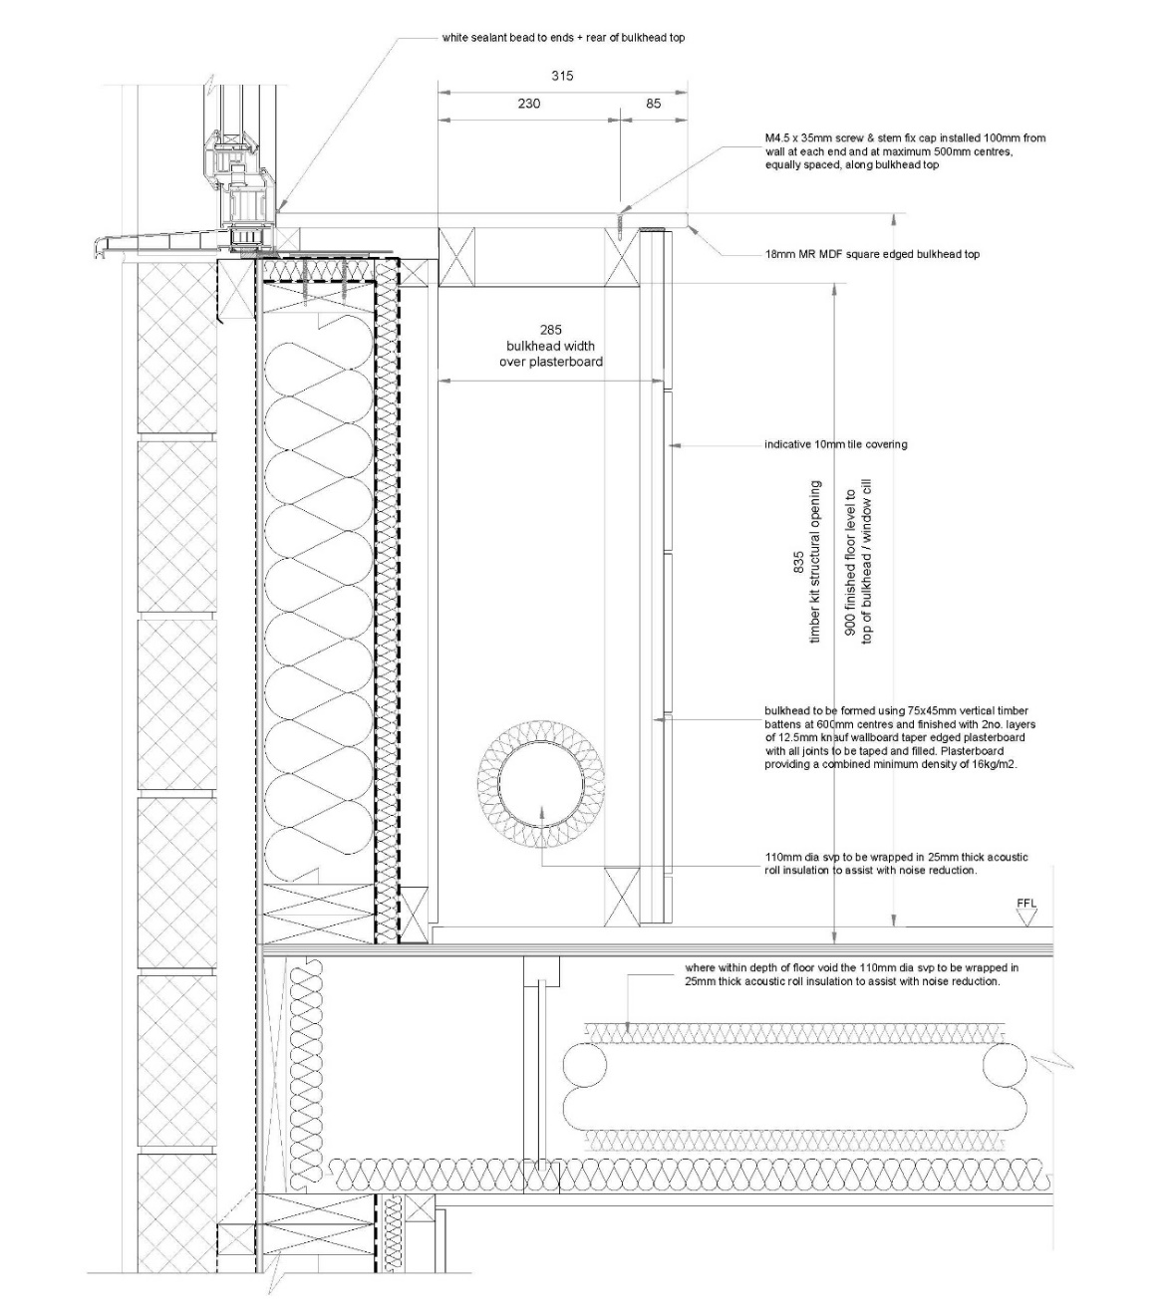
Note - we recommend that all maintenance work on brass/sanitary ware and particularly your shower valve is carried out by a qualified and experienced plumber.
The shower has been factory set to typically 42 degrees centigrade (this is a safety feature). It is possible to adjust the temperature setting and the ‘installation instructions and user guide’ for the Bristan thermostatic dual control shower valve contained in your hand over pack provides details. Please note we recommend that any adjustments to the temperature setting must be carried out by a qualified and experienced plumber, and you should be aware that having the setting adjusted so that it can produce higher temperatures could have safety implications.
Kitchen sink and tap
Please refer to the kitchens section of this Home Owner’s Information Pack for cleaning and maintenance instructions for the kitchen sink and kitchen mixer tap along with details of how to use isolating valves (where fitted).
Thermostatic mixing valve
A thermostatic mixing valve is fitted below the bath. It limits the hot water temperature at the bath tap to a maximum of 48°C. This is a building regulation requirement. Access to the thermostatic mixing valve is normally obtained by removing the bath panel.
The thermostatic mixing valve manufacturer’s instructions recommended that you arrange for initial temperature checks to be carried out six weeks after occupation of the property, and then for an annual check to be carried out. This is to test the water temperature from the tap to make sure that the mixing valve is operating properly and to ensure the maximum limit of 48°C is not exceeded.
Hot Water Temperature (kitchen sinks and wash hand basins)
The hot water from your kitchen sink taps and wash hand basins can initially have a low temperature as cooler water sitting in the pipes is discharged but can then become hot suddenly. Appropriate care should be taken to avoid risks of scalding.
All other reference material, care recommendations and operating instructions for your brass and sanitaryware is contained within the manuals pack which will be left in the house at handover.
OPERATING INSTRUCTIONS FOR THE ELECTRICAL INSTALLATION
The Consumer Control Unit for your property is located, typically, within a cupboard, please refer to drawings for the specific location. It contains labelled main isolator, RCDs and circuit breakers or “trip switches”.
This is a device that controls the electricity supply to your home, splitting the incoming electric supply into various electrical circuits around your home.
The consumer control unit contains Main Switch, RCBOs (Residential Current circuit Breaker with Overload protection), RCD (Residual Current Device) and MCBs (Miniature Circuit Breakers). The main switch is normally ‘ON’. In order to isolate all supplies, switch to ‘OFF’. It may also include a dedicated MCB for a subsidiary consumer unit located within a detached garage, where applicable.
There are two RCDs in your consumer unit. Each RCD protects a section of the consumer unit. They are designed to ‘trip’ when there is an electrical leakage to earth thereby giving protection to personnel. An RCD would normally trip before an MCB.
These circuit breakers and RCDs are all designed to trip if there is a fault in a circuit, or if a faulty appliance is switched on. This helps to prevent serious accidents that may result in damage and injury. Under fault conditions these will be in the ‘tripped position’.
The model of consumer unit used has the capacity to provide separate circuits for the solar PV installation and a detached garage (where applicable), along with spare capacity in order partially to “future-proof” for potential items. The consumer unit installation is generally within a meter/utility cupboard and the board to which various services are fitted will generally follow a standard layout.
You should not routinely interfere with this but, as the board may contains meters, isolation switches and other items related to solar PV, TV wiring and fibre internet, you may need to be aware of where these items are. This location is typically the entry point of electric and fibre internet supply to your new home, also being the central distribution point for future TV aerial/dish installation and wiring. The typical layout below gives example of the board that is likely to be within your new home.
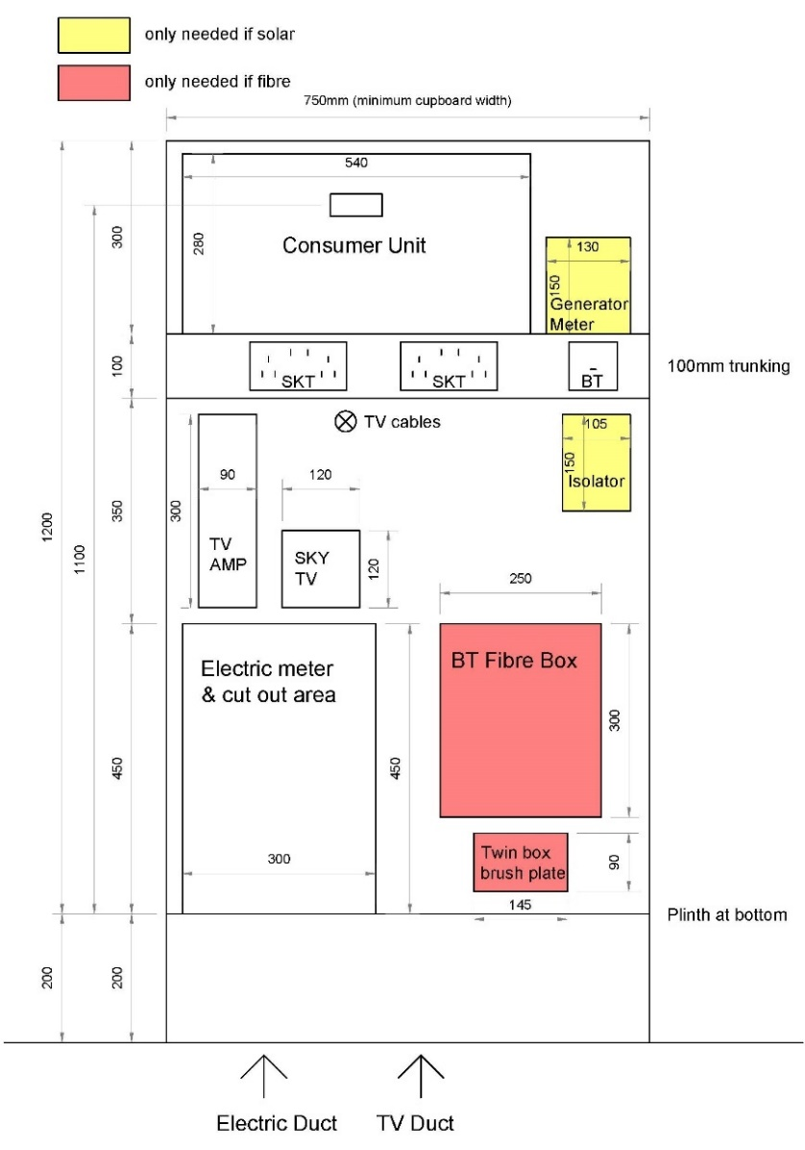
We recommend that the electrical installation in your home is inspected and tested at intervals not exceeding every 10 years.
IF AN ELECTRICAL CIRCUIT FAILS
NOTE: Electricity is dangerous and can kill. If you are unsure of any aspect of your electrical installation, please consult a qualified electrical contractor – you should do this in the first instance unless you are entirely confident of the steps below.
A circuit may trip OFF. If this happens, you should follow the procedure set out below.
1. Check with the aid of a torch whether the RCD (mid position) or MCB (fully down) is in the OFF position.
2. Switch RCD (press down then push to the fully up position) or MCB to ON position.
3. If the RCD does not re-set, switch off all the MCBs, re-set the RCD then switch on each MCB individually until the faulty circuit is identified.
4. To identify the cause of the fault switch off all appliances in that circuit, re-set the RCD and MCB, then switch back on each appliance until the defective appliance is found.
Over-filling kettles, irons etc. can cause this type of fault.
N.B. It is important to ensure that the bulbs used in light fittings do not exceed the rating for that fitting.
solar pv (PHOTOVOLTAIC) panels
A number of panels have been fitted on the roof of your new home in line with the requirements of relevant Building Standards which mandate the use of a renewable energy source in order to meet with the carbon dioxide emissions standards for individual homes. The panels themselves are inset to the surrounding roof tiles and also perform the same function of weather protection and roof tightness.
Solar PV panels convert light energy from the Sun into electricity, which is then converted by an inverter from DC (direct current) into AC (alternating current) form in order that it can be used in a normal electrical network. The inverter and AC/DC isolation switches are normally located in the roof space, with additional wiring leading to meters and distribution boards which will normally be co-located with the electricity consumer unit. The roof space installation has been designed so as to be complementary to the recommendations contained elsewhere in this document pertaining to storage in and use of that area.
The image below is a schematic of a typical solar PV installation, this may not represent the exact detail in every home (e.g. differing numbers of panels) and is for information only.
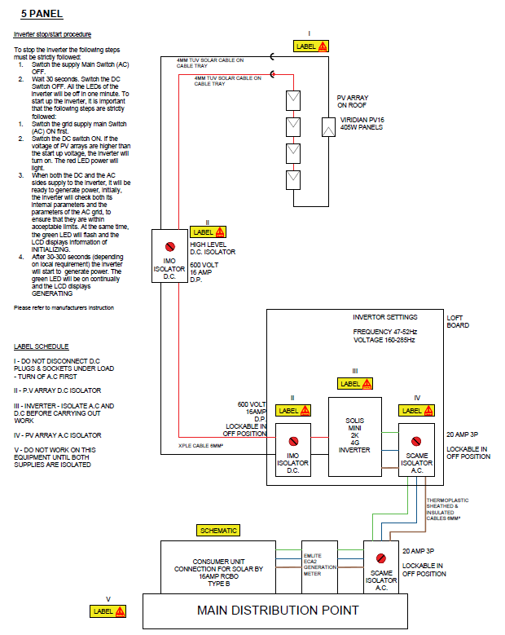
Handover documentation will include all manuals, along with items such as the MCS (Microgeneration Scheme) certificate, handover certificate, customer information form and shading/maintenance guidelines. All of this information must be retained and should be made available to a qualified contractor before any works, or to a future homeowner.
Electricity generated by these panels will be available for use at nil cost to the homeowner. Any surplus generated capacity that is not used will be exported to the National Grid and may be subject to payments back to the homeowner under the government’s Feed-In Tariff (FIT) scheme. Property/owner details must be registered with any applicable FIT at the time of settlement, which is normally then valid for 20 years, but it should be noted that the future availability of such schemes and associated payments is subject to possible withdrawal/amendment by the government.
It is important to note that the homeowner alone must register for the FIT, Scotia Homes cannot do this. This is a relatively simple process of contacting the energy supplier (British Gas at the time of handover, although you may wish to move to another supplier) and requesting that they register your details under the FIT scheme. For this, you will need the MCS certificate as a minimum, which is part of the handover pack.
At the time of writing, a typical form which may require to be completed is:
https://www.britishgas.co.uk/aem6/content/dam/britishgas/documents/FIT-Application-Form.pdf
More information and details concerning future changes can be seen here https://www.gov.uk/feed-in-tariffss. It should be noted that, whilst Scotia Homes will register your details (if the FIT is still available) with the relevant energy supplier at the time of handover, all future responsibilities for submission of readings, payments, changes of details etc. rest with you as the homeowner.
As with all other aspects of the electrical installation, maintenance or other works should only be carried out by a qualified electrical contractor, please do not interfere with any aspect of the Solar PV installation. This installation has been carried out by a certified Solar PV installer, and any future amendments, such as expansion of capacity/installation of batteries, must be done by a similarly certified installer in order to comply both with electrical regulations and the FIT scheme.
The roof pitch, combined with natural rainfall, should allow for generally natural cleaning of the panels, although annual cleaning may be recommended to guarantee optimum efficiency.
Contrary to popular belief, the generation of electricity by Solar PV does not require direct or constant sunlight. You may wish to monitor the generation of electricity in your new home via the generation meter/s and/or separate smart meters and this might have beneficial impact upon your electricity usage patterns and resulting costs.
Detail is shown below relating to a typical installation:

SMOKE, HEAT & CARBON DIOXIDE DETECTORS/ ALARMS
Depending on your house type, your home is fitted with smoke detectors in the living room (or dining area) and the ground and, where applicable, first floor halls/bedrooms.
A heat detector has also been fitted in the kitchen area. These alarms are mains operated with battery back-up. The smoke detectors are extremely sensitive to smoke and dust particles of any kind and can be activated by the likes of burning toast. The heat detector in the kitchen is less likely to cause ‘false alarm’ problems as it is not responsive to any type of smoke or fumes, only heat such as generated by a chip pan type fire (but not from smoke caused by burning toast or similar).
You must read and fully familiarise yourself with the instructions for the smoke and heat detectors. Copies of the instructions are contained in your handover pack and are also available for downloading from the manufacturer’s website - the instructions contain vital information on the operation and maintenance of your detectors.
If any of the smoke detectors are activated you should check the property and, if no reason for its activation is found, it could be a nuisance alarm caused by cooking smoke reaching one of your smoke detectors or something similar. If this occurs, open a window to clear the smoke or dust and the alarm will cease and test/ maintain the detector as described in its instructions. Please note that smoke alarms are interconnected so that when one is activated, all alarms will sound.
If the heat detector activates you should follow the advice contained in the heat detector instructions.
Your new home is designed and constructed so there are few leaks or draughts. However, it is important to ventilate it adequately to help maintain a healthy indoor environment for you and your family. As well as minor irritations, for example, a dry throat or headache, poor indoor air quality can also make existing conditions, such as asthma, worse. Extreme cases of poor indoor air quality may also be a causal factor of other respiratory and health conditions. Please see the “Ventilation” section for further information.
Providing adequate ventilation will also reduce the levels of humidity within your home and therefore reduce the possibility of condensation forming. Further to the information provided in the ventilation section of this document, it is important to reiterate that extract ventilation systems should not be switched off, as these are essential in providing balanced air quality.
A Carbon Dioxide (CO₂) monitor (DETA 1142) may also have been fitted in the principal bedroom in order to detect increased levels of carbon dioxide generally produced by the air that you exhale. It is sometimes difficult to identify when additional ventilation is required as it is not easy to tell when the quality of the air in your home is poor.
Information shown by this monitor will make you aware of increased levels of Carbon Dioxide (and potentially other pollutants) and will highlight a need to provide additional ventilation. Instructions and maintenance should be read and carried out in a similar manner to the other detectors. The CO₂ monitor requires free air movement around it, therefore, do not place furniture or other objects in front of it that may impede its operation.
The monitor is not an alarm and the display may generally appear blank. However, it can be checked at any time to show CO₂ levels in p.p.m. (parts per million) along with periodic averages and a “traffic light” system of red/amber/green to indicate higher and lower levels. It is recommended that the CO₂ level is checked each morning as the bedroom positioning covers the location and period when CO₂ build-up is potentially greatest with the least air movement. It may also include a temperature reading.
The CO₂ monitor will be mounted between 1400mm and 1600mm from floor level and away from the location of a bed head. This location will also be at minimum distances from wall and ceiling junctions, doors, windows, ventilation openings and any form of obstruction such as curtains, blinds or furniture in order that a clear flow of air can pass over the sensor. In the event of any move of the sensor required for decoration or maintenance, replacement/position must be done by a qualified installer and in accordance with manufacturer instructions.
To reset or to test the smoke, heat and CO₂ detectors follow the manufacturer’s instructions as enclosed in your Handover Pack.
The alarms/detectors are sealed units fitted with internal rechargeable back-up batteries for use in the event of power failure. These units have a lifespan of 10 years and will emit a warning sound at the end of this period, this date may also be displayed on the side of the alarm/detector.
The installation of detectors/alarms/monitors is generally mandated by building regulations for your own safety and these must be maintained and under no circumstances removed.
TELEVISION INSTALLATION
A television aerial socket has been provided within the Living Room and, depending on specification, other rooms (specific room may depend on house type, please refer to plans). Your individual alterations may have requested additional points or a ‘returned’ signal to additional points in other rooms. Depending on these requests, an aerial amplifier may have been installed alongside the electrical consumer unit and aerial cable run to the attic space. It is your responsibility to arrange for the supply and installation of a suitable aerial and/or satellite dish and final connections.
The image below is a schematic approximation of typical final installation/s. Please be aware that some items shown may particularly be dependent on your choice of Extras, and future aerial and/or satellite dish installation remain the homeowner’s responsibility after handover.
When considering TV/aerial installation, the following points should be noted in conjunction with the above illustration:
• Supply and installation of digital TV aerial and/or satellite dish remains homeowner responsibility after settlement, with sufficient length of CT100 coaxial cables normally left coiled in loft space, routing back to central location (normally at location of consumer unit/master BT point)
• A TV amplifier may be fitted at this central point (specified via Customer Extras), otherwise a suitable splitter point must be installed to feed signal to standard specification and Extra TV points within property by way of:
1. Main TV multi-point (normally one as standard spec. in Living room) – 4 x CT100 cables and 1 x cat. 5 cable leading to point including 1 x male TV (return), 1 x female TV (return), 1 x telephone, 1 x twin satellite – this multi-point is suitable for items such as SkyQ main boxes
2. Additional TV multi-points (standard specification or Customer Extra) – 1 x CT100 cable and 1 x cat. 5 cable leading to point including 1 x female TV & 1 x telephone – this multi-point is suitable for items such as SkyQ mini boxes
3. Standard TV point (normally Customer Extras) – this point is suitable for normal Freeview compatible TVs/boxes
The telephone points that connect TV multi-points with the central location are principally designed for connection of boxes such as SkyQ which require a telephone line, but the cabling is cat. 5, which also means the connection points could be changed to ethernet points suitable for connecting smart Ultra HD TVs which may require a hard internet connection rather than wi-fi for streaming of Ultra HD services.
TELEPHONE INSTALLATION
The main incoming telephone line point (master point) is normally located adjacent to the consumer unit (specific location depends on house type, please refer to plans). The telephone connection point is compatible with any BT approved phone.
It is your responsibility to arrange connection to your chosen telephone service provider and arrange final connection of secondary socket wiring to the master point.
Fibre broadband internet connectivity
Infrastructure will be installed at the development to provide FTTP (Fibre to the Premise) technology, which provides estimated speeds of up to 300Mbps at the entry point to the home.
Hardware provision for this may include various elements co-located with the consumer unit. These elements, where fitted, should remain in situ and only be worked on by a qualified electrical contractor in the event of failure or modification.
Final connection and service provision within the home remains the homeowner’s responsibility and ultimate connection speeds will be dependent on the service provided by the chosen communications provider.
An information sheet from the fibre infrastructure provider is on the following pages and provides information as to final connections/subscriptions etc.

EXTRACTOR FANS (DMEV SYSTEM)
Greenwood Unity CV2GIP mechanical extract fans have been fitted in your home. These are continuously running single point dMEV (decentralised Mechanical Extract Ventilation) fans with GIP (Guaranteed Installed Performance). The fans run continuously at a low (extremely quiet) speed and are automatically ‘boosted’ to a higher speed when required (the fans boost automatically using their humidity sensor). It is essential that the fans remain in operation at all times (unless switched off for maintenance) to maintain good air quality.
Pictures of the Greenwood CV2GIP fan
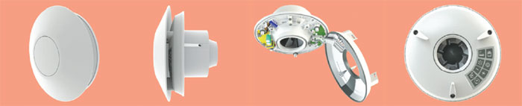
This is an energy efficient fan designed to provide an economical ventilation solution to the modern home. It utilises SMART Technology to control humidity and boost run-on times to minimise the periods of time when it is running at its highest speed, minimising nuisance running noise and unnecessary energy wastage and heat loss typically associated with ‘traditional’ extract fans.
Electrical isolator switches (where applicable) for the extractor fans should be left in the on position to ensure that your home is protected from a build-up of moisture. Failure to use the extractor fans as they have been designed to be used may result in a build-up of condensation and/or mould and may affect your warranties.
Before carrying out any maintenance or cleaning work on the fans you should refer to the manufacturer’s instructions contained within your handover pack. A qualified electrician should be employed to carry out any maintenance work on your ventilation fans (apart from general cleaning which can be done by yourself as long as you follow the procedures for cleaning as noted in the manufacturer’s instructions).
- Always isolate the fan from the mains electricity before cleaning it.
- Do not use solvents to clean the fan.
- Wipe the front grille (the internal grille) clean using a slightly damp cloth avoiding getting any water into the internal fan unit. If removing the grille to wash it, you must ensure that it is fully dry before re-fitting.
- Cleaning and servicing – extract from manufacturer’s instructions.
- When re-fitting the internal grille ensure no wires are trapped.
VENTILATION AND AVOIDING CONDENSATION
Condensation will be a problem in all new houses if adequate background heating and ventilation is not used. All new homes need ‘running-in’ and we recommend that you read carefully the section within the NHBC booklet ‘Guide to your new home’, subtitled ‘Reducing Condensation’.
Windows may be fitted with “trickle” ventilators at the top of the window. These can be opened or closed to allow more or less trickle ventilation. We recommend that, particularly during the ‘running-in’ period, the “trickle” ventilators are left fully or partially open to maximise the fresh air entering your home.
Some rooms, such as “wet” rooms and kitchens may not require windows to be fitted with “trickle” ventilators, this is quite normal and is designed to complement the dMEV system, which may “draw in” air from the rest of the property. It is normal for a small gap to be present at the bottom of doors to allow internal movement of air, whilst a new property does not require individual internal doors to remain closed to retain heat (efficient insulation and heating systems balance this), bathrooms and kitchens may require doors to be closed during use.
The following are general guidelines for your information.
To deal with condensation, take these two steps:
Produce less moisture
Ordinary daily activities produce a lot of moisture very quickly:
Cooking: To reduce the amount of moisture in the kitchen, cover pans and do not leave kettles boiling, open a window to allow excessive amounts of steam to be ventilated to the outside.
Washing clothes: Put washing outdoors to dry if you can. Alternatively, please dry the washing in the bathroom (which is designed to accommodate drying clothes) with the door closed – the humidistat function of the extractor fan will help to remove the moist air to the outside (also if weather conditions permit – the bathroom window can be opened). If you have a tumble dryer, ventilate it to the outside (unless it is the self-condensing type). D.I.Y. kits are available for this.
Drying clothes on radiator-mounted airers or on airers in rooms other than the bathroom may lead to excessive internal moisture.
Ventilate to remove moisture - you can ventilate your home without making draughts.
Some ventilation is required to expel the moisture, which is produced all the time, mostly just by normal breathing of occupants. Keep a small window ajar or a trickle ventilator open when someone is in the room.
You need much more ventilation in the kitchen and bathroom during cooking, washing up, bathing and drying clothes. This means opening windows to assist in the ventilation of moisture to the outside and ensuring that the extractor fans are in full working order.
Close the kitchen and bathroom doors when these rooms are in use. This helps prevent the moisture reaching other rooms, especially bedrooms, which are often colder and more likely to get condensation.
Two useful guides to avoiding unnecessary condensation can be viewed here:
https://hug.nhbc.co.uk/HUG-Portal-View/content/conn/ContentServer/path/Contribution Folders/PDF Files/NHBCCondensationinHomes.pdf
https://hug.nhbc.co.uk/HUG-Portal-View/content/conn/ContentServer/path/Contribution%20Folders/PDF%20Files/NHBCCondensationinRoofSpaces.pdf
Improving the air quality of your home - As homes become more insulated and efficient, they also make it easier to trap indoor air pollutants. Chemicals like benzene, formaldehyde, and ammonia can come from household items and pollute your home’s atmosphere without any visual warning.
Neglecting the quality of the air you breathe on a daily basis could result in serious consequences. Illness, allergies, asthma and frequent headaches are just a few of many inconveniences that come from airborne particles floating around your home. Air pollution is also one of the factors that can affect your digestive system.
Some years ago, NASA conducted studies on the benefits of house plants and they found that there are plenty of plants that soak up harmful particles in the air and release fresh oxygen – all while adding a decorative touch.
Where does it all come from?
One of the scariest things about indoor air pollution is the seemingly harmless nature of its many sources. Listed below are some of the most common ways a home can become polluted.
• Glues and Adhesives
• Carpets (especially new carpets)
• Chemicals in household cleaners (instead of using poisonous household cleaners you can make your own natural household cleaners)
• Foam insulation materials
• Paint
• Pressed-wood products (plywood, particle board, and medium-density fibreboard)
If plants are good enough for the pioneers of space travel than they must be doing something right. They also might spark a newfound hobby of gardening as well!
If you have pets than you should be aware that most indoor plants aren’t safe for pet consumption. If you plan on growing plants in or outside of your home you should be aware of their toxicity. You can consult with your vet and see how it may affect your dog, cat, or any other animal that may consume it.
Graphics illustrating some of NASA’s findings and useful recommendations for healthy plants to have in your home can be seen on the following pages.


KITCHENS
The kitchen (and Utility room, where applicable) furniture that has been fitted is of Nobilia manufacture and is designed and installed by Laings of Inverurie. It is important that you refer to the manufacturer’s instructions for operating and cleaning of kitchen appliances, sinks, units and worktops. These are enclosed in your handover pack along with a Laings welcome pack (typical extracts from kitchen instructions have also been included below).
Enclosed within this pack are your warranty documents, guarantees and instruction manuals for the items Installed in your kitchen.
The guarantee documents should be completed & submitted to the manufacturer as soon as possible to validate (see Smeg notes further on). Each item will have differing manufacturer's guarantee periods and time limits
If any of the items in your kitchen fall within the manufacturer's warranty period, the manufacturer will advise on whether the Item Is covered and If there will be a cost for the repair. Please contact the manufacturers directly, we have listed some useful telephone numbers below.
Smeg Tel. 0844 81S0701 www.smeg-service.co.uk
Hotpoint Tel. 03448 224224 www.hotpoint.co.uk
Blanco sinks/taps Tel. 01923 635200 www.blanco.co.uk
Should you wish to order any additional items for your kitchen then please contact Laings directly using your plot number and site name.
Please remember that your first point of contact for any customer care query in respect of your new kitchen remains with Scotia’s own Customer Care department.
Please refer to the information contained in your handover pack for information on the manufacturer’s recommendations for kitchen unit and worktop cleaning and maintenance. We have also included some general notes below from the supplier/manufacturer (note that not all of the following information may be applicable to your home depending on your house type and choices you have made for your kitchen).
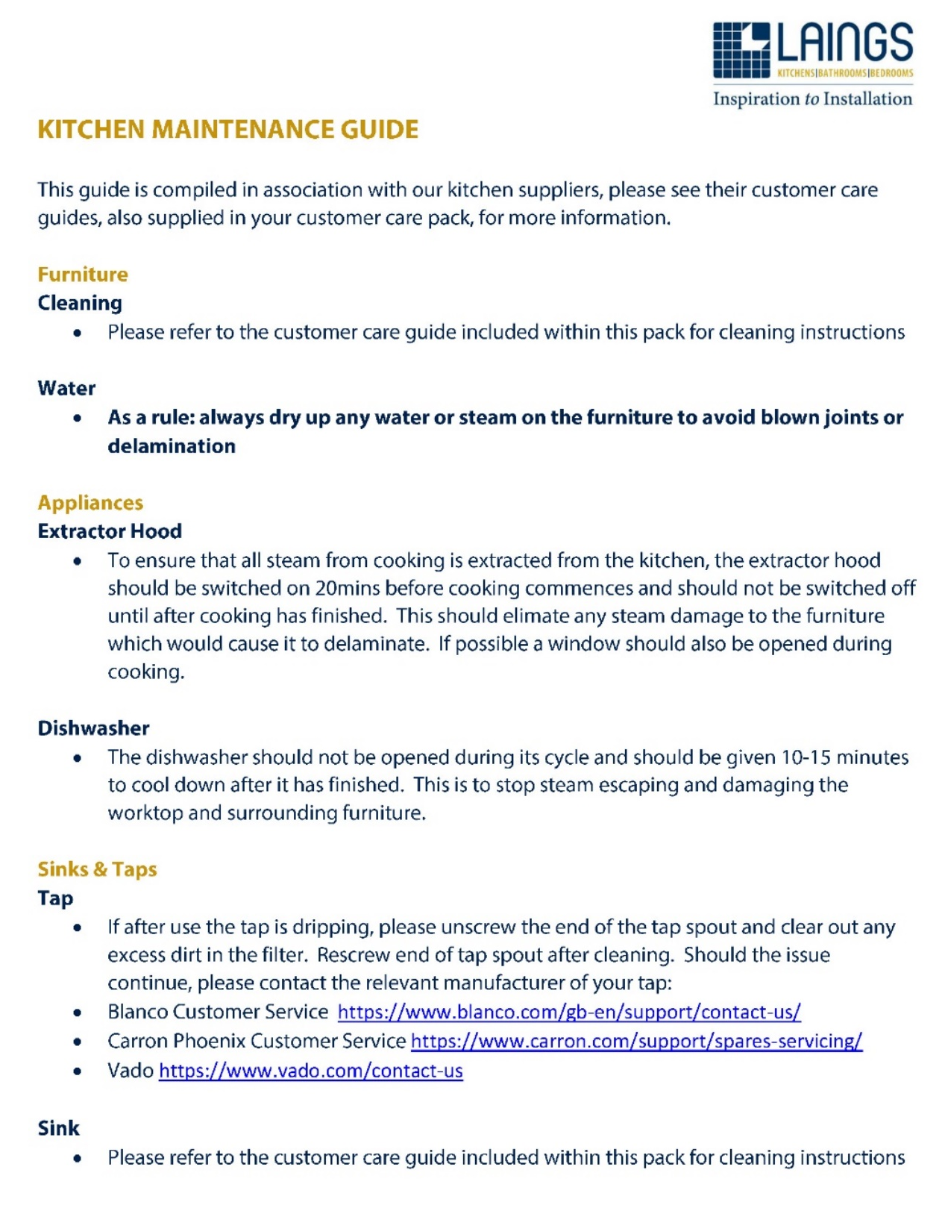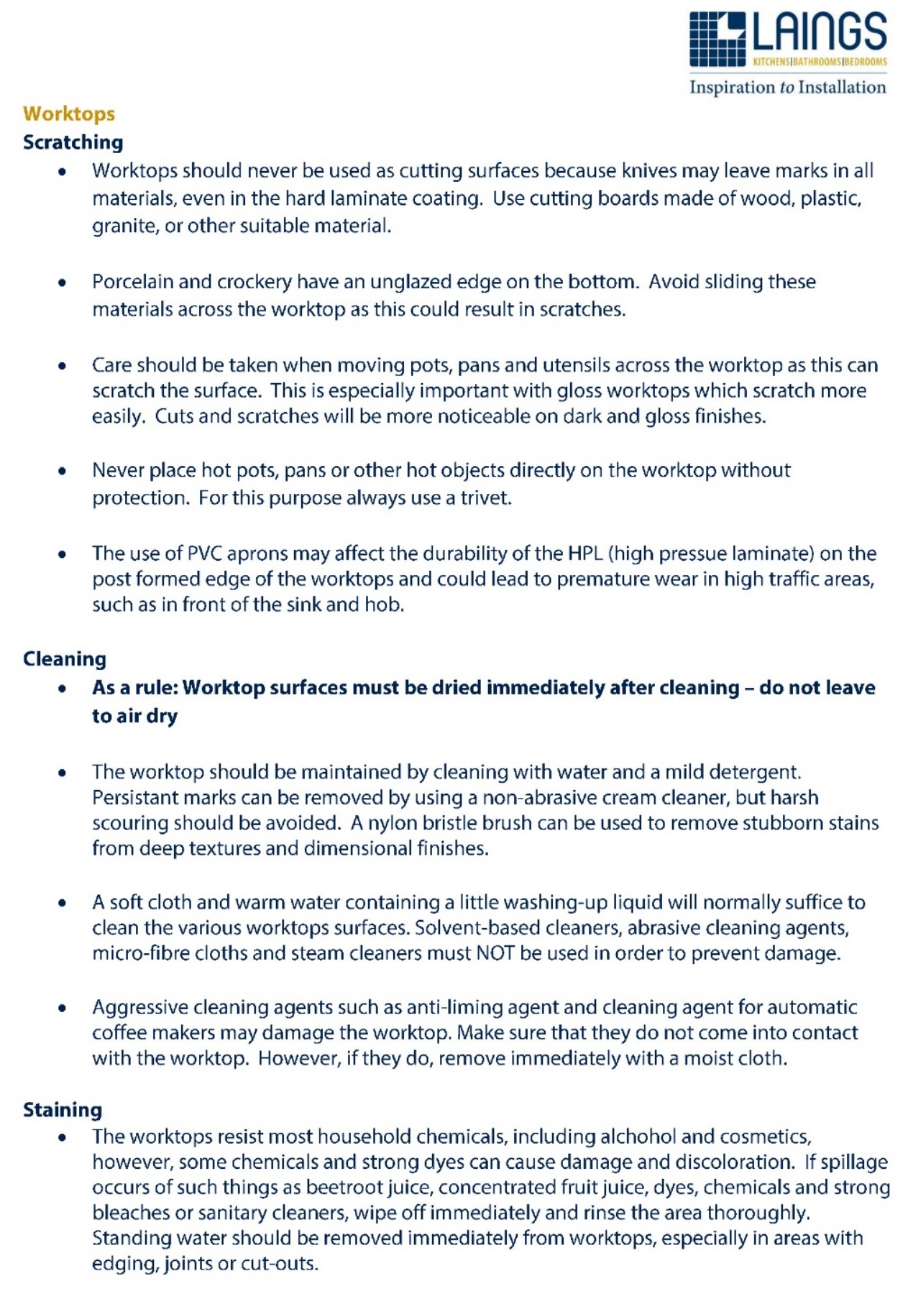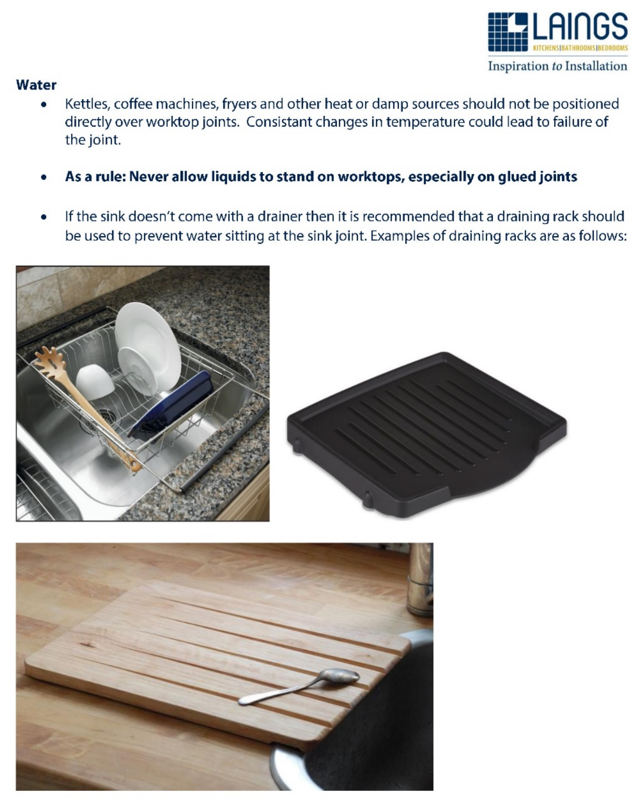
Care and Maintenance Instructions
Read these care and maintenance instructions thoroughly prior to using your kitchen for the first time. They contain general information as well as special instructions, which pertain only to our own products. Keep these documents in a safe place and, if applicable, pass them on to the subsequent owner.
Moreover, pay close attention to the Operating Instructions and any additional information that is enclosed with the furniture, accessory items and electrical appliances.
The manufacturer accepts no liability for damages resulting from improper use of kitchen furnishings. Furthermore, the manufacturer accepts no liability for the results of improper care and operation of the kitchen.
We wish you much enjoyment in and with your new kitchen.
General Care Instructions
The high-quality surfaces of a kitchen are generally very easy to care for. To retain the value and prolong the service life of your new kitchen for many years to come, you should, however, regularly and above all, properly, care for it.
For this reason, please observe the following care instructions:
- Use only mild, water-soluble household cleaning agents, the product information of which expressly states that they are designed for use on kitchen furnishings.
- Never use solvents or products containing alcohol.
- Regardless of whether you have purchased a high gloss front or a super matt laminate front, never use harsh chemical substances such as abrasive agents or solvents on your fronts. Scouring powders, steel wool or pot scrubbers can also damage the surface to a degree that it is no longer possible to repair or touch up.
- Never use glass cleaners on this surface because they contain solvent-based substances.
- Use a soft, non-pilling cloth, a leather cloth or a soft sponge for cleaning.
- Do not use micro-fibre cloths or eraser cleaning pads. These often contain fine sanding particles which can scratch the surfaces of your new kitchen.
- Always remove soiling as quickly as possible. Fresh stains can be much more easily and thus, usually completely removed.
- Under no circumstances should you use a steam cleaner or running water!
- After cleaning, always wipe all surfaces completely dry. In general, avoid extremely moist surfaces from using cloths, that are too wet, or steam build-up during and after cooking.
Keep all surfaces dry at all times! Allowing water or other liquids to pool on the surface can lead to lasting damage!
Varying material designs require individualised care instructions. Therefore, please observe the special instructions for the care of your kitchen.
For fronts with integrated, milled bar handles, use extra care when opening and closing doors, flaps and pull-outs as fingernails and rings, among others, could leave marks on the sensitive surface. The premium quality lacquer in the bar handle vicinity will nevertheless likely show some small scratches. These are the consequence of the selection of this style front and thus construction-induced and do not constitute grounds for complaint. Please protect the bar handle from standing or flowing liquids.
Spilled liquids, condensing moisture or standing moisture from cleaning could collect in the milled bar handle. Immediately remove any moisture. Otherwise, this could result in swelling. Damage of this type will not be accepted as grounds for complaint.
Care instructions for laminate fronts and niche cladding
Laminate fronts can be easily cleaned with conventional household and commercially available mild cleaning products. Do not use abrasive cleaners.
Apply cleaning agent diluted with water respective to the degree of soiling. Use a soft cloth for cleaning. Then, remove any cleaning agent residue with clean water and wipe the doors dry.
Stubborn stains such as lacquer, glue residues or grease spatters can be easily removed with commercially available plastic cleaners. Prior to use, test the cleaning product on a small, concealed area of the surface.
Vinegar cleaners, cellulose or resin thinners and nitro-based cleaners are not suitable for cleaning these surfaces.
Never use a steam cleaner!
Care Instructions for High Gloss Fronts
Fronts with a high gloss surface are characterised by their brilliant sheen, which is created by a high-gloss polymeric lacquered laminate.
To ensure that the fronts are protected from damage during processing as well as transport, they are covered with a protective film. This protective film should only be removed during the final step of installation.
High gloss fronts are exceptionally easy to clean since the surface is completely sealed. Soiling can, therefore, be easily removed with little or no use of force and largely without the use of chemical agents.
Never use glass cleaners on this surface because they contain solvent-based substances!
Ensure that any cleaning materials (cloths, sponges, etc.) are completely clean.
Any pre-existing mineral-based soiling such as sand or dust particles could lead to scratching of the surface.
The manufacturer accepts no liability for any signs of wear of this type.
All cleaning materials - if possible, cotton cloths (no micro-fibre cloths!) - must be thoroughly cleaned and rinsed prior to use. Repeatedly rinse out all cleaning materials to ensure that mineral dust particles or perhaps metallic dust that was picked up while cleaning leave no marks on the high gloss surface.
After assembly, it is recommended cleaning the inside of the units with a cleaning agent (sold separately). Metallic abrasion might occur while screw connecting the units, which could lead to scratches on the fronts.
This could result in tiny, microscopic signs of wear. These marks are noticeable depending on colour and amount of light coming into the area. These marks in no way reduce the practical value but are unavoidable over the long term as with all high gloss surfaces on cars, glasses or other furniture surfaces.

The manufacturer accepts no liability for signs of wear of this type.
Care instructions for Ultra Matt and Polymer Coated Fronts
Fronts with ultra matt finishes are distinguished by a velvety smooth look and feel. They are wear-resistant and have a highly cross-linked functional layer. Due to an innovative anti-fingerprint coating they are extremely robust and have outstanding care properties.
To ensure that the fronts are not damaged during processing or transport they are covered with a protective film.
This film should only be removed in the final work step during installation.
Ultra matt fronts are characterised as being very easy to clean, since, unlike with other finishes, dirt can be removed without the use of force or chemical agents.
Never use glass cleaners on this surface because they contain solvent-based substances!
Ensure that any cleaning materials (cloths, sponges, etc.) are soft and completely clean.
Any pre-existing mineral-based soiling such as sand or dust particles could lead to scratching of the surface.
The manufacturer accepts no liability for any signs of wear of this type.
All cleaning materials - if possible, cotton cloths (no micro-fibre cloths!) - must be thoroughly cleaned and rinsed prior to use. Repeatedly rinse out all cleaning materials to ensure that mineral dust particles or perhaps metallic dust that was picked up while cleaning leave no marks on the surface.
After assembly, it is recommended cleaning the inside of the units with a cleaning agent (sold separately). Metallic abrasion might occur while screw connecting the units, which could lead to scratches on the fronts.
This could result in tiny, microscopic signs of wear. These marks are noticeable depending on colour and amount of light coming into the area. These marks in no way reduce the practical value but are unavoidable over the long term as with all surfaces on cars, glasses or other furniture surfaces.
The manufacturer accepts no liability for signs of wear of this type.
Care instructions for lacquered fronts and niche cladding in 3D digital print
Lacquered fronts are characterised by excel-lent surface properties. A topcoat of polyurethane varnish is used to create the distinctive look and feel and to make the lacquer finish more resilient.
To ensure that the fronts are protected from damage during processing as well as transport, they are covered with a protective foil. This protective foil should only be removed during the final step of installation. For a short time, the familiar lacquer odour might occur once the protective film is removed. This will fade over time.
When completely cured, the surface offers a high degree of resistance. Final curing could take a few days after removing the protective film, depending on climatic conditions. Nevertheless, the lacquer surface must be handled with care during later use. Lacquered fronts are renowned for being easy to clean because their surface is sealed, which means that, unlike with matt surfaces, soiling can be easily removed without applying force or the use of harsh chemicals. Never use glass cleaners on this surface because they contain solvent-based substances! Ensure that any cleaning materials (cloths, sponges, etc.) are completely clean. Any pre-existing mineral-based soiling such as sand or dust particles could lead to scratching of the surface!
The manufacturer accepts no liability for any signs of wear of this type.
All cleaning materials – if possible, cotton cloths (no micro-fibre cloths!) - must first be thoroughly cleaned and rinsed prior to use. Repeatedly rinse out all cleaning materials to ensure that mineral dust particles or perhaps metallic dust that was picked up while cleaning leave no marks on the high gloss surface.
After assembly, it is recommended cleaning the inside of the units with a cleaning agent (sold separately). Metallic abrasion might occur while screw connecting the units, which could lead to scratches on the fronts.
*These care instructions also apply to niche cladding in 3D digital print
This could result in tiny, microscopic signs of wear. These marks are noticeable depending on colour and amount of light coming into the area. These marks in no way reduce the practical value but are unavoidable over the long term as with all surfaces on cars, glasses or other furniture surfaces.
The manufacturer accepts no liability for signs of wear of this type.
Genuine wood fronts feature carefully selected veneers and woods that have been provided with a protective as well as equalising lacquer finish. The natural variations in the colour and texture of the wood cannot and should not be completely evened out.
Characteristics such as the grain of the veneer, the degree of knotting and variations in colour are all expressions of natural individuality.
In addition, different lighting can also result in colour deviations. Variations in exposure to incidental light and sunlight can lead to changes in colour over time. For this reason, differences between patterns and showroom kitchens cannot be excluded. Therefore, replacements or subsequent purchases may not be identical, but only near in colour and texture.
Genuine wood fronts are oriented toward an indoor climate where temperatures range between 15 and 25 degrees Celsius and relative humidity ranges between 45 and 55%. Wood expands and contracts! Indoor climates that are significantly drier can result in drying cracks, whereas climates that are significantly more humid can lead to swelling.
The lacquer on the genuine wood fronts enables simplified care and cleaning with conventional household cleaning products.
Due to the open pore structure of the genuine wood fronts stains should never be allowed to dry!
Residual stains can be removed using a hot soft soap solution and a soft, non-fuzzing cotton or leather cloth. Subsequently wipe up using lukewarm water, then wipe dry.
Do not use micro-fibre cloths or eraser cleaning pads. These often contain fine sanding particles that can lead to scratching of the surface.
Genuine wood gives an interior an amazing feel-good ambiance and a pleasant room climate.
The veneer creates a natural solid wood look with characteristic wood features such as knots, cracks and rays. The surface is brushed and sealed with natural hard wax. With time, sunlight may affect the surface. That is why the furniture should be protected from strong light. However, changes in colour have no effect on the function or durability of the furniture.
Dirt should be removed immediately to prevent it from soaking into the surface. Fresh stains are easier to remove. We recommend using an absorbent cloth (not a microfibre cloth) for this purpose. For heavy stains, use a damp cloth and neutral cleaning agent, then wipe dry. Always keep the surface dry, as water puddles can cause damage.
Worktops should never be used as cutting surfaces because knives will leave marks on the worktops, even with their hard laminate coating. Use cutting boards made of wood, plastic, granite, or other suitable material.
Porcelain and crockery have an unglazed edge on the bottom. Avoid sliding these materials across the worktop as this could result in slight scratches.
Glossy spots may develop on deep-matt décors from daily use due to sliding objects back and forth.
Never place hot pots, pans or other hot objects directly on the worktop without protection.
For this purpose, always use a trivet!
Worktops can be cleaned with conventional household cleaning agents (however, no scouring agents!). Apply cleaning agent diluted with water according to the degree of soiling. Use a soft cloth for cleaning.
Aggressive cleaning agents such as anti-liming agent and cleaning agent for automatic coffee makers may damage the worktop. Make sure that they do not come into contact with the worktop. However, if they do, remove immediately with a moist cloth.
As a rule: Never allow liquids to stand on worktops, especially on glued joints.
Care instructions for quartz worktops
Wipe off your worktop with a clean, commercially available cotton cloth or sponge cloth and dishwater (washing-up liquid, non-moisturising).
The following generally applies: Wipe up any standing liquids from the worktop immediately to prevent any soiling or colourants from staining the surface.
Always rinse thoroughly with lukewarm water and dry the worktop with a clean, dry tea towel or kitchen roll. In this way, any remaining dirt as well as soap or water residue will be absorbed.
For heavy soiling, you may use an eraser sponge. If persistent stains are still not completely gone, you may use a very small amount of scouring cream cleaner. Finally, rinse well with water and dry thoroughly with a clean tea towel or kitchen roll. Scuff marks from metal pots and pans can be removed this way.
This method is not intended for daily cleaning. Intensive cleaning in one spot could result in a difference in the degree of gloss. For this reason, please test the product on a concealed spot prior to use. Do not use any hard abrasive materials such as wire wool or sandpaper.
Generally, worktops should never be used as a cutting surface, since knife cuts can leave nicks in every kind of material. Always use a cutting board.
Sand and dust particles can lead to scratches, especially when pots are placed on top of them. Ensure that no dirt remains on the worktop.
In order to prevent damage and discolouration, never place hot pots, pans or other hot objects directly on the worktop.
Always use a trivet beneath hot objects! With quartz, it is possible that cracks could form due to high temperatures from contact with hot objects, particularly along the edge and near hot plates and sinks.
Heavy strain at one spot could result in damage. Never sit or stand on the worktop. Mechanical impacts at one spot could result in chipping.
Signs of wear, which occur during use of the worktop, do not constitute grounds for complaint.
It is not necessary to treat the surface with special care products.
General cleaning: Use soapy water to remove stains from substances such as grease, coffee, tea and red wine as soon as possible after they occur. Leave the cleaning agent on for the necessary time to allow it to react, then use a slightly damp eraser cleaning pad. Afterwards rinse thoroughly with lukewarm water and dry.
Limescale: Apply commercially available vinegar cleaner, allow it to react and use an eraser cleaning pad.
Persistent stains and deposits such as ink, paint, nicotine, wax, oils: Use soapy water, leave it on for 5 minutes, then treat the stain with an eraser cleaning pad. If necessary, you can use cleaning solvent or ethyl alcohol.
Important notes: Avoid harsh scouring agents, acidic cleaning agents, paint thinners, caustic soda, hydrofluoric acid and oven cleaners as these may do permanent damage to the surface.
Quartz material description
Quartz material is made from natural quartz of varying grain size along with colour pigments and binding agents (= composite material). This can naturally result in colour and / or textural deviations within a single commission.
Surface indentations, pigment accumulations and/or structural variations can occur with all composite materials. These are typical properties of this type of product and do not constitute grounds for complaint.
Due to the material properties, pots and pans may leave metal scuff marks on the surface.
Hinges and Pull-Out Rails
Hinges, drawer and pull-out runners are maintenance-free. Adjustment is possible.
Cutlery Trays
Cutlery trays can be removed for cleaning. These can best be cleaned with a mild cleaning agent.
Burnt-on residues can best be removed while still hot using a scraper with razor blade that is suitable for use on ceramic glass surfaces.
Ensure that no sugar or foods containing sugar (e.g., jam) can burn onto the cooking zones!
Immediately remove these residues with a moist cloth!
Also observe all special instructions from the appliance manufacturer.
Care Instructions for Hobs and Sinks
Clean hobs and sinks made of stainless steel, enamel or plastic, using a moist cloth together with dishwashing liquid.
Stubborn water spots can be removed with commercially available cleaners or normal household vinegar.
In this regard, also pay careful attention to the special instructions of the appliance and sink manufacturers.
Care Instructions for Electrical Appliances in General
Pay careful attention to the special information provided by the appliance manufacturers for the care and operation of your electrical appliances.
Instructions for Steam and Heat
Ensure adequate ventilation during cooking and make certain that steam cannot condense on the furniture elements.
Always use the appropriate power level on the cooker hood! Several cooker hoods and downdraft extractor fans are equipped with an after-run function. These continue to operate for a limited time after switching off to “blow out” any remaining water or steam from the system.
Occasionally check the surface temperature along the side edge of the oven door. As long as you can still touch the edge with your fingertip, the amount of heat dissipation is acceptable. If this is not the case, the door seal must be checked by the appliance manufacturer’s service technicians.
Do not allow oven and dishwasher doors to re- main slightly open for ventilation purposes be- cause the escaping heat and moisture could
Avoid water spilling over.
Also pay careful attention to the special instructions of electrical appliance.
Do not operate coffee machines, electric kettles or toasters directly beneath the wall units. Over time, the escaping steam as well as the high temperature could damage the furniture. Never place hot pots or other hot objects directly on the worktop or other furniture elements without using a protective trivet.
If an electric appliance (e.g. oven, built-in cooker, microwave, built-in bean-to-cup coffee machine, etc.) is installed behind a furniture front (e.g. a sliding door), the electric appliance, housing unit and floor may be damaged by the accumulated heat and moisture behind the closed furniture front. Always leave the furniture front open while using the installed electric appliance. Only close the furniture front when the electric appliance has fully cooled down.
General Instructions and Safety Information
Working in the kitchen entails handling water, high temperatures, steam, humidity and dampness. Moreover, many foodstuffs cause tough stains.
Even though modern furniture materials are resistant to most types of wear, there are limits to what these can withstand based upon the specific characteristics of the respective materials.
To ensure that you have years of enjoyment from your new kitchen, here are a few brief but important instructions to observe:
The kitchen should be placed in a room with a normal climate. This applies to the temperature as well as the relative humidity in the room. The furniture is oriented toward an indoor climate where temperatures range between 15 and 25 degrees Celsius and re- lative humidity ranges between 45 and 55%. Indoor climates that are significantly drier can result in drying cracks and warping, whereas climates that are significantly more humid can lead to swelling and moulding.
Check the condensation overflow in your refrigerator regularly to ensure that the condensation water does not ice up or spill over.
Only allow trained professionals to carry out electrical and plumbing installation work. Have these installations regularly checked by an expert.
Always use your kitchen properly. Improper or inappropriate use could result in injury to persons as well as damage to property.
Do not stand or sit on the worktop. Never leave children unattended in the kitchen when there is a chance of them switching on electrical appliances.
It is prohibited for anyone - especially small children - to crawl inside the units as the doors could shut automatically. These are very difficult, if not impossible, to open from inside.
Do not hang on the wall units! Improper loading could pull the unit away from the wall.
Attention, danger of injury!
Never remove the delivered and installed manufacturer’s safeguards such as safety brackets, spacers or similar. Attention, life-threatening danger.
Wall units are generally hung on a mounting rail. Do not lean with your full weight against individual hanging wall units. There is a danger of slippage!
Do not remove any fittings!
Attention, danger of injury!
Disconnect power supply prior to replacing light bulbs or cleaning electrical appliances.
Attention, danger of death!
Every kitchen is identified with a product identification code (PIC). This is pasted in the interior of the sink unit by the fitter.
Adjustment of Hinged Doors
All hinged doors are equipped with all metal 3-D quick-fit hinges. The doors can be installed or removed from the mounting plate without tools by means of the clip engagement latches.
1 Depth Adjustment
2 Height Adjustment
3 Side Adjustment
Adjustment of drawers and pull-outs removing front panels
1 The front panel can be removed by turning the screws on both sides.
Installing front panels
2 Guide the front panel to the frame. The panel engages automatically and audibly on both sides.
Height adjustment
3 The front panel can be adjusted by turning the screws on both sides.
Side adjustment
4 The front panel can be adjusted by turning the screws on both sides.
5 Put the cover caps in place.
Tilt adjustment
6 The drawer can be adjusted by turning the screws in the back panel.
Adjusting the tension fitting
The tension fitting is intended to prevent warping of large front elements. Should differing loads cause material warping over time, the installed tension fitting can be adjusted as follows.
General load bearing information
All units have been designed using the latest, state-of-art technology. They meet all relevant standards such as, e.g., DIN 68930. All furnish- ings have received the GS seal for tested and proven safety.
All maximum loads listed in the following have been statically defined, which means: the determined load bearing capacities are the result of careful and proper placement of objects, and not of letting fall, throwing or similar improper handling.
The load must be evenly distributed across the surface. Avoid heavy loading of only one spot.
The user is responsible for proper usage.
All shelves, including adjustable shelves, can hold a load up to 50 kg/sq. m.
1. Wall units can hold 75 kg, whereby the individual shelves only hold a maximum of 16 kg. The wall unit iMove has a maximum load capacity of 4 kg per shelf.
2. Depending on the unit dimensions, the drawer system has a total load-bearing capacity of 40 to 70 kg, resulting in the following max. permitted added loads:
3. The maximum load capacity for carousel and swivel pull-out corner units is 20 kg per shelf.
4. 15 cm wide pull-out units can hold up to 6 kg per shelf.
Quality, energy and environmental management
Quality, energy and environment management is an essential element of our company policy, and is in line with the standards DIN EN ISO 9001, 14001 and 50001.
In March 2018, the certificates for our quality management system according to DIN EN ISO 9001:2015, the environmental management system according to DIN EN ISO 14001:2015, and the energy management system according to DIN EN ISO 50001:2011 were reconfirmed. DIN EN ISO 9001:2015 is concerned with customer focus and process quality with regard to product and design requirements as well as satisfaction.
DIN EN ISO 14001:2015 is the certification standard of environmental management systems recognised worldwide. Certification ac- cording to DIN EN ISO 50001:2011 confirms the measures taken by the company to reduce costs in conjunction with energy management.
The Möbelprüfinstitut LGA Nürnberg [Furniture Test Institute LGA, Nuremberg] has subjected the ranges of this collection to a safety inspection. As a result of this inspection, we were awarded the GS seal certifying that the requirements with regards to operating convenience,
The DGM [Deutsche Gütegemeinschaft Möbel - (German furniture quality seal)] have tested Nobilia in accordance with RAL-GZ 430. Following this test, Nobilia was awarded the RAL quality seal, the Golden M. This ensures that each kitchen leaving our factory complies with up-to-date standards and quality requirements of the market.
The company is certified in accordance with the PEFC. The certification permits Nobilia to use wood for kitchen furniture production that comes from sustainably managed forests and other managed sources. PEFC = Programme for the Endorsement of Forest Certification Schemes.
The furniture in this collection was awarded the emissions label of the Deutschen Gütegemein- schaft Möbel e.V. (The German Association of Quality Furniture) with the highest emissions class of A in accordance with the award requirements.
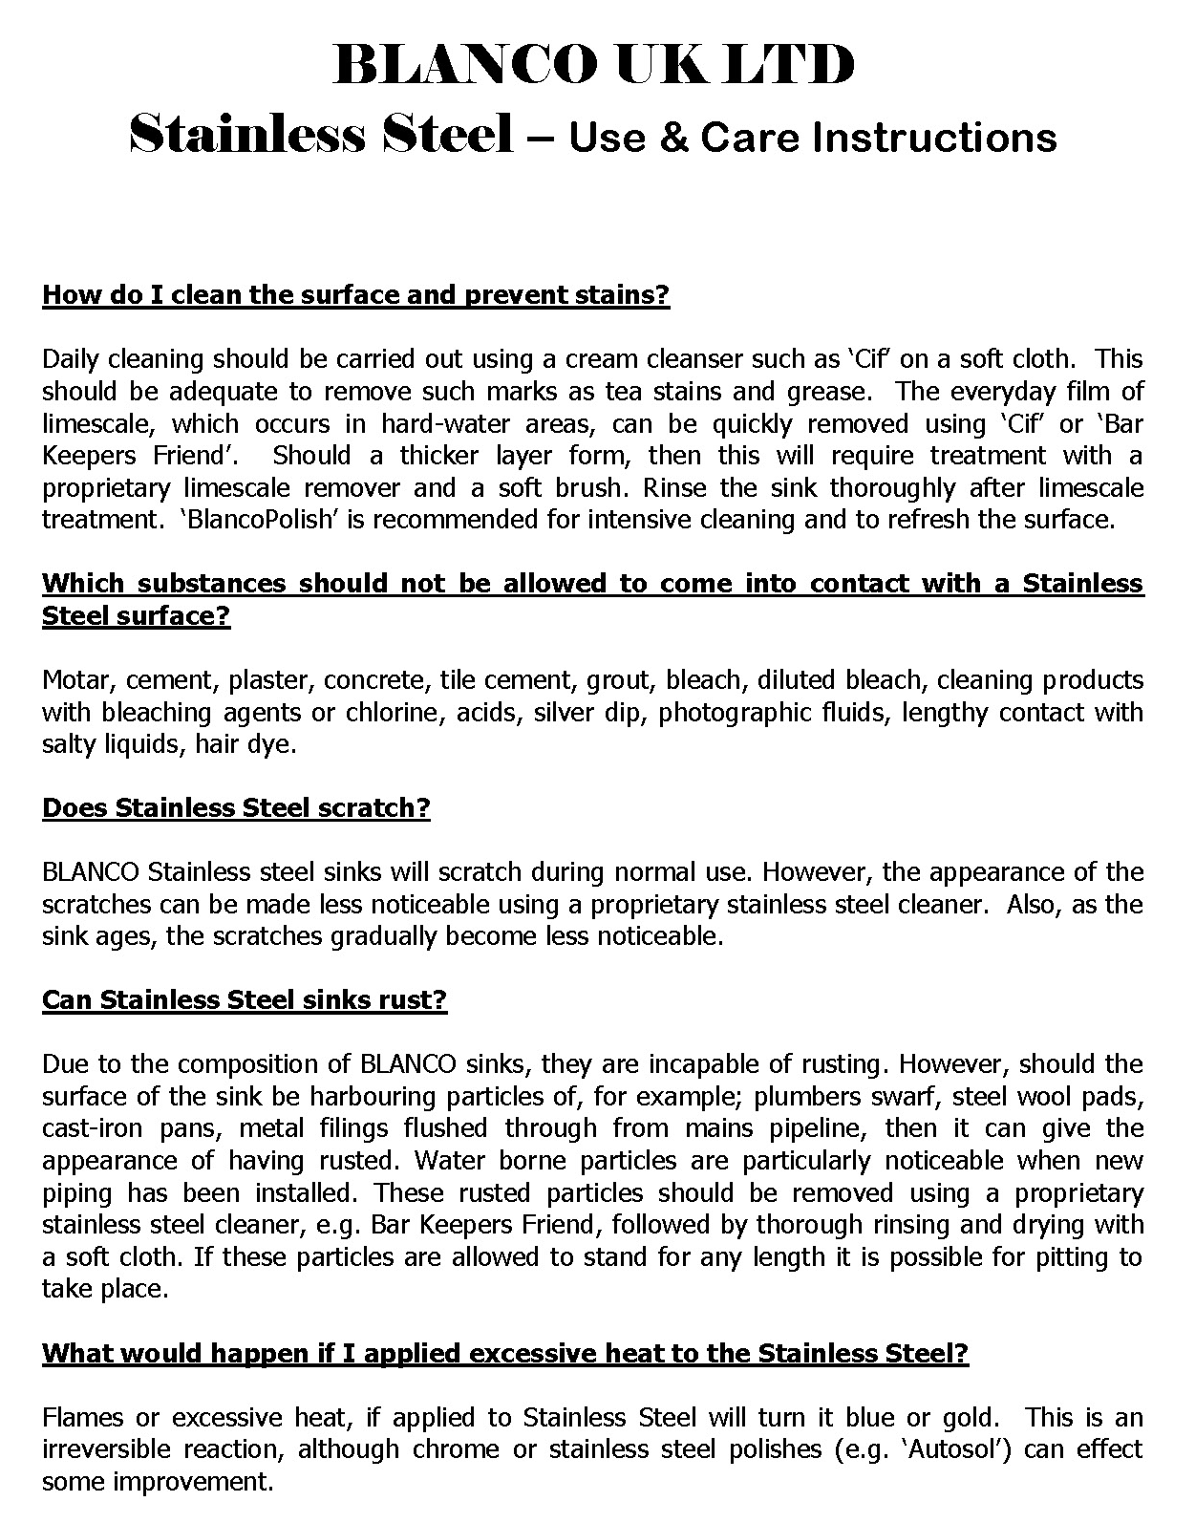
Please see specific handover material for upgrade composite sinks.
Any appliance fitted such as oven, hob, extractor hood, etc. will be covered by the manufacturer’s normal warranty. Smeg appliances only – these are covered by a manufacturer’s 2-year warranty which is pre-registered, do not re-register this warranty as this may cause the warranty inadvertently to revert to 1 year. In the event of a fault, a Smeg contact information sheet is included within the handover material and shown below, post code and plot handover date must be quoted for reference.

Notes on kitchen appliances:
Cooker hood – Please refer to the manufacturer’s instructions for operating, maintaining and cleaning instructions for the cooker hood (which are contained in your handover pack, or are available for download from the manufacturer’s website).
Please note the following important points which are applicable to all cooker hoods:
- There can be a fire hazard if the grease filters are not maintained as recommended in the manufacturer’s instructions (the metal grease filter and the inside of the cooker hood must be cleaned at least once a month - or more often depending on the sort of cooking and if used more than 3 hours a day).
- The hood has also been installed for use in the recirculation mode and a charcoal filter has been fitted. The charcoal filters normally require changing after every three/four months or more frequently if used more than 3 hours a day. Replacement charcoal filters are available from on-line retailers.
- Do not cook under the cooker hood if the metal filters are not fitted- e.g. if you have them removed for cleaning.
- You must not produce flames under the cooker hood.
- Do not place anything on top of the cooker hood.
- Disconnect the appliance from the electricity supply before carrying out any cleaning or maintenance work.
NOTE:
A recirculation model extractor hood has been fitted. This is designed to work in conjunction with the dMEV ventilation fan system in the Kitchen and the rest of the home, which is designed to provide adequate ventilation and air quality in modern homes which have high levels of thermal insulation and airtightness.
It is not recommended to change the extractor hood to an externally-vented model as this may cause an imbalance with the dMEV system, causing it not to work effectively and possibly invalidating relevant warranties. Should you wish to investigate such a change, this should be done with the guidance of a qualified ventilation engineer.
Induction hobs – your home has been fitted with an electric, induction hob, which offers many benefits of efficiency, safety and use over older style hobs.
An induction hob has a surface made from glass ceramic on which a cooking pot is placed. Underneath the hob are induction coils made from copper wire that create a magnetic field as soon as a cooking zone is supplied with electricity. If a pan with a magnetised base is placed on the cooking surface, its base will be heated directly. The glass ceramic surface is only heated by the heat given off by the cookware and only where the pan comes into contact with the induction hob. If no pan with a magnetised base is placed on the induction hob, the hob will remain cold. An induction hob is not only safe, but also heats up quickly and is easy to use.
This does require that pans used have a magnetised base, so purely aluminium, copper, glass etc. will not be suitable, but the majority of cookware is now manufactured with this in mind.
Pacemakers and interaction with induction hobs - pacemakers are small electrical devices that regulate electrical activity in the heart. Anything that produces a strong electromagnetic field can interfere with a pacemaker and induction hobs do generate electromagnetic fields, so keep a distance of at least 60cm (2ft) between the hob surface and your pacemaker.
Many other appliances contain a magnet, such as handheld hairdryers, large stereo speakers and electric toothbrushes and are quite safe with regulated use. If you do get too close to your hob, don’t panic – moving further away again should mean that your pacemaker settings return to the correct level.
Most people should be able to use an induction hob if they follow these precautions, but if in doubt, check the written information given to you when your pacemaker was inserted.
Connecting appliances – (where applicable)
Electrical connections for cookers and other electrical appliances requiring wiring work should be made by a qualified electrician using the pre-fitted wiring and fittings installed for this purpose.
When fitting a dishwasher or washing machine, please ensure the blanked end of the waste pipe tee piece has been removed. Note – this is not applicable where a ‘standing waste’ pipe has been provided. Please also ensure that the water supplies and wastes are securely connected to the pipework.
Please also note that, where Scotia have not installed a washing machine but have left a space for one with a cold water supply adjacent to it, then the home owner is responsible for removal of the cap that has been fitted to the cold water washing machine valve – please ensure you remove this cap before making the water connection to your washing machine. Please also ensure that the appliance water supply and waste pipe is securely connected to the property’s pipework before turning the appliance on.
An useful video demonstrating the typical process for connection of such appliances can be viewed here - https://www.youtube.com/watch?v=0RXYB8e3q5g
You may find washing machine/dishwasher isolation valves identified using the tags below:
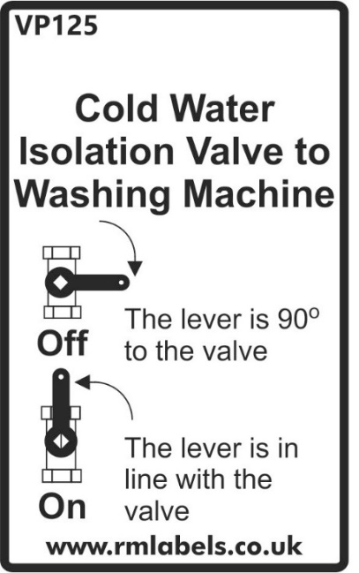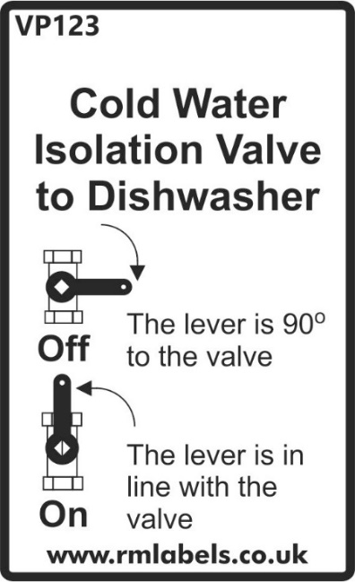
Notes on isolation valves:
Isolation valves may have been fitted to your kitchen sink tap (and also may have been fitted to utility and bathroom taps) - these valves, where fitted, allow the water to be turned off to the tap only to allow maintenance work to be carried out on the tap (instead of shutting off the water to the whole property). The two diagrams shown below show the isolating valves in the closed and open positions.
PROVISION FOR A GROUND FLOOR SHOWER
Some 2 storey house types include provisions for the installation of a shower on the ground floor of your home if you should need one at any point in the future (unless you have asked for a ground floor shower to be installed as a client upgrade).
In most instances the location identified for part or all of this future accessible shower is in the cupboard next to or within the ground floor toilet. In some circumstances, the required space may be crossed by existing partition walls, radiators and electrical point positions etc., which may require to be removed/repositioned in order to install the shower. Partition walls will have been designed to be de-mountable in this situation.
Where provision has been made for a possible future shower, a 100mm diameter drainage pipe has been installed under the floor to suit a future shower. The pipe is installed with a cap and is located just under the top of the concrete floor. Any installer will require to ‘break through’ the floor in this specific location in order to make connection to your home’s drainage system.
If you decide to install a shower in this location in the future please note that, depending on the type of shower you are considering using, we recommend that you consult a qualified heating engineer as your hot water system may need to be upgraded in order to accommodate the shower. Please ensure that all plumbing, electrical and joinery works are carried out by competent tradesmen. This may also require the removal of partitions and the installation of an additional/replacement extractor fan.
WALL TILING
Wall tiles and in particular the grout between tiles should be regularly cleaned using a proprietary tile/grout cleaner in accordance with the manufacturer’s instructions. Grout should be inspected and any areas which become loose should be replaced.
SHOWER WALL PANELLING (where fitted)
Laminate wet wall panelling (where fitted) should be cleaned by using hot water and a mild detergent applied with soft cloths or soft nylon brush. Non-scratch cleaners may also be used. On no account should scouring pads, acid-based toilet cleaners or limescale cleaners be used as they will damage the laminate surface of the panel.
Wall panelling and shower enclosure/tray should be dried off after use.
The sealant around the base of the wall panel should be inspected and replaced as necessary to prevent water ingress between the shower tray and the panelling.
INTERNAL DRAINAGE – ACCESS POINTS
Drainage soil and vent stacks run vertically through your home. The soil stacks are hidden within plaster-boarded ducts and bulkheads (which may also have hot and cold water pipework located in them). These ducts and bulkheads may have panels located at points where access may be required in the future if maintenance work is being carried out.
Picture of a typical access panel:
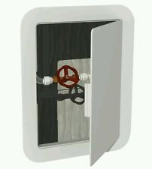
These access panels are recessed into the plasterboard and have a hinged fully removable door for easy and convenient access. They can be painted over, if required, during any future re-decoration work that you may carry out. Please note that these access panels should not be removed or sealed up – they are there to allow fast access to rodding or drainage access points (or hot and cold water valves and the like) – access may be required if, for example, a blockage occurs in the soil pipe.
CONSTRUCTION OF WALLS, roofs, PARTITIONS, FLOORS & CEILINGS
The following notes provide, for your information, outline details of the construction for each part of your home.
This information is generalised and particular areas of your home may differ – always seek appropriate advice and carry out detailed investigation works before making any alteration to your home in the future.
External walls:
The house external walls comprise a 100mm thick block-work leaf with render and/or facing brick finish, 50mm wide cavity and timber framed kit inner leaf. The timber-framed inner leaf comprises; a reflective breather membrane on the cavity side on a 9mm sheathing board, on 140mm thick load bearing timber studs at maximum 600mm centres, with 140mm thick mineral wool insulation between the studs.
All plots will have 30mm PIR insulation on the inside of which there is a 38mm timber framed service void and 15mm thick plasterboard lining. A reflective vapour control layer will be fitted on the inside face of the PIR insulation.
Safety Note – all external walls are load bearing and must not be altered without getting professional advice.
Party walls:
(Walls between houses- where applicable). These walls comprise two 90mm thick timber panels with 9mm sheathing boarding to the cavity side and a 50mm cavity between the panels, which is fully filled with party wall insulation for thermal and acoustic performance. Acoustic insulation is fitted between the timber studs. On the room side a layer of 19mm thick plasterboard plank is fitted and then this is over laid with 15mm plasterboard. Where there are sockets, electrical services or other items installed on the party walls a service void is also formed using 38mm thick timber framing overlaid with a layer of 15mm plasterboard lining.
Safety Note – all party walls are load bearing and are constructed to a fire-resistant specification – they must not be altered in any way. If any damage occurs to plasterboard and plank linings to the house side of the party walls the damage must be repaired immediately.
Roofs:
The main roof is pitched and comprised of concrete roof tiles mounted upon battens above a roofing membrane and boards all of which are supported by the structural timber trusses and rafters.
This also includes a system of appropriately ventilated eaves, verges, fasciae, soffits and ridges to provide the required junctions and edging to the roof structure, with valley structures and lead flashings where additional drainage protection is required.
All partitions:
Timber framed partitions with 15mm thick plasterboard each side. Mineral wool acoustic insulation is fitted in the partitions to bedroom, bathroom and other such areas.
SAFETY NOTE – some internal walls are loadbearing, so do not remove or alter them, or make substantial alterations to them, without getting professional advice.
Ground floor:
Concrete floor slab on rigid board insulation with damp proof membrane and sand blinding on up-fill.
First floors:
Intermediate floors comprise engineered I-joists with a 15mm decking board on top of the joists and a 22mm thick flooring overlay. 15mm plasterboard linings to the underside of the I-joists. A layer of acoustic insulation is installed between the joists where the floor is above an integral garage for thermal performance.
Safety note – all floor joists are load bearing and must not be cut or notched without first getting professional advice.
Top floor ceilings:
Plasterboard fixed to the underside of the roof trusses.
Future alterations – should you consider making any alterations to your home in the future such as altering the partition layout or forming a new opening through a wall you should check relevant Local Authority permissions and/or use the services of a qualified architect before starting.
The external wall service voids, internal partitions, 1st floors and attic space may all have services such as pipes and cables installed in them – refer to the safety precautions below if installing any fixings into these parts of your home.
Appropriate proprietary fixings should always be used to suit the wall construction (see below).
FIXING TO WALLS, CEILINGS OR FLOORS – IMPORTANT NOTICE
Wall fixings (for pictures, mirrors etc.) must be of the appropriate type for the type of walls described above. Be very careful if nailing or drilling into walls, ceilings or floors to avoid contact with any pipes or electric cables which may lie hidden behind the surface. We recommend that you use a services detector (cable detector) before drilling or nailing – it can reduce the risk of serious injury. If using power tools to install a fixing, you should always use a R.C.D. (residual current device). You should also always check for pipes and cables before drilling or nailing into floors or ceilings.
Note for any houses with under-floor heating (if applicable) - you should never drill or nail into any floor which has under-floor heating fitted.
In addition to the above please note that fixings should never be made to the following wall areas:
a) Directly above or below any electrical socket outlet, switch or appliance.
b) Directly horizontal to any electrical socket outlet, switch or appliance.
This is because electrical cables run in these areas.
WINDOWS AND FRENCH DOORS
Your home has white inside/ grey outside outward opening casement windows and outward opening French doors (where applicable to your house type).
The windows are fitted with lockable window handles to all ground floor windows and standard (non-locking) handles to all first-floor windows (where applicable).
A key is supplied to operate the lockable handles and care should be taken to prevent damage to the handle by trying to force it open when lock is engaged. The key to combination windows should be retained on the window sill.
The first-floor handles are non-locking (no removable key) to comply with the requirements of the Building Regulations in respect of emergency fire escape. However, the Building Regulations recognise that individual home owners may want to fit additional locking mechanisms to first floor windows (see note below) after they have moved in to their new home (for example where there are small children in the room) and if you wish to install any of the large variety of ‘child restrictor catches’ or any other additional locking mechanism that are available to your first floor windows then please note that they must be a ‘quick release’ type (without a key which might be lost) - a type which does not hinder escape through the window in the event of an emergency. The restrictor must also be suitable for the type of window and we also recommend that they are fitted by a skilled tradesman and that particular care is taken to ensure that they are fitted strictly in accordance with the restrictor catch manufacturer’s instructions. An incorrectly fitted additional locking mechanism can damage the window and lead to window guarantee problems. Advice can also be obtained from the window supplier (refer to the Schedule of Materials for contact information).
NOTE ON WINDOW RESTRICTORS:
Where there is a first floor window with a low (able to be climbed) sill, this will be fitted with a concealed safety restrictor catch as described above. The type may vary depending on the particular window, please refer to manufacturer’s instructions or via the Schedule of Materials for operation and maintenance guidance.
Notes regarding glass coatings:
To comply with the building regulations all double-glazed units installed in your home will have a low emissivity coating. Low emissivity (Low-E) glazing is a vital component of an energy efficient window or patio door. It has a surface coating that allows short wavelength heat from the winter sun to enter your home through the glazing, while reflecting back into the room the long wavelength heating produced by your heating system. This reduces heating costs and minimises internal condensation. Please note that this Low-e coating has considerable advantages, but you should be aware that there are some minor features, due to the coating of the glass, which you can see in some or all of the following ways:
• As a tint in the glass
• As a ‘haze’ when viewing through the glass at some angles and in some lighting conditions
• By the appearance of condensation on the outside of the glass under certain weather conditions (which is positive proof that the glass is preventing heat loss from your house)
• There may be minor blemishes visible arising from the coating process and the tint may also change between individual double-glazed units if the units are made from different batches of glass. These are not detrimental to the functioning of the unit and are not a defect.
Please note that if you are replacing any of your double-glazed units in the future you should ensure that your glazier uses low emissivity glass in your windows.
Notes regarding glass specifications (safety glass):
In addition to the note regarding Low-e coatings above, you should also be aware that certain windows may have either laminated or toughened safety glass installed. This ‘safety glazing’ is installed to comply with the Building Regulations.
Any future replacement glazing units should be to the same specifications as originally fitted. Any competent glazier will be able to identify the glazing specification used and you should ensure that lower specifications are not used. Please be aware that some larger windows are of considerable weight and this must be taken into consideration by any contractor for manual handling limitations.
It should be noted that windows with safety glazing have characteristics inherent to the nature of the product and its production process. Specifically, you may find that the windows fitted with safety glass are heavier. In addition, whilst all double-glazed units use ‘processed glass’ (and are subject to an amount of imperfections occurring during the manufacturing process) safety glass is more prone to these minor visual imperfections. An example of this is that when toughened safety glass is being manufactured it is heated to extremely high temperatures, creating micro-tears which on cooling add strength to the glass. This process can result in small imperfections or visual distortions forming on and in the glass- these are not usually noticeable under normal viewing conditions but may be evident under close inspection. They are, however, an acceptable characteristic of the finished product and are not recognised as a defect in the glass itself. Laminated glass, which is manufactured from several layers, has similar characteristics and it can also be subject to minor blemishes and imperfections which is a consequence of the manufacturing process and is not a defect.
Safety Note - Maintenance and Cleaning:
Care should be taken when opening and closing your windows for cleaning and maintenance- never lean out of the window or stand on a chair or other possibly unstable platform to reach the top of the window – use a suitable pole extension when cleaning the glass and window.
Note regarding external sealant to windows and doors:
The windows and, if applicable, patio doors (and other external doors) have an external polysulphide sealant bead between the uPVC frame and the external render bead. This sealant bead is designed to provide a tough weather-tight seal to these joints. The sealant beads should be inspected at least once a year and if any signs of deterioration of this bead are found it should be repaired or replaced with an equal specification exterior polysulphide sealant.
General Cleaning and Maintenance Tips for Windows and Patio Doors
Glass may be cleaned with either a proprietary household glass cleaner (following the manufacturer’s instructions) or a mild, neutral pH, diluted detergent. Glass can be easily scratched, therefore ensure heavy grime or dirt is removed carefully using soapy water.
uPVC frames should be cleaned every 3 months with a soap or washing up liquid and warm water solution.
A non-abrasive proprietary cleaner suitable for plastic may be used for more stubborn blemishes following the manufacturer’s instructions.
Avoid using solvent based or acid-based detergents or abrasive cleaners as these will damage the uPVC frames and glass.
At least once a year lubricate or oil all moving parts & locking points, using only clean and non-resinous grease or oil.
Check all components for looseness or wear. If necessary, tighten screws.
Please refer to the manufacturer’s guide/s (contained within your Handover Pack) for more information on maintenance and also for information on operating your windows and patio doors (where applicable).
Copied below are extracts from a typical guide:
EXTERNAL DOORS
The external front doors fitted to your home are typically GRP (glass-reinforced plastic)/uPVC composite door sets manufactured by Pinefield Glass.
The external rear/Utility room doors fitted to your home are typically uPVC fully glazed door sets manufactured by Pinefield Glass.
Security locking is accomplished by a 3-stage process:
- Close door
- Lift handle upwards to engage locking mechanism
- Turn the key until locking is completed
General cleaning and maintenance Instructions:
All ironmongery should be cleaned on a regular basis using warm soapy water. Do not use abrasive or corrosive material to clean the ironmongery as this will damage the finish to handles, letter plate, eye viewer, chain and rain deflectors.
Glazing can be cleaned with warm soapy water, avoid using anything which may scratch the glass.
The multi-point locking system and hinges should be lubricated with WD40, or a similar product, on a regular basis to ensure the smooth operating capabilities of the cylinder, handle and the locking mechanism. The weather sill at the base of the door should be kept clear of debris to allow the drainage holes to function. The rubber gaskets in the sill and door frame should also be checked periodically for damage and replaced as required.
Additional manufacturer’s care and maintenance instructions for windows and external doors can be seen at https://www.eurocell.co.uk/homeowners/help/all-downloads (uPVC Care and Maintenance Guide).
INTERNAL DOORS
Handles should be cleaned with a soft non-abrasive cloth and for stubborn stains mild soapy water may be used. Care should be taken to avoid scratching surface of handles. The mechanism of the handle should be lubricated once a year with a light oil. Hinges and latches/locks should be lubricated on a regular basis with WD40 or similar product.
FLOOR FINISHES
Please note that any wooden flooring or other feature flooring such as tiles or adhered ‘Karndean’ (or similar flooring) laid by you when you move into your home will not be lifted and re-laid as a result of any maintenance work which may require access to the floor. If maintenance work is required to any part of a floor or to any under-floor services, we will require you to arrange the lifting and replacement of any feature flooring to allow us access.
Notes regarding concrete floors (normally ground floors) – concrete floors in your home have been finished to standard tolerances obtainable by the material. Before laying floor coverings such as vinyl or wooden overlay flooring to concrete floors you should be aware that some important steps should be taken by you:
- You should have your floor covering installer check the moisture content of the concrete floor. This is particularly important if you are laying the floor covering immediately after moving into your home, as the concrete floor may still be drying out and moisture can affect some flooring materials. If necessary, you should allow the concrete floor to dry out sufficiently before laying any flooring which may be affected by moisture or the concrete floor should be treated in accordance with the flooring supplier’s recommendations before installing any vinyl or wooden or other feature type flooring.

- Concrete floors will normally need a self-levelling screed applied prior to laying any vinyl or overlay type floor covering, again in accordance with the floor covering installer’s recommendations.
Notes regarding Chipboard Flooring - Chipboard flooring (normally to the first floor) should be prepared in accordance with manufacturer’s recommendations prior to fitting of vinyls, wooden overlays or ceramic floor tiles. Also note that chipboard flooring may have service ducts installed (sections of flooring which can be removed to allow access to pipes and other services). We have installed these ducts so that they are level with the adjacent floor – however it should be noted that because timber floors naturally shrink as they dry this drying shrinkage of the floor may result in minor differences in level between the duct cover and the surrounding floor. This may become evident with some types of thin floor coverings and your choice of floor coverings should take this possibility into account.
Note regarding installation of carpets to staircases – carpet smooth edge/gripper strips must be glued or screwed to timber staircases – not nailed. Scotia will accept no responsibility for risers damaged due to nailing of carpet grippers. The notice below will be affixed to elements of the staircase and should not be removed.
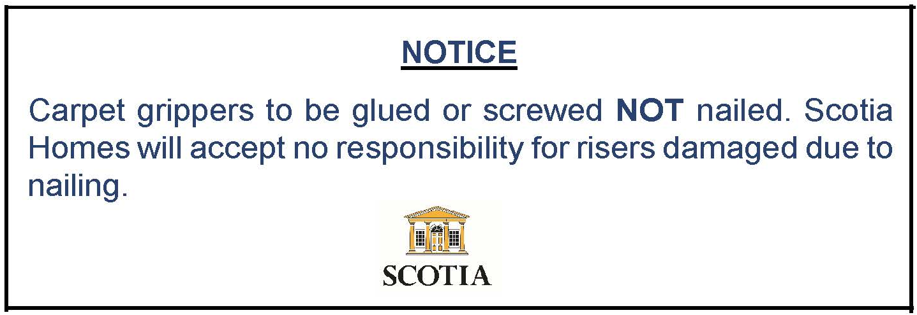
DO NOT use “hammer-on” carpet gripper. Hammer and nail fixing will break the bond between the tread and riser, resulting in a noisy and deflecting stair tread.
Recommended “gripper” fixings:
Liquid nails, specialist adhesive or light gauge wood screws. (gripper can be held in place while the adhesive cures with a narrow gauge i.e. low-impact nail/pin gun)
In addition, please be aware that most elements (treads, risers, newel posts, balustrading, handrails, nosings, stringers etc.) are integral to the structure, function and/or safety of a staircase and must be left intact as designed/installed. Should a flooring contractor intend to remove or alter any component, this must only be done with the guidance/approval of a suitably qualified structural engineer, or there is a risk of failure of the staircase structure, for which Scotia cannot accept responsibility.
ROOF SPACE
The attic space has not been designed to allow for storage. Do not use the attic space for storage. Flooring the roof space and using it for storage may cause deflection in the roof structure.
The attic has mineral wool insulation between and over ceiling joists. This insulation can cause skin irritation. If handling the insulation, it is recommended that appropriate protective clothing and equipment be worn.
Care should also be taken if entering the attic – the ceiling plasterboard between the joists will not support your weight and there may be service pipes, extract fan ducting and cables hidden by the insulation that you can damage by inadvertently stepping on them.
Typically, 2 storey houses have attic access hatches located in a bedroom ceiling - but if the attic access hatch is in the first floor hall ceiling near the stairwell then particular care should be taken if you are entering or exiting the attic space to avoid falling into the stairwell. Do not stand on or use the stairwell balustrade as a support if entering or exiting the attic.
It is advised that you do not enter the attic space. The attic access hatches should only be used by competent tradesmen for access to the attic space for any essential maintenance works.
The attic/loft access hatch used will generally be a Manthorpe GL250-015-PU model and, if access is required, the guidelines shown below must be followed.
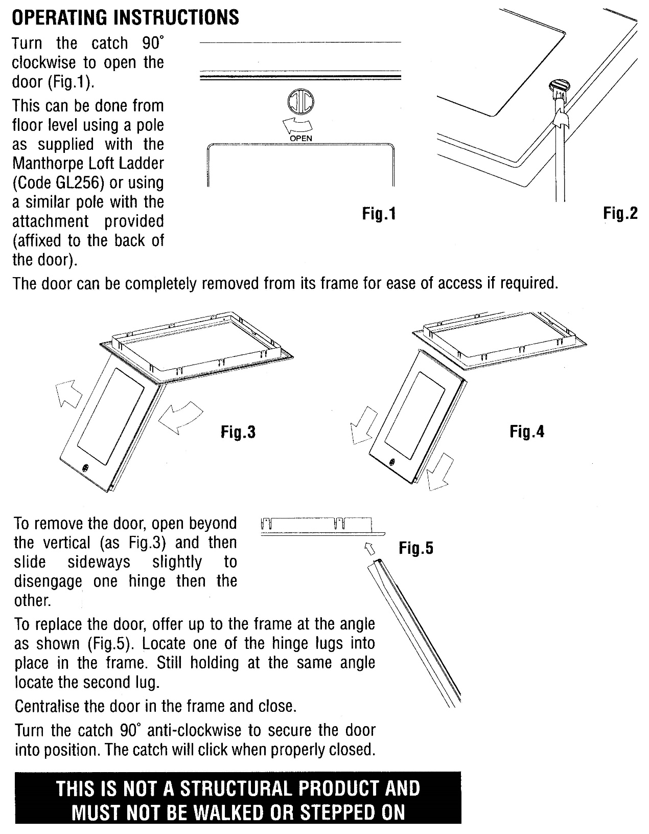
GARAGEs (where applicable)
Detached garages
The garage external walls are constructed from 215mm thick concrete blockwork with render finish externally to match the house. The inner face of the blockwork is “bag-rubbed” as a finish to remove any excess mortar.
The roof will be to the same pitched and tiled construction specification as the associated house, without an internal ceiling.
Integral garages
The construction of the garage will be the same as the timber-framed associated house, excepting the thermal insulation which is not required for the garage. The internal walls and ceiling will be lined with plasterboard, taped and painted.
The garage floor is constructed from a reinforced concrete floor slab with a smooth, even finish, laid to fall towards the front door on a damp-proof membrane on sand blinding and hardcore upfill.
It may be your choice to paint the floor and/or walls of your garage. This item is not offered as an Extra during the construction process as the drying-out process poses challenges in paint adhesion and durability, particularly in detached garages. It is recommended to leave a period of six months between completion and painting of these surfaces, which should be done with suitable masonry paints and only those applicable to the surface in question e.g. appropriate to floor use.
A Garador retractable garage door has been fitted to your garage (where applicable). Please refer to the Fitting, Operating and Maintenance instructions for this door contained in your hand over pack (copies of which can be downloaded from the Garador website) for operating and maintenance information and note also the following important points:
- The garage door should be maintained in accordance with the manufacturer’s instructions.
- Always keep the swivelling and opening area of the door clear and make sure neither persons, children in particular, nor objects are located within the door’s area of travel
- Operation of the during heavy winds may be dangerous
- Have a specialist inspect and maintain the door at least once a year
- Have the door tension springs replaced after approx. 25,000 door cycles.
Extracts from manufacturer’s operating instructions:
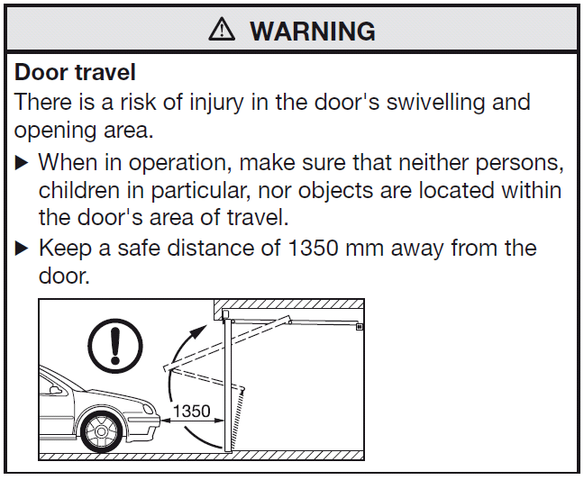
Where a garage side (pedestrian) door is fitted, this will be an outwards-opening door and may be fitted with a concealed overhead restrictor which will limit the maximum opening to 90 degrees. This restrictor must be maintained in order to fulfil warranty conditions, care should also be taken when opening the door in windy conditions so as to avoid inadvertent damage.
Garages are by definition a building, or a part of a building used to house a motor vehicle. Whilst exact detail will vary depending on whether a garage is detached, attached or integral; design and construction does not necessarily require that the garage has the same level of insulation, ventilation and other features as the associated house.
Consequently, the garage should only be used for the storage of vehicles as part of their regular use and is not directly designed or suitable for the storage of other items.
Where vehicular doors do not provide a “seal”, you should not seal or block these gaps, or any other ventilation features, such as external vents or roof voids. Storing large quantities of items within a garage to an extent that normal ventilation and air movement is impeded may result in damp and potentially mould.
Note:
Where a position for a potential future garage has been shown on the site plan, but not been constructed, a duct will lead (through the concrete floor slab) from the house consumer unit to the exterior of the house, in order that extension of electricity supply to a future garage is better enabled. Please note that this will still require supply and “draw-through” of additional cabling, along with installation of underground ducting to future garage location and supply/installation of all materials required therein.
external fixings
Any external fixings should only be made with consideration to the Deed of Conditions and also to the surface material to which anything is being mounted, both in terms of type of fixings used and load/weight.
efflorescence
The appearance of a white deposit on external walls is caused by ‘efflorescence’. This is a consequence of drying out and can often occur after a new house is constructed and is drying out. It can also occur when a wall dries out after period of heavy rain or in the spring as a result of drying out after a wet winter. As well as external wall materials such as block-work and mortar joints, it can also occur on products such as precast window sills, driveway paviours and paving slabs and also internally on concrete floors and areas of similar construction.
The efflorescence is caused by natural salts being drawn out of the wall materials while drying out and is quite normal. It is neither harmful nor detrimental to the performance of the material and, whilst it may look unsightly, the majority usually disappears over time. The advice given by most brick, block, cement and precast concrete manufacturers is that it is best dealt with by the combined effect of time and weather. If efflorescence occurs externally on your home, it is our policy to follow this advice and allow it to disappear naturally. It will usually disappear within a few weeks, washed away by normal rainfall. This process may take some time to draw out and remove all of the natural salts causing the efflorescence however it should be apparent that each time the efflorescence appears it will be in decreasing amounts.
Whilst natural weathering is the preferred cure for external efflorescence, if you wish (where it is in a safely accessible location) you can speed up the process by brushing down with a stiff non-metallic brush (not a wire brush), making sure that the deposit does not enter the wall at a lower level. Any remaining deposit can be removed or reduced using a minimum quantity of clean water. We advise that you do not use any proprietary cleaning agents as some varieties contain a concentration of acid, which can permanently affect the appearance of the wall materials. A power washer should not be used as it can damage mortar joints and the wall materials if used incorrectly.
Our advice is that you let the weather deal with external efflorescence.
Other external areas, such as concrete slabs and pathways, may be prone to efflorescence of a slightly different appearance, including red/yellow/brown stains which look similar to rust. This may be caused by the presence of iron oxide in the base materials of the concrete and can indeed cause noticeable variations for a period between neighbouring installations of the same concrete product. Again, this effect has no material impact on the performance or durability of the concrete and it should be temporary.
Care should be taken if applying lawn treatments/weed-killing chemicals in proximity to concrete and stone surfaces as chemical reactions may also cause a rust-like effect which may prove difficult to clean and take time to erode via rainfall.
If efflorescence occurs on internal concrete floors or other such areas then it too can be removed by brushing with a non-metallic brush and then removing the deposits with a vacuum cleaner. Internally occurring efflorescence should disappear quicker after brushing and vacuuming than external efflorescence as the home is dried out by the heating.
Should persistent efflorescence occur internally which does not disappear after removing it by the methods described above, then please contact Scotia Homes’ Customer Care department for further advice.
CARE AND MAINTENANCE OF BOUNDARY WALLS
General Maintenance Advice (where applicable and the responsibility of your own plot, some boundary walls may be the responsibility of the factor/others).
Maintenance of Polysulphide Mastic Sealant
Your boundary walls are pointed with a sealant along the top of the precast concrete copes and under the topmost coping stones. This sealant is to prevent the ingress of water and it should be maintained and kept in good condition. We recommend that should any damage occur or if any signs of deterioration are found in the sealant joints then it should be repaired as soon as possible. Note also that power washing or use of any aggressive chemicals to clean the wall can result in damage to this sealant. For your information an extract from a typical sealant data sheet is attached at the end of this section.
Maintenance of Mortar Joints
The mortar joints in the boundary wall blockwork should be periodically inspected (we suggest at least once a year in spring after the worst of the winter weather has passed) and any loose or damaged mortar should be raked out and repaired to prevent water ingress into the wall and possible freeze/thaw damage to the wall.
Cleaning of Boundary Walls
Depending on the geographic location, surrounding environment and prevailing weather conditions all external wall finishes can, over time, suffer from the likes of moss, algae or wind-blown dust and dirt. If you decide to clean the wall to remove any unsightly surface contamination then care should be taken to ensure that you do not damage or stain the wall. Loose wind-blown contaminants can be removed with a soft bristle brush and any more stubborn dirt or moss can be loosened with a little clean water and non-aggressive cleaner.
A multi surface biocide can be used to remove algae and other natural plant life. For your information a copy of the manufacturer’s data sheet for a typical product is attached at the end of this section.
Please note we do not recommend the use of a power washer to clean the boundary walls unless you are experienced in their use, it is a low pressure model and you are confident you can safely avoid any damage to the render or mortar/ sealant joints in the wall- if used incorrectly power washers can drive water into the wall, loosen render and cause considerable damage. A high-pressure power washer should never be used.
We strongly recommend, should you decide your wall needs cleaning, that you clean a small inconspicuous area first and allow it to dry to make sure you are satisfied with the result.
Please also note that parts of your boundary walls may have received a water repellent treatment and the following section provides more information on this treatment.
Water Repellent treatment
It is likely that a masonry protection cream has been applied (where applicable) to the stone cope at the top of the wall, precast concrete copes at steps in the walls and also to the facing block base-course (under the rendered area of the walls). This masonry protection treatment lasts over 25 years and if you do decide to use an algae cleaner or similar product on your walls it would be recommended to re-apply similar masonry protection after the area has thoroughly dried. An extract of a typical product data sheet is attached at the end of this section for your information.
Repairing Damage to Boundary walls
Any damage to your boundary wall, such as impact damage, should be repaired as soon as possible.
If significant damage occurs, then specialist advice should be obtained on its method of repair and all repair works should be carried out by an experienced tradesman.
Gardening Activities near boundary walls
There are some garden activities to be avoided near to your boundary walls including:
Do not excavate deep holes near to the wall (for deep water features or ponds etc.) - risk of undermining the walls foundations causing collapse of the wall. If you are digging near the wall, please do not go deeper than 450mm without seeking specialist advice.
Do not plant trees or shrubs near to the wall unless they are of a type which will remain compact with minimal spread of roots. Any young tree or shrub planted too close to the wall which then grows big can cause damage to the wall foundations arising in loss of integrity of the wall.
Do not change the existing ground levels alongside the boundary walls. Lowering the existing ground levels can allow winter frosts to reach the foundation level causing damage to the wall from ‘frost heave’. Raising the ground levels can allow moisture in the ground access into the wall leading to possible render damage or damage to other parts of the boundary walls.
Fixings into Boundary Walls
We do not recommend installing any fixings into the boundary wall as they can allow an entry point for moisture which can then freeze and damage the surrounding wall area. However, if you do decide to install fixings (for handing basket brackets or similar items, then you should ensure that the fixing is of the appropriate type for the purpose that you are using it for. The boundary walls must not be used as supports for any heavy items.

Extract from Fosroc Nitoseal MS60 sealant data sheet.

Copy of Safeguard Soluguard Multi Surface Biocide data sheet.

Copy of Safeguard Stormdry Masonry Protection Cream Data sheet.

EXTERNAL AREAS
Manholes give access to the underground drains - do not obstruct or cover them with soil. You may need to provide access to them quickly if there is a blockage. Please note that there are live underground services cables in the ground around your house. Great care MUST be taken if digging or carrying out excavation work in the vicinity of live underground cable routes.
Underground cables may be found just below the surface, although they are normally laid between 0.45m to 1.0m deep from the surface. Reduced depth may result from ground disturbance after laying or because the cable had to be laid over an underground obstruction. Even shallow excavations (e.g. for post holing and fencing work or for garden features such as ponds) may be a source of danger.
If you do uncover a cable during excavation work - ALWAYS assume it is live. If in any doubt contact a qualified person to seek advice before carrying out excavation work.
Garden and exterior areas maintenance - caring for your garden.
Fencing and gates – boundary timber fencing has been vacuum/pressure-treated with either:
- Tanalith preservative with Tanatone colour additive – colour brown 3999
Or
- Wolmanit CX-8 preservative with Wolmanit ProColour brown 2007 colour additive.
Re-treatment should be done in the same or similar colour.
Depending on the layout of the external areas for your particular plot, some or all of the following notes may be applicable:
Caring for the grass (including trees and shrubs where they have been provided) in your garden is essential. This will ensure that the planting is successfully established and your garden thrives.
The rear gardens of most new homes are finished in rotovated topsoil, allowing you the opportunity of designing and landscaping to your own requirements. It is important that the landscaping is carried out as soon as possible after the date of the handover, as it is only by working the soil that it will remain aerated and weeds will be prevented from becoming established. This will also help to establish the finished level of the soil and ensure it drains more effectively- so reducing the potential of any flooding during wet weather conditions (see also maintenance of garden areas below). However, if there has been rain please take this into consideration when carrying out landscaping work to your rear garden – let the topsoil dry out sufficiently before working on it - compacting wet topsoil will damage it making it unsuitable for good drainage or good grass or plant growth.
The areas to the front of your home may be turfed and/or have shrubs, hedging or trees planted in them.
There follows some important care and maintenance requirements for your garden ground:
Maintenance of garden areas:
Watering of turf – In the absence of regular heavy rainfall you should water turf at least twice a week – daily if the weather is hot and dry – after moving in. A newly turfed garden looks deceptively mature, but the new grass has only a very small reserve of moisture in the soil attached to the turf. Until the grass roots grow into the underlying soil the turf is prone to drying out and shrinking. This can leave unsightly gaps. Light rain is often not enough to sufficiently water the turf and underlying soil. The best way to irrigate your garden is by using an oscillating sprinkler.
Damage to turf – Walking on turf before it has properly settled in can cause considerable damage. Dents and hollows made on new turf will not disappear and are often difficult to repair. It usually takes about a month to become firm enough to walk on, but this can vary according to weather and soil conditions. If you are installing or removing a sprinkler use wide boards to spread your weight and minimise damage.
Mowing turf – it is recommended that you do not mow the turf for at least the first week after moving in. Let it grow to establish itself and make sure before mowing for the first time that its roots have grown down into the soil below. For the first cut leave the grass higher than normal and then gradually reduce the height in subsequent mowings until you reach the height you want.
In order to assist drainage of these areas the turf requires to be regularly aerated, to a minimum depth of 25/30mm by spiking the turf with a garden fork or spade. For better results deeper spiking (100-150mm deep) with an appropriate proprietary tool should be carried out and we would recommend that you seek expert advice on the preparation and sowing of new grass seed or laying of new turf as clay soils particularly will require the addition of sharp sand, organic matter or compost to aid drainage.
In the event that your lawn does become waterlogged you should, wherever possible, avoid walking on it until it dries out.
Trees, shrubs and hedging also need copious watering after planting. As with turf, the roots have not yet grown into the surrounding soil and can only pick up moisture from a very limited area. Planning permission for planting schemes usually requires that planting shown on the approved plans is maintained for a specified period of time. This obligation is passed on to you once you take up ownership of the property. Scotia Homes does not replace turf, trees, hedging or shrubs that have failed due to a lack of watering.
More detailed garden considerations - Soil structure and pH (acidity or alkalinity) will vary according to the geography and geology of the area. Sometimes you will be lucky enough to find a neutral pH and wonderfully rich soil full of humus but most of the time, soil conditions will produce challenges, so expectation is something that one needs to manage from the beginning!
Once you have established what the soil structure is like in your garden and what pH you have, it’s a case of doing a bit of research to understand how best to work with it and working with it is the key to success. There is no point in trying to put an acid loving plant that likes full sun and dry conditions in a lime, wet soil, in the shade. Assessing the conditions and helping the soil to improve where necessary and then finding the right plant for the right place will get you there.
When preparing for lawn (grass seed or turf) you need to assess and understand the soil conditions and the drainage before you start. Drainage is an important issue where lawns are concerned so it’s worth spending time understanding what you have to work with and on the preparation to produce the best conditions achievable. This will help you to understand how to get the best out of your garden and particularly the type of plants best suited to clay soils.
To assist you on both counts; apart from the many books and articles available on the subject, try www.rhs.co.uk or www.beechgrove.co.uk/factsheets where you will find a wonderful library of tried and tested advice on a wide range of gardening and horticultural subjects, including plant suggestions for various conditions. Just remember that in the garden, everything takes time, so patience is truly a virtue but be comforted in the knowledge that you will get out of it what you are prepared to put in.
Additional notes for garden areas:
Fencing – in some cases it is possible that a rear or side boundary is shared with other plots on the development and fencing has previously been erected at the time of completion of those plots. Under normal circumstances, this will not be replaced and may be subject to natural weathering, resulting in colour differences which are not considered to be a defect. Where joins/extensions require to be made to existing fencing, any remedial works will be undertaken, but this will not include the replacement of whole panels/sections, unless they are defective.
Rotary clothes dryer – If a rotary clothes dryer has been provided, please note that it is solely designed for the purposes of hanging and drying washing, children should not play with this product. It is recommended that when not in use it is folded and, in the event of exceptional wind conditions, perhaps even removed and stored safely. If parts are worn or damaged, replacement should be considered. The model generally used at the time of writing is a Hills’ Supadry Hoist Rotary Dryer 4 Arm 60 Metre.
Damp proof courses – there are damp proof courses built into your external walls to prevent damp from the ground soaking up the outside walls. These are normally approximately 150mm from the ground level around your house. It is important that these damp proof courses are kept clear – if you are carrying out any landscaping or groundworks alongside your external walls then please ensure that you do not cover these damp proof courses (including any cavity weep vents) or otherwise bridge them, allowing damp to rise up past the damp proof course.
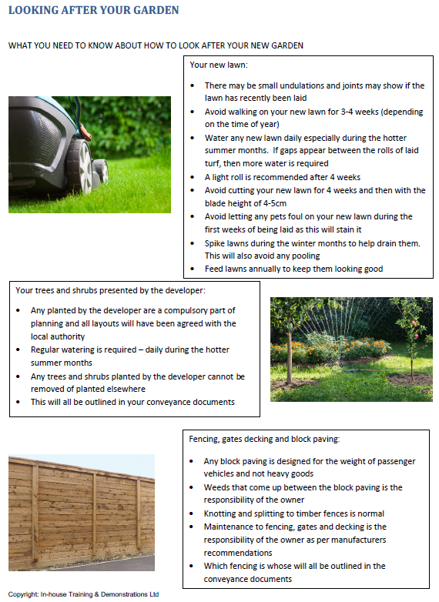
DRAINAGE CONSIDERATIONS
The rainwater and any driveway drainage systems have been designed to comply with Local Authority Regulations (such as Planning, Building Standards and Roads Construction Consent conditions) and SEPA (Scottish Environment Protection Agency) requirements including SUDS (Sustainable Urban Drainage Systems). In simplified terms these regulations require us to ensure that the drainage systems designed and installed around your home collect any rainwater which falls onto your house and surrounding plot and drains it away in a responsible manner.
There are a number of very important points that you should be aware of in relation to the drainage around your home:
Alterations to your driveway or parking spaces (or other areas within your plot curtilage). It is important that rainwater does not run off your plot onto the adjacent roads and footpaths (this is particularly important where the road is adopted by the local authority). We have designed the access driveway to ensure that any rainwater falling onto it either runs off into your plot where it soaks away into the ground or is collected into a gully or a permeable surface is used on the drive. If you subsequently make any alterations to your drive, you must bear this in mind and make sure you have obtained the necessary permissions from the relevant local authority. Failure to make such drainage provision will be likely to lead to the local authority demanding that the original surface be reinstated. Also, if you extend your drive over garden ground you must ensure that existing drainage provisions are adequate. Finally, it should also be noted that if you are changing the surface of your driveway the local council may require that an initial portion of your drive must be a ‘hard surface’ – not stone chippings or gravel or similar loose surface- again it is important that you obtain the necessary permissions prior to making any alteration to your drive.
Alterations to your garden ground. Removal of garden areas and installation of, for example, large impermeable patio areas or a large area of other hard standing will reduce the area of ground available to soak up rainwater and could lead to flooding problems if adequate drainage is not installed at the same time. If you decide to ‘slab over’ your garden ground, you must also ensure that you make adequate provision for dealing with any rainwater to avoid increasing the risks of flooding your own and your neighbours’ properties.
Maintenance of the drainage system. It is essential that the drainage systems installed around your property are maintained to keep them in good working order. This not only ensures that any rainwater which falls onto your house and plot is dealt with efficiently but will ensure that risk of flooding to your home and your neighbours is minimised. Similarly, the foul drainage needs maintained to keep it in good working condition and to ensure it does not become blocked or damaged. Depending on the particular drainage systems installed around your home the following general maintenance notes should be adhered to (where applicable):
Rainwater gutters and downpipes- depending on the likes of tall trees and other sources of debris in the surrounding area, rainwater gutters require to be cleaned out on a regular basis to prevent debris and dirt travelling into the underground rainwater drainage system and either blocking it or reducing its effectiveness. Keeping the rainwater gutters clear also reduces the possibility of them overflowing during thunderstorms or periods of very heavy rain - a leaking or over-flowing gutter could damage the external envelope of your home and lead to damp and other problems. Any debris clearance work at height must be done with reference to relevant safety considerations.
Underground rainwater and foul drainage pipes- you are responsible for the maintenance and repair of your underground drainage pipes from your house to the disconnecting manholes. Disconnecting manholes are normally located in your access drive or in the front garden. To minimise problems with your underground drainage it is essential that inappropriate items are not allowed to enter your underground drainage pipes as per the further notes below.
Drives / parking areas (if installed) – lock-block/paviours may be porous to allow for through drainage to the substrate material but will also be generally installed with adjacent drainage channels, which must be retained and maintained (cleaned of debris build-up), including replacement of any damaged covers, so as to preserve their ongoing function.
Garden ground – please refer to the maintenance information contained in the previous ‘External Areas’ section.
Avoiding blocked drains. The foul drainage system from your home is designed to take used water from sinks, showers, baths and toilet waste. The drainage is not designed to take inappropriate items such as wipes (baby, personal cleaning and the like), sanitary items, cotton wool, cotton buds, disposable nappies, cooking fat or oil or grease and similar substances.
Blocked drains can lead to flooding of your property and your neighbouring properties. A majority of blocked drains are caused by inappropriate items being put down the toilet or fat, oil or grease being put down the sink. Please refer to the Scottish Water material on the following pages for more information.
Water butts. If you decide to install a water butt to one or more of your rainwater downpipes please ensure that you also fit an over-flow back into the rainwater downpipe (to avoid the water butt over-flowing and causing flooding) and that any water butts are located in accordance with any relevant Deed of Conditions. Kits for water butt overflows are available in any good garden centre.
METERS
The Electric meter is typically located adjacent to the consumer unit.
UTILITY SUPPLIERS
The existing supplier for electricity to your new home will be recorded and your understanding of this confirmed on the ‘New Home Introduction’ form. Suppliers are required to be in place prior to completion for the purposes of installing infrastructure, making connections, and testing various features of the property. At the time of writing, the supplier for electricity will be British Gas at the point of handover.
Once you have taken possession of your new home and ownership has been legally transferred, it of course becomes your own right to decide which particular supplier you wish to use. It is at this point that meter readings are recorded on handover documentation, thereby denoting the change in responsibility for payment of ongoing bills. This same documentation, specifically the Handover Certificate, also includes MPAN (Meter Point Administration Number) details, which are determined well in advance of construction completion and provide supply point identification for your new home.
It is strongly recommended that you keep this Handover Certificate in a safe place.
Utility suppliers are then provided, by us, with these readings and confirmation of change of responsibility in order that they may start to invoice you directly as a private customer and homeowner.
From this point, it is possible for you to review, and indeed change, the tariff and/or supplier for electricity. Although the administration of the changed contact details may take a little time for some suppliers to update, all that is required to process a change is simply the MPAN details as a starting point.
Whilst there is an inevitable time period during which specific contact details applicable to an address are updated to current suppliers and this is subject to administrative process, the use of correct MPAN details as noted above should provide sufficient reference for review and/or change of supplier after the point of handover.
N.B. Some developments may already be fitted with ‘smart’ meters, which allow for both remote taking of meter readings and a separate display of usage and costs. These meters are progressively being installed in both new and existing properties and will become prevalent in the near future. Should your new home be fitted with a ‘smart’ meter and you choose to change supplier, please be aware that you may lose some ‘smart’ functionality if the chosen supplier is not yet compliant with this technology.
Please see below for example of a flyer detailing British Gas’ services:


biodiversity & eco-habitats
There is a Planning requirement to mitigate the effects of development upon local wildlife populations. For this reason, some properties and other areas of the development may include wildlife habitat aids which are designed to integrate seamlessly into the construction of properties and be an attractive feature as well as providing the best possible artificial accommodation for a variety of different species, without harming the fabric of buildings. These may include but are not exclusive to features such as the below:
Establish areas of wild flower rich grasslands
Wet meadow creation
Planting native broad leaved trees and scrub
Native species rich hedges
Retain dead wood on site
Install habitat for invertebrates, nesting birds, red squirrels and pine marten
Planting for pollinators
Managing artificial lighting for bats.
Any such installations must be retained in situ and do not generally require any maintenance.
LOCAL AUTHORITY REFUSE AND RECYCLING COLLECTION
The development has been planned to incorporate the required storage stances for wheeled bins and routes for collection vehicles. The responsibility for organising a wheeled bin with the local council (Aberdeenshire Council) is your own, and you may have already done so, if not, please contact them via their access line on 03456 081207 or at https://www.aberdeenshire.gov.uk/waste/household-rubbish/waste-and-recycling-bins. They will also guide you as to the requirements and processes for recycling, garden waste and other bins/processes.
It is worth noting that, should you ever move from your new home, the waste and recycling bins generally remain the property of the local authority and should remain with the property.
Should you have any queries or need advice regarding Waste and Recycling, perhaps for costs/additional bins, advice on special collections or waste collection calendars in your area, please contact the Aberdeenshire Council Recycling and Waste team via the above number or at https://www.aberdeenshire.gov.uk/waste.
winter procedures
Scotia Homes do not undertake winter maintenance of public or private areas (gritting, snow clearing etc.).
Where there are pubic areas of the development which are complete but not yet adopted by the local authority, Scotia Homes will organise grit bins to be located in these areas and, where possible, ensure these are supplied with grit. In the event that the bins are depleted, owners should contact Scotia Homes’ Customer Care department, who will arrange for supplies to be replenished.
All costs associated with topping up and/or providing grit bins will be paid for by Scotia Homes until roads are adopted by the Local Authority. The responsibility for spreading the grit rests with the homeowners.
council tax
The local authority will be aware of the new homes which are within your development, with a responsibility for payment of council tax falling upon the new owner (yourself). The authority will have made a banding valuation for your own property type and will issue payment instructions and schedules accordingly.
Should you not receive confirmation of this from Aberdeenshire Council or have any questions, please contact their Council Tax team at:
• Post: PO Box 18533, Inverurie, AB51 5WX
- Email: council.tax@aberdeenshire.gov.uk
• https://www.aberdeenshire.gov.uk/council-tax

SCHEDULE OF MATERIALS
Item | Description | Supplied by/Tel. /Website
Structural timber frame | Including floor and roof joists, eaves, fascia boards and gable barge boards. | Caledonia Homes  01358 721661  https://caledonia-homes.co.uk/index.html
Windows | White inside/anthracite grey outside uPVC casement windows | Pinefield Glass  01343 545222  www.pinefieldglass.com
French doors | White inside/ anthracite grey outside uPVC sliding patio doors. | Pinefield Glass  01343 545222  www.pinefieldglass.com
Internal Door Leafs | Premdor Ladder moulded solid core internal door leafs. | Travis Perkins  01463 231171  https://www.travisperkins.co.uk/branch/0400
Ironmongery for internal doors | Door Handles – Carlisle Brass Trend ref SZM 160 CPSN (polished chrome/ satin finish). Bathroom thumbturn and release- Carlisle Brass Serozzetta ref SZM004-CP, polished chrome. | George Boyd  01382 458918 https://www.george-boyd.co.uk/
External Doorsets | GRP/uPVC composite and uPVC (fully glazed) external doorsets (grey outer/white inner) | Pinefield Glass  01343 545222  www.pinefieldglass.com
Garage doors (where applicable) | Garador Carlton Retractable framed garage door factory finished colour anthracite grey. | Travis Perkins  01463 231171  https://www.travisperkins.co.uk/branch/0400
Skirting boards & Door Facings | MDF 95 x 14mm skirtings and 70 x 18mm facings, 18mm thick MDF cill boards, 18mm thick MDF bulkhead tops. | Fleming Buildbase  01224 258200  http://www.buildbase.co.uk/storefinder/store/Aberdeen-1228
Wardrobe doors | Sliding mirror doors. | Kelvin KBB Ltd.  01236 784444  www.kelvinkbb.com
Paint to internal walls and ceilings (standard decoration) | Dulux Trade super matt emulsion, colour Timeless. | Clandec Ltd.  01241 870120
Paint to skirting boards, internal doors, internal door facings, staircase spindles etc. (standard) | Dulux Quick Dry Satinwood, colour Timeless. | Clandec Ltd.  01241 870120
Kitchen & Utility Room Units, Worktops, Sinks and Taps | Various – see Specification, Bespoke Options and plot Extras/Options Statement documents for specific details | Laings Kitchens, Bedrooms & Bathrooms  01467 620311  https://www.laings.com/
Kitchen Appliances | Various, principally Smeg (depending on plot/Extras – see Specification, Bespoke Options and plot Extras/Options Statement documents for specific details | Laings Kitchens, Bedrooms & Bathrooms  01467 620311  https://www.laings.com/
Sanitary ware | Various – see Specification, Bespoke Options and plot Extras/Options Statement documents for specific details | Laings Kitchens, Bedrooms & Bathrooms  01467 620311  https://www.laings.com/  Duravit UK Limited  0845 500 7787  Hansgrohe  Limited  01372 472 001  Merlyn  Showering  0808 101 1429
Central Heating + Hot Water System | Daikin Altherma Air Source Heat Pump and associated controls and valves. | Wolseley  01382 8111178 https://www.wolseley.co.uk/
Radiators | Myson Premier HE. | Wolseley  01382 8111178 https://www.wolseley.co.uk/
Radiator Valves | Danfoss RASC2 (15mm). | Wolseley  01382 8111178 https://www.wolseley.co.uk/
Solar PV installation | Viridian PV16-405-M10 solar panel with associated inverter, switchgear and meter/s. | Edmundson Electrical Ltd.  01224 894050  https://www.edmundson-electrical.co.uk
Switches, Sockets and electrical accessories | Click Mode Range switches and sockets. | Holland House Ltd.  01224 638129  https://www.hollandhouselectrical.co.uk
Electrical consumer units | Elucian Board | Holland House Ltd.  01224 638129  https://www.hollandhouselectrical.co.uk
Extract Fans | Greenwood extract fans. | Holland House Ltd.  01224 638129  https://www.hollandhouselectrical.co.uk
Smoke, Heat + CO detectors, CO₂ monitor. | Aico Ei3024 smoke detectors, Aico Ei30028 or Ei3018 heat detectors, DETA 1142 CO₂ monitor (where fitted) | Holland House Ltd.  01224 638129  https://www.hollandhouselectrical.co.uk
External light fittings | Front Doors – Saxby 75430 Palin PIR Twin Wall IP44 7W  Back doors – Timeguard SLB88 PIR Bulkhead | Holland House Ltd.  01224 638129  https://www.hollandhouselectrical.co.uk
Gutters and downpipes | Marley deepflow gutters and circular downpipes. | Huws Gray  01224 258200  https://www.huwsgray.co.uk
Roof Tiles | Marley Edgemere | Forster Group Ltd.  01356 628560  https://forstergroup.co.uk/
Attic insulation | Glass fibre mineral wool insulation in attic space | Logical Insulation Solutions Ltd.  01324 477090  http://logicalinsulations.co.uk/
Precast door thresholds | Natural colour smooth precast concrete. | Fair City Precast  01738 629501  http://www.faircityprecast.co.uk/
External walls Render | Dry Dash Roughcast  Stonepack Nordic Chips on stonepack white cement top-coat with white Renderplas RS15 stop beads, MJ15 movement joint beads and B20 bellcast beads. | Robertson Specialist Division  01382 787400  https://www.robertson.co.uk/business/robertson-specialist-division
Facing Brick | Gleneagles Granite | Precon Bricks  01236 433351
Timber fencing | Timber fencing and gates to gardens  NOTE:  Finished in water based satin woodstain in a colour approximate to RAL 7016, this colour should be maintained during the course of any re-treatment. | J.B. Corrie & Co. Ltd.  01250 873989  https://jbcorrie.co.uk/ices.co.uk/
Plot landscaping | Including turf, planting (where applicable), grey riven precast concrete paving slabs, Bodpave for driveways etc. | Root One North  0800 999 7645  https://r1group.net/  JKR Contractors  01358 701 665  http://www.jkrcontractors.com/
Rotary clothes dryer | Hills Supadry 4/60 | JKR Contractors  01358 701 665  http://www.jkrcontractors.com/
Note - Not all items or colours are applicable to all properties
Scotia Homes Limited
Balmacassie, Ellon, AB41 8QR ● Tel: 01358 722441
info@scotia-homes.co.uk ● www.scotia-homes.co.uk

