Bespoke Options
Dubford, Bridge of Don

Flats

Plots 101-106, 130-135, 1601-1606, 1701-1706, 1904 & 1906

Kitchen (including Utility rooms/cupboard, where applicable)
Standard furniture
Standard door fronts | Complementary carcase inside/outside | Handle No. | Laminate work surface (Quadra 3mm radius profile) & upstands  
Riva 889 – Concrete Slate Grey | White interior, with all exterior panels, including plinths in 194 - Slate Grey | 062 - Stainless Steel  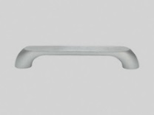  069 - Stainless Steel  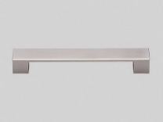  276 – Metal handle, Antique Iron colour  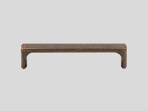  715 – Metal handle, Brushed Anthracite  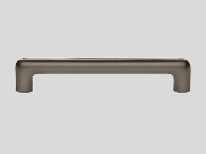  732 – Cast Iron handle, Black  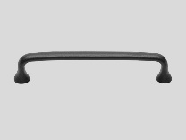  677 - Metal Knob, Stainless Steel  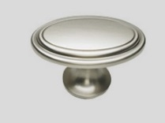  (Nobilia) Suite 608, Stainless Steel  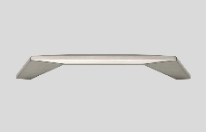 | R 6234 FG Rabac
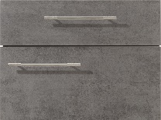 |  |  | 
Speed 259 - Satin Grey | White interior, with all exterior panels, including plinths in 070 - Satin Grey |  | R 4282 FG Chapel Oak
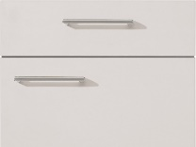 |  |  | 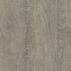
Riva 893 – Sanremo Oak | White interior, with all exterior panels, including plinths in 078 – Sanremo Oak |  | R55004 RU Ponderosa Pine
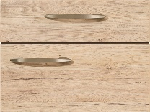 | 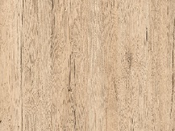 |  | 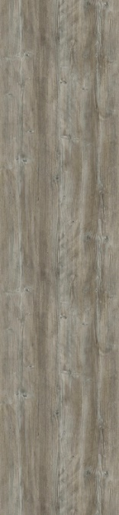
Speed 239 - White Softmatt | White interior, with all exterior panels, including plinths in 106 - White |  | R 6461 CT Natural Messina
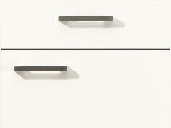 |  |  | 
Riva 891 – White Concrete | White interior, with all exterior panels, including plinths in 075 - Mineral Grey |  | F76044 Bellato Grey
 |  |  | 
Laser 415 - Sand | White interior, with all exterior panels, including plinths in 122 - Sand |  | R 6265 CT Ipanema White
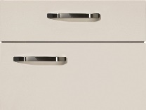 |  |  | 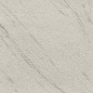

Upgrade furniture (these choices are available at extra charge through your client upgrades, please see your Sales Adviser)
Upgrade door fronts | Complementary carcase inside/outside | Handle No. # | Silestone work surface & upstands (incurs additional template and fitting costs) †
(Nobilia) Flash 450 – white high gloss | White interior, with all exterior panels, including plinths in 022 – white gloss | Handles for this furniture should be selected from the Nobilia standard range | Aluminio Nube
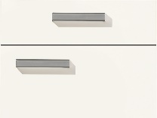 | 
(Nobilia) Flash 455 – satin grey high gloss | White interior, with all exterior panels, including plinths in 070 - Satin Grey |  | Amazon
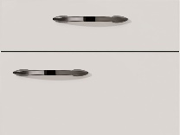
(Nobilia) Lux 823 – slate grey high gloss | White interior, with all exterior panels, including plinths in 194 - Slate Grey |  | Marengo
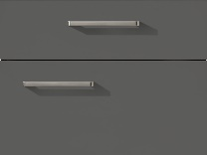 |  |  | 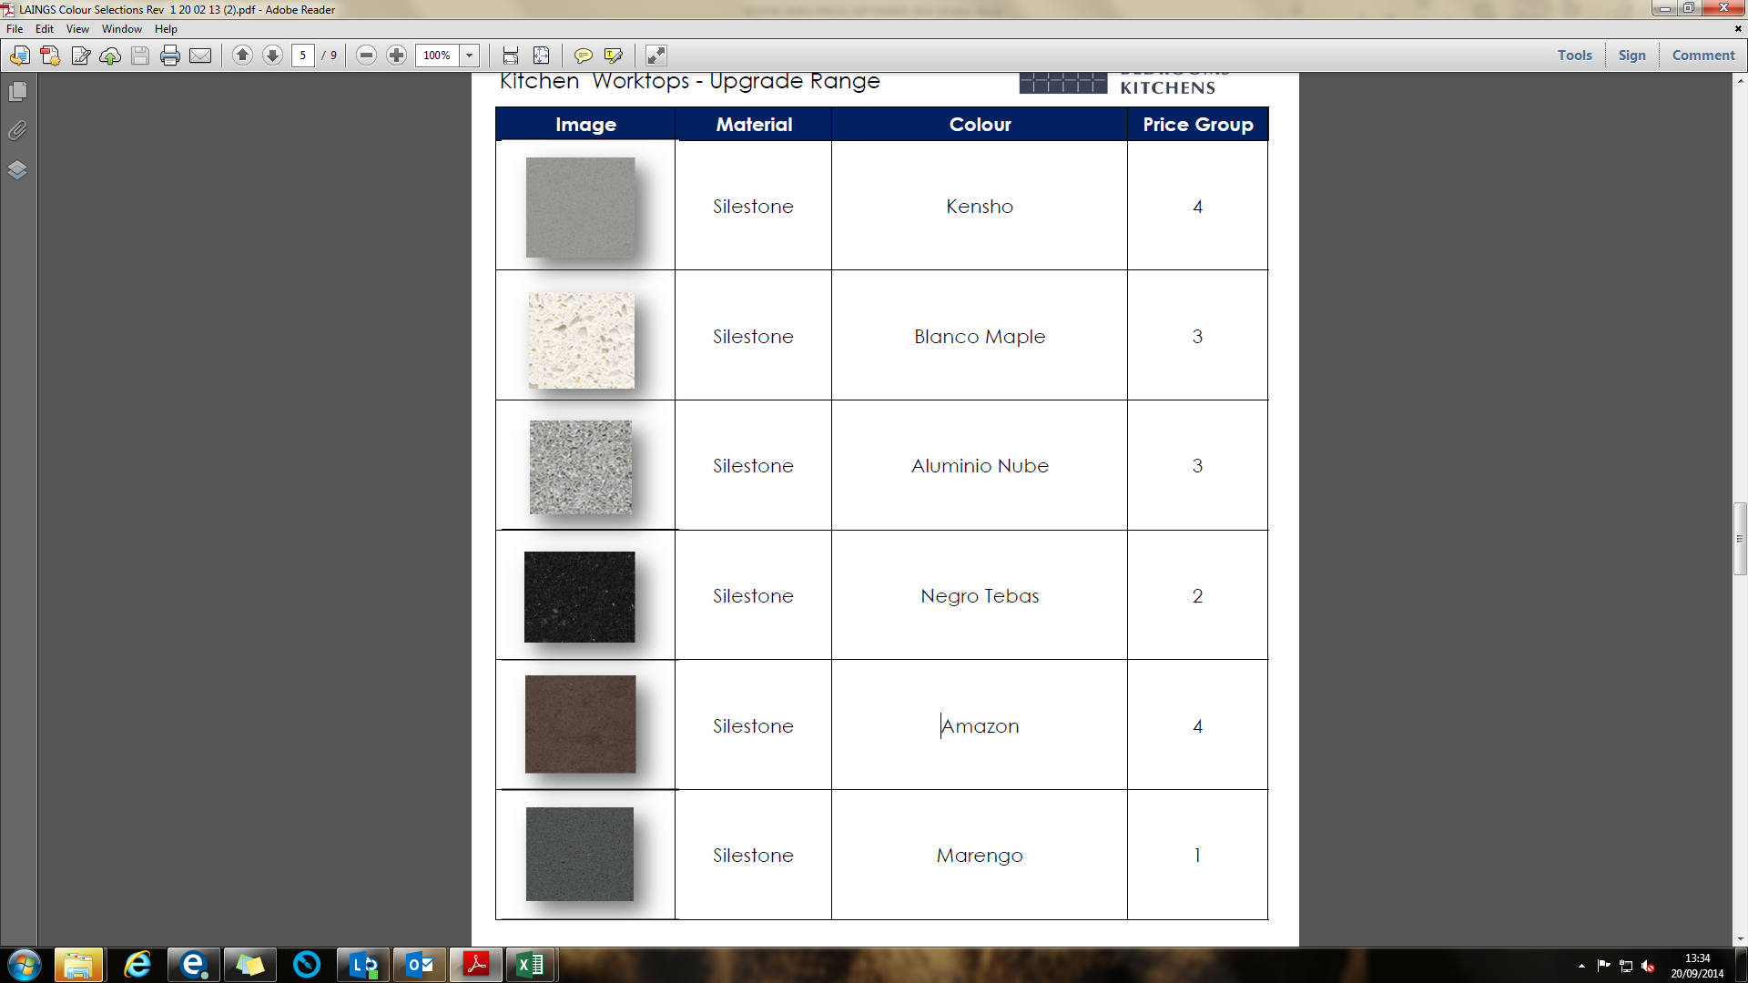
(Mackintosh) Trend shaker – Sage Grey | Lissa Oak | (Mackintosh) Suite 670, flared iron knob  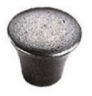  (Mackintosh) Suite 693, polished nickel knob  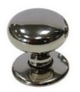  (Mackintosh) Suite 600, shaker cup handle  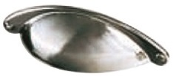  (Mackintosh) Suite 655, brushed steel D handle with chamfered edges  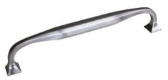 | Negro Tebas
(Mackintosh) Trend shaker – Light Grey | Lissa Oak |  | Kensho
(Mackintosh) – Trend shaker – White | Lissa Oak |  | Blanco Maple

Upgrade laminate worksurfaces (these choices are available at extra charge through your client upgrades and represent a premium range of laminate work surfaces in colours chosen to complement the standard furniture, please see your Sales Adviser)
225 Stem Oak | 354 Concrete Slate Grey | NOTE:  Décor upstands for this laminate are supplied in min. 200mm height, rather than the 100mm as standard specification. This may require electrical points to be raised slightly in order to avoid conflict with upstand. Should 100mm be preferred, this can be requested and priced for on-site cutting/installation.
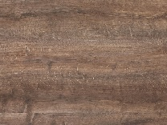 | 
353 White Concrete | 345 Yukon Oak
 | 

Choice of glass panel splashback (behind hob)
Choice of glass panel splashback (behind hob) | Choice of glass panel splashback (behind hob) | Choice of glass panel splashback (behind hob) | Choice of glass panel splashback (behind hob)
ECOAT 01 | ECOAT 02 | ECOAT 03 | ECOAT 04
ECOAT 05 | ECOAT 06 | ECOAT 07 | ECOAT 08
ECOAT 09 | ECOAT 10 | ECOAT 11 | ECOAT 12
On screen and printed colours may vary slightly from the actual product, please refer to physical samples for colour matching. Classic cornice and light pelmet are included as standard with upgrade painted shaker kitchens. Visible carcase sides are plant on panels in colour matching finish with upgrade painted shaker kitchens
† Different colour choices may vary in price, these items will be priced on request
# These handle choices may be available on standard range door fronts (subject to confirmation), but will be subject to additional charge

Sinks and taps
Kitchen: | Leisure stainless steel 1½ bowl or Rangemaster Glendale GL9502 stainless steel 1½ bowl sink, Bristan Ruby monobloc sink mixer with single flow spout

Appliances
Fitted as standard is a stainless steel electric oven, gas or electric hob, contemporary style extractor hood and either a separate integrated fridge and freezer or a single/combined unit depending on kitchen layout.
- | Smeg SF478X or SF6400TVX - single stainless steel fan oven
- | Smeg SE364TD 60cm touch control ceramic hob with straight edge glass
- | Smeg KSE60XE-2 600mm or KSE90XE-2 900mm slim-line box chimney or KSET600XE 600mm telescopic or KI90XE 900mm island stainless steel extractor hood, depending on layout. This will be a recirculating model in plots fitted with a dMEV ventilation system (see specification document).
- | Refrigeration appliances willl include one or more of; Smeg C7280FP 70/30 tall fridge/freezer, S7212LS2P mid-height fridge, KUD7108FSEP under worktop freezer, UKUD7140LSP under worktop fridge and/or UKUD7122CSP under worktop fridge with ice box, depending on layout
At an additional charge an upgrade to some of the kitchen/utility room packages can be fitted. This can include additional appliances in the kitchen i.e. integrated dishwasher, integrated microwave oven, and either an integrated or free-standing washing machine/washer/dryer – please ask the Sales Adviser for details.

Wall and floor tiling

Bathrooms, En suites & WCs
Whilst the choice of wall tiling is entirely your own, we recommend that you consider the size of individual tiles when considering locations, as this may have an effect on both the visual appearance, and also the need for ‘cut’ tiles upon installation.
Where orientation is not specifically confirmed on your colour choice requests, these will be fitted ‘portrait’ to bathrooms/en suites, where applicable. This may have an effect on the visual appearance, as noted above.
N.B. Whilst all floor (available as an upgrade through your Extras) tiles listed are suitable for general internal floor use, further advice must be sought with regard to slip ratings if these are to be installed in a ‘wet’ floor environment.

Standard range wall tiling
Range/Colour |  | Tile size | Trim (not in Utility rooms/cupboards) | Grout/Sealant | Upgrade Floor Tile (recommended)
Park Lineal Gris |  | 250x443mm | 10.0 mm White | Gris (grey) | Park Gris (443x443mm)  Grout = Manhattan | 
Jersey Mix |  | 250x443mm | 10.0 mm White | Gris (grey) | Bali Nieve (443x443mm)  Grout = Gris | 
Shine Dark |  | 250x443mm | 10.0mm White | Antracita | Ferroker  (443x443mm)  Grout = Antracita | 
Shine Aluminio |  | 250x443mm | 10.0mm White | Manhattan | Ferroker Aluminio  (443x443mm)  Grout = Manhattan | 
Japan Blanco |  | 250x443mm | 10.0 mm White | Blanco (white) | Japan Blanco (443x443mm)  Grout = Gris | 
Japan Marine | 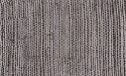 | 250x443mm | 10.0 mm White | Cemento (cement grey) | Japan Marine (443x443mm)  Grout = Cemento | 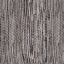
Madgascar Blanco |  | 250x443mm | 10.0 mm White | Blanco (white) | Madagascar Blanco (443x443mm)  Grout = Gris | 
Madagascar Natural |  | 250x443mm | 10.0 mm White | Gris (grey) | Madagascar Natural (443x443mm)  Grout = Gris | 
Malaga Beige | 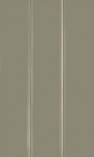 | 250x443mm | 10,0mm White | Blanco (white) | See further options below
Malaga Acero | 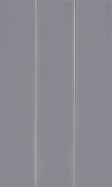 | 250x443mm | 10,0mm White | Blanco (white) | See further options below
Malaga Ocean |  | 250x443mm | 10,0mm White | Blanco (white) | See further options below
Malaga Blanco |  | 250x443mm | 10,0mm White | Blanco (white) | See further options below
Crystal White (previously Formas Blanco) |  | 250x443mm | 10.0 mm White | Blanco (white) | See further options below

Upgrade range wall tiling
These tiles are available at extra charge through your client Extras and different choices may vary in price, please see your Sales Adviser for further information.
Range/Colour |  | Tile size | Trim (not in Utility rooms/cupboards) | Grout/Sealant | Upgrade Floor Tile (recommended)
Retro Blanco |  | 100x200mm | 10.0 mm White | Blanco(white) | See further options below
Calpe Blanco |  | 75x300mm | 10.0 mm White | Blanco(white) | See further options below
Calpe Seagreen |  | 75x300mm | 10.0 mm White | Gris (grey) | See further options below
Calpe Warm Grey |  | 75x300mm | 10.0 mm White | Blanco(white) | See further options below
Retro Blanco, Calpe Blanco, Calpe Seagreen and Calpe Warm Grey tiles above will be fitted in brick-bond format.
Nimbus Blanco |  | 250x443mm | 10.0 mm White | Blanco(white) | Nimbus Blanco (333x333mm)  Grout = Gris | 
China Blanco |  | 316x592mm | 10.0 mm White | Blanco(white) | See further options below
Marmol Carrara Blanco |  | 316x592mm | 10.0mm white | Blanco (white) | Carrara Blanco Brillo  Grout = Manhattan | 
Nast Grey |  | 316x592mm | 10.0mm white | Gris (grey) | Nast Grey  Grout = Manhattan
Nast Blanco |  | 316x592mm | 10.0mm white | Blanco (white) | Nast Blanco  Grout = Manhattan
Rodano Lineal Acero |  | 316x592mm | 10.0mm white | Gris (grey) | Rodano Acero (443x443mm)  Grout = Manhattan | 
Sena Acero |  | 316x592mm | 10.0mm white | Gris (grey) | Rodano Acero (443x443mm)  Grout = Manhattan
Rodano Acero |  | 316x592mm | 10.0 mm White | Manhattan (mid grey) | Rodano Acero (443x443mm)  Grout = Manhattan
Mosaico Rodano Acero |  | 316x592mm | 10.0 mm White | Manhattan (mid grey) | Rodano Acero (443x443mm)  Grout = Manhattan
Rodano Caliza |  | 316x592mm | 10.0 mm White | Gris (grey) | Rodano Caliza (443x443mm)  Grout = Gris | 
Rodano Lineal Caliza |  | 316x592mm | 10.0 mm White | Gris (grey) | Rodano Caliza (443x443mm)  Grout = Gris
Dover Caliza |  | 333x592mm | 10.0 mm White | Gris (grey) | Dover Caliza (443x443mm)  Grout = Gris | 
Madagascar Natural |  | 333x592mm | 10.0 mm White | Gris (grey) | Madagascar Natural (443x443mm)  Grout = Gris
Madagascar Blanco |  | 333x592mm | 10.0 mm White | Blanco(white) | Madagascar Blanco (443x443mm)  Grout = Gris
Dover Antique |  | 316x592mm | 10.0 mm White | Cemento (cement grey) | Dover Caliza (443x443mm)  Grout = Gris
Ronda White |  | 200x316mm | 10.0 mm White | Blanco(white) | See further options below

Upgrade range floor tiling (where a complementary choice is not detailed above)
These tiles are available at extra charge through your client Extras and different choices may vary in price, please see your Sales Adviser for further information.
Range/Colour | Tile size | Grout/Sealant
Ferroker | 443x443mm | Antracita (anthracite grey) | 
Ferroker Aluminio | 443x443mm | Manhattan (mid grey) | 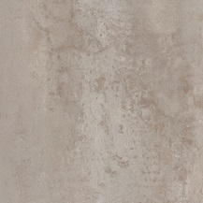
Carrara Blanco Brillo | 446x446mm | Manhattan (mid grey) | 
Nast Grey | 443x443mm | Manhattan (mid grey) | 
Nast Blanco | 443x443mm | Manhattan (mid grey) | 
The following tiles are from premium ranges and will incur additional pricing:
Marmi Blanco | 435x435mm | Gris (grey) | 
Oxford Acero | 220x900mm  (tiles will be fitted in brick-bond format) | Manhattan (mid grey) | 
Antique Silver | 596x596mm | Cemento (cement grey) | 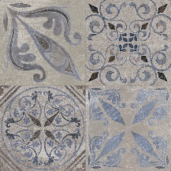
Dover Antique | 596x596mm | Cemento (cement grey) | 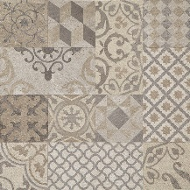

Sanitary ware and fitments
Sanitary ware colour will be – White.
Bathroom | Ideal Standard Tempo Cube 1 tap hole bath
Bathroom | Ideal Standard Unilux E3194 bath panel.
Bathroom | Bristan Prism mono bath filler.
Bathroom | Chrome plated luxury bath pop-up waste kit.
Bathroom | Bristan Prism thermostatic dual control shower valve and adjustable riser (where fitted)
Bathroom | Ideal Standard Tempo Range 1 tap hole basin with semi pedestal.
Bathroom | Bristan Prism basin mixer with chrome waste kit.
Bathroom | Ideal Standard Tempo close coupled W.C. with seat and cover or Ideal Standard Tempo back to wall WC with concealed cistern, dual flushing plate, seat and cover.
Bathroom | Novellini Aurora 3 – 2 panel 960mm x 1500mm clear glass bath splash screen (where fitted)
En suite  (where applicable) | Ideal Standard Tempo Range inset 1 tap hole basin with semi pedestal.
En suite  (where applicable) | Bristan Prism basin mixer with chrome waste kit.
En suite  (where applicable) | Ideal Standard Tempo close coupled W.C. with seat and cover or Ideal Standard Tempo back to wall WC with concealed cistern, dual flushing plate, seat and cover.
En suite  (where applicable) | Just Fusion shower tray with wall panel & Ideal Standard Synergy chrome/clear glass enclosure.
En suite  (where applicable) | Bristan Prism thermostatic dual control shower valve and adjustable riser.

En suite shower paneling (where applicable)
The feature aqua paneling within the shower enclosure can be chosen from either Alpino Matt/Shell White 8100 or Gloss White 8100.
Please consult your Sales Adviser for further information. Not all items/details will be applicable to every situation, please review plot specific drawings when considering these options.
Although every care and attention has been taken to ensure the accuracy of all information given, the contents do not form part of or constitute a representation or warranty of any contract.
Scotia Homes Limited reserves the right to vary the above specifications (including any quoted sizes and specific products/model nos.) where necessary but to similar or higher standards.

